Guest Speaker (GS01), Guest Speaker
GS01_S1
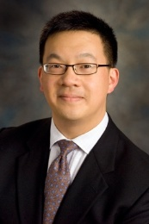 | Family Name (Last Name) | Lai
 | Given Name (First Name) | Stephen
 | Country | USA
 | Position / Department | Professor
 | Institute / Organization | UT MD Anderson Cancer Center
Education Background | MD, PhD
Professional Career | surgeon-scientist
Research Field | novel therapies for head and neck cancers, development of imaging technologies for monitoring tumor response and normal tissue toxicity
Presentation Topic | Integrating Clinical and Research Efforts to Develop Novel Therapies for Anaplastic Thyroid Cancer
Abstract | Anaplastic thyroid cancer (ATC) accounts for about 1.3% of thyroid cancer cases in the US but over 50% of thyroid cancer-related deaths. Over the past decade, we have developed the FAST (Facilitating Anaplastic Thyroid Cancer Specialized Treatment) program to improve patient access to multidisciplinary care and cutting-edge clinical trials. Our efforts have reshaped the standard of care for this devastating disease and enabled us to build a robust translational research program committed to developing critical preclinical models to advance novel therapies. While ATC shares some genetic traits with melanoma, such as BRAF mutations, it has a unique mutational profile and response patterns that require distinct therapeutic strategies. Additionally, ATC typically presents as an invasive, rapidly progressing disease, necessitating swift and aggressive treatment. Rapid assessment of treatment response is crucial to make timely adjustments if the disease does not respond to the initial therapy. Although treatments such as radiation therapy and systemic therapies, including BRAF/MEK kinase inhibitors, are available for aggressive tumors like ATC, dosing is often based on empirical data rather than individualized assessments of patient and tumor characteristics. We have developed a new program, ImpACT: Improving Treatment Strategies for Anaplastic Thyroid Cancer Through Integration of Novel Therapies and Assessment of Tumor Response, to enhance therapeutic outcomes for ATC patients. New projects are designed to investigate and validate signaling pathways and markers associated with drug resistance, identify immunogenic T cell receptor (TCR) targets to develop peptide-specific cytotoxic T lymphocytes, explore metabolic imaging with hyperpolarized 1-13C-pyruvate as a minimally invasive method for early detection of therapeutic response and resistance, and investigate cellular plasticity and transformation in ATC through an integrated multi-omic computational approach. We are focused on these studies with the goal of providing paradigm-shifting insights into the biology of ATC and its clinical treatment.

Guest Speaker (GS02), Guest Speaker
GS02_S1
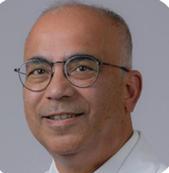 | Family Name (Last Name) | Sinha
 | Given Name (First Name) | Uttam
 | Country | USA
 | Position / Department | Professor and Director of USC Head and Neck CenterCaruso Department of Otolaryngology-Head and Neck Surgery
 | Institute / Organization | Keck School of Medicine of University of Southern California, Los Angeles, CA, USA
Education Background | Research Fellowship, Neuro-Oncology, Department of Pathology, USC School of Medicine, Los Angeles, CA, USA, 1986 – 1990 Residency, Department of Otolaryngology- Head and Neck Surgery, USC School of Medicine, 1990 – 1995 Clinical Fellowship,T he Mount Sinai Medical Center (Mircrovascular Surgery), New York, New York, 1995 – 1996 Clinical Fellowship, Cabinet de Phoniatrie (Laryngology), Lyon, France, 1996 – 1997
Professional Career | Tenured Professor, Departments of Otolaryngology-Head and Neck Surgery, Radiation Oncology and Neurosurgery.Associate Dean of Surgical Innovation and Simulation, Keck School of Medicine of University of Southern California
Research Field | Uttam K. Sinha, MD, is an academic otolaryngologist–head and neck surgeon, clinician-scientist, and educator. His career integrates complex head and neck cancer care, translational research in cancer immunology, epigenomics, and liquid biopsy, survivorship innovation, speech and rehabilitation, mentorship, and academic leadership, advancing multidisciplinary care and improving patient outcomes
Presentation Topic | THE CLOCK IS TICKING: EARLY INTERVENTION FOR DYSPHAGIA IN HEAD AND NECK CANCER
Abstract | Dysphagia is one of the most common, disabling, and enduring consequences of head and neck cancer and its treatment. Historically, management has often been delayed until substantial functional decline is clinically apparent. However, mounting evidence supports a paradigm shift toward earlier intervention, with the goal of preserving swallow physiology, reducing long-term morbidity, and improving survivorship outcomes. Treatment-related swallowing impairment is multifactorial, arising from surgical disruption, radiation-induced fibrosis, neuromuscular injury, edema, sensory loss, and stricture formation. Early rehabilitation strategies—including baseline assessment, traditional swallow therapy, neuromuscular electrical stimulation, and longitudinal functional monitoring—may mitigate the progressive cycle of disuse, fibrosis, aspiration, and feeding tube dependence. Clinical work from our group and others has shown that initiation of combined swallow therapy before and during chemoradiotherapy is associated with improved functional oral intake and lower gastrostomy dependence compared with delayed therapy. Mechanistic studies further suggest that neuromuscular stimulation may modulate radiation-related fibrosis through restoration of TGF-β1/MyoD homeostasis. For patients with advanced late dysfunction, salvage approaches such as self-esophageal dilation and combined antegrade-retrograde dilation may restore swallowing in selected cases, although outcomes are more limited once severe stenosis is established. Advanced imaging modalities, including real-time magnetic resonance imaging, also offer new insights into dynamic swallowing physiology and may refine assessment beyond conventional videofluoroscopy. Early intervention should be viewed not as supportive care alone, but as an integral component of comprehensive head and neck cancer treatment. A proactive, multidisciplinary approach is essential to preserving function, improving quality of life, and redefining standards of survivorship care.(Could be provided before June 15)

Guest Speaker (GS03), Guest Speaker
GS03_S1
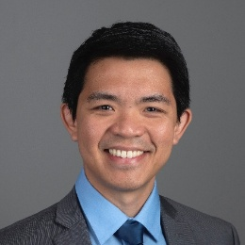 | Family Name (Last Name) | Gomez
 | Given Name (First Name) | Ernest (Ted)
 | Country | United States
 | Position / Department | Assistant Professor / Otolaryngology
 | Institute / Organization | Harvard Medical School / Beth Israel Deaconess Medical Center
Education Background | B.S. Engineering (Bioengineering) – University of PennsylvaniaB.S. Economics (Health Care Management and Policy) – Wharton School, University of PennsylvaniaM.D. – Perelman School of Medicine, University of PennsylvaniaM.S. Translational Research - Perelman School of Medicine, University of PennsylvaniaOtolaryngology Residency – Hospital of the University of PennsylvaniaHead and Neck Oncology / Microvascular Reconstruction / Transoral Robotic Surgery Fellowship – Hospital of the University of Pennsylvania
Professional Career | Faculty at Beth Israel Deaconess Medical Center and Harvard Medical School since 2019
Research Field | Surgical Education, Surgical Simulation, Head and Neck Surgery Outcomes, Surgical Skill Assessment
Presentation Topic | Shaping the Next Generation of Otolaryngologists: Simulation-Based Training in the United States
Abstract | (Could be provided before June 15)

Guest Speaker (GS04), Guest Speaker
GS04_S1
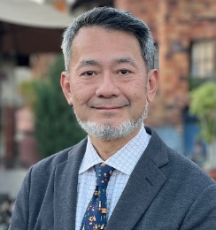 | Family Name (Last Name) | NAKAYAMA
 | Given Name (First Name) | MEIJIN
 | Country | JAPAN
 | Position / Department | MEDICAL DOCTOR
 | Institute / Organization | NAKAYAMA ENT CLINIC
Education Background | KITASATO UNIVERSITY SCHOOL OF MEDICINE
Professional Career | KITASATO UNIV / YOKOHAMA CITY UNIV / YOKOSUKA KYOSAI HOSPITAL
Research Field | H&N LARYNX PRESERVATION, MILLIMARY INVASIVE SURGERY
Presentation Topic | My 40-year experience in ORL-HNS
Abstract | My father graduated from Taiwan Univ in 1958. He opened an ENT clinic in Pingtung 1962, the year I was born. My grandfather graduated from JIKEI Univ in Tokyo in 1928 and became a surgeon in Kongsan. Without these two great ancestors, I cannot be here.After 40-year services at academic field in Japan, I stepped down as a H&N surgeon March 2026. Upon the generous invitation from President Wang, I politely declined because I am no longer active in the field. But, Chen-Chi told me, “You are most welcome not because of any title or position, but because of your longstanding contributions to the H&N community and, most importantly, because of our cherished friendship.” Like many Taiwanese mentors I know, Chen-Chi you are a good person.We are entering a super-aging era and ENT patients are getting older ever. In past 50 years, average age at initial visit gained 20 years in head and neck cancer patients in Japan. As Otolaryngologists, we are facing various challenges. In head and neck surgery, the elderly patients may not tolerate radical treatments associated with great invasiveness. To survive the 21st Century, we must innovate and improve.“Minimally invasive surgical (MIS) interventions” and “Functional preservation” are the two keywords in the future medicine. I will present ideas of how to keep our practice in MIS manners. I will also talk about my signature surgery Supracricoid Partial Laryngectomy SCPL, how I encountered, practiced, and updated SCPL to meet the MIS era.

Keynote Lecture (K01), Keynote lecture
K01_S1
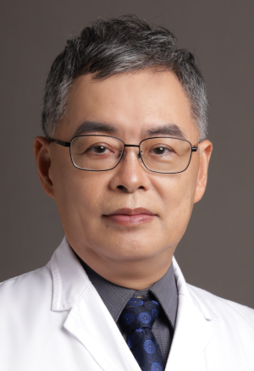 | Family Name (Last Name) | Leu
 | Given Name (First Name) | Yi-Shing
 | Country | TAIWAN
 | Position / Department | President/Taiwan Head Neck society
 | Institute / Organization | MacKay Memorial Hospital
Education Background | Taipei Medical University (1989)
Professional Career | Assistant professor
Research Field | Head and neck cancer, trail
Presentation Topic | The treatment consensus of oropharyngeral cancer in Taiwan
Abstract | Background: Management of oropharyngeal squamous cell carcinoma (OPSCC) has evolved toward deintensification strategies for disease associated with human papillomavirus (HPV) infection in Western populations. However, Taiwan presents a unique epidemiologic challenge—also known as the Taiwan Paradox, whereby alcohol, betel quid, and cigarette smoke (ABC) exposure substantially worsens the prognosis of HPV-positive OPSCC, which in turn renders Western deintensification data potentially inapplicable.  Methods: A multidisciplinary panel of 15 head and neck oncology specialists from major Taiwanese academic centers conducted a modified Delphi consensus process over three rounds. A total of 30 clinical questions were developed across 5 domains, with recommendations graded by evidence level and consensus strength.  Results: Key consensus recommendations are as follows: (1) HPV testing with concurrent esophagoscopy-based screening at diagnosis; (2) classification of HPV-positive patients with high ABC exposure as high-risk patients; (3) site-specific surgery for early-stage disease (prioritizing the tonsils and avoiding the soft palate); (4) definitive concurrent chemoradiotherapy for locally advanced disease regardless of HPV status; (5) HPV-status-dependent clear margin definitions (≥3 mm for HPV-positive disease and ≥5 mm for HPV-negative disease); (6) radiotherapy deintensification restricted to nonsmoking HPV-positive patients with a favorable pathology or induction chemotherapy response; and (7) immunotherapeutic regimens as the first-line treatment for recurrent or metastatic disease, with Taiwan-specific tegafur–uracil combinations.  Conclusion: This consensus provides evidence-based, region-specific guidance for OPSCC management in betel-quid-endemic regions. It emphasizes risk stratification involving both HPV status and ABC exposure to optimize treatment selection.

Keynote Lecture (K02), Keynote lecture
K02_S1
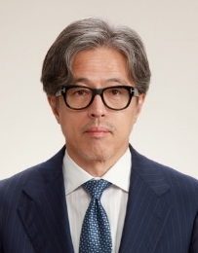 | Family Name (Last Name) | Takahiro
 | Given Name (First Name) | Asakage
 | Country | Japan
 | Position / Department | Professor/Head and Neck Surgery
 | Institute / Organization | E-Mail
Education Background | 1985-1991 Faculty of Medicine, Yamagata University, Japan
Professional Career | 1991-1993 Department of Otorhinolaryngology, Tokyo University, Japan1994-2003 Department of Head and Neck Surgery, National Cancer Center Hospital, East, Japan2003-2015 Department of Otorhinolaryngology, Tokyo University, Japan2015-2024 Department of Head and Neck Surgery, Tokyo Medical and Dental University, Japan2024- Department of Head and Neck Surgery, Institute of SCIENCE TOKYO
Research Field | Clinical research, particularly skull base surgery and tongue cancer
Presentation Topic | Real-World Data on Near-infrared Photoimmunotherapy for Head and Neck Cancer in Japan: A Report on Our Own Cases
Abstract | Near-infrared photoimmunotherapy (NIR-PIT) was approved in Japan 2020 for unresectable locally advanced or locally recurrent head and neck cancer. We evaluated large-scale real-world data on its safety and efficacy. Between 2021 and 2025, 220 patients were enrolled from 58 institutions across Japan. The safety and efficacy analysis populations comprised 199 and 178 patients, respectively. Most patients (87.9%) had locally recurrent disease, and 95.4% had squamous cell carcinoma. Adverse reactions occurred in 87.9% of patients, most commonly injection-site pain (54.2%), laryngeal edema (20.6%), and dysphagia (15.0%). Grade 4 or 5 laryngeal edema and tumor bleeding occurred in 6.5% and 0.5%, respectively. Complete and partial responses were achieved in 34.2% and 34.8% of patients, respectively. This large-scale multicenter real-world study demonstrates substantial antitumor activity of NIR-PIT, with complete responses in approximately one-third of patients, supporting its clinical value for unresectable head and neck cancer.

Keynote Lecture (KS03), Keynote Lecture
K03_S1
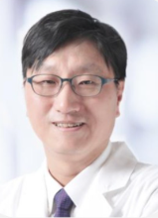 | Family Name (Last Name) | Ahn
 | Given Name (First Name) | Soon-Hyun
 | Country | Republic of Korea
 | Position / Department | Professor/Dept. of ENT
 | Institute / Organization | Seoul National University Hospital
Education Background | M.D., 1993 College of Medicine, Seoul National UniversityM.S., 1998 College of Medicine, Seoul National UniversityPh.D, 2004 College of Medicine, Seoul National University. Seoul, Korea
Professional Career | 1994-1998 Resident of Otolaryngology, Seoul Nat’l Univ. Hospital, Seoul, Korea2001-2003 Clinical & Research Fellow of the OtologySeoul Nat’l Univ. Hospital, Seoul, Korea2006-2007 Postdoctoral fellow, M.D. Anderson Cancer Center. Houston, TX, USA2003-2017 Seoul National University Bundang Hospital2017-Now Seoul National University Hospital
Research Field | Head Neck Reconstruction, Head Neck clinical oncology
Presentation Topic | Head and Neck Reconstruction, Selection of flap
Abstract | In advanced head and neck cancer, appropriate reconstruction is essential for planning the surgery. Now microvascular free flap has become golden standard and depending on the situation of institution, free flap by head and neck surgeon by themselves became a common practice.When performing reconstruction as a head and neck surgeon, I believe it is right to choose a method that is relatively safe, allows for rapid recovery, enables subsequent radiation therapy to be performed on time without issues, and preserves function. And Efforts to reduce surgery time are also important.In this regard, free flaps, including ALT which is useful for Asians, RFFF, and fibular free flaps, can treat most patients, and it is important to become familiar with them quickly.The PMMC, a regional flap, is the most important flap; along with this, becoming familiar with the latissimus dorsi flap provides a powerful reconstruction method, and most problems can be resolved using these flaps.I would like to discuss the adaptation of the flap through experience.

Mini Symposium (MS01), Endoscopic & Robotic surgery
MS01_S1
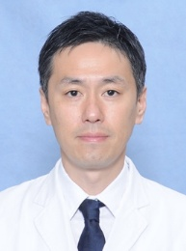 | Family Name (Last Name) | Obata
 | Given Name (First Name) | Kazufumi
 | Country | Japan
 | Position / Department | Junior Associate Professor / Department of Otolaryngology-Head and Neck Surgery
 | Institute / Organization | Tokai University
Education Background | M.D., Ph.D.,
Professional Career | Kazufumi Obata, M.D., Ph.D., is a Junior Associate Professor in the Department of Otorhinolaryngology–Head and Neck Surgery, Tokai University, Isehara, Japan. His clinical and research interests include head and neck surgery and oncology, endocrine surgery, minimally invasive surgery, postoperative swallowing function, and quality of life. He has extensive experience in the surgical management of head and neck disease.
Research Field | Surgery of Head and Neck Cancer
Presentation Topic | Comparison of Postoperative Quality of Life After Transoral Robotic Surgery and Transoral Videolaryngoscopic Surgery for Head and Neck Cancer
Abstract | Background: Transoral robotic surgery (TORS) and transoral videolaryngoscopic surgery (TOVS) are minimally invasive procedures for head and neck cancer, but direct longitudinal comparisons of postoperative quality of life (QOL) are limited. This study compared postoperative QOL between TORS and TOVS and identified factors associated with temporary deterioration.Methods: We conducted a single-center retrospective cohort study of 103 patients with head and neck tumors treated between July 2016 and December 2024. Eighty-three underwent TOVS and 20 underwent TORS. QOL was assessed preoperatively and at 1, 3, 6, 12, and 18 months postoperatively using the EORTC QLQ-C30 and QLQ-H&N35. Longitudinal changes were analyzed with the Kruskal-Wallis test followed by Dunn’s multiple comparison test, and intergroup comparisons with the Mann-Whitney U test. Risk factors for early postoperative pain and mouth opening limitation were evaluated using a generalized linear mixed modelResults: At 1 month, both groups showed significantly worse pain, mouth opening limitation, and painkiller use than at baseline. These symptoms gradually improved between 3 and 6 months. No significant differences in QOL scores were found between groups. Pain scores at 1 month were 14.0 ± 17.9 in the TOVS group and 22.8 ± 22.2 in the TORS group (p=0.117); mouth opening limitation scores were 11.3 ± 18.2 and 28.9 ± 35.3, respectively (p=0.115). Neck dissection was an independent risk factor for pain and mouth opening limitation, and oropharyngeal cancer was an additional risk factor for mouth opening limitation.Conclusions: TORS and TOVS showed no statistically significant difference in postoperative QOL outcomes. Early postoperative pain and mouth opening limitation were the principal contributors to transient QOL decline in both groups.

Mini Symposium (MS01), Endoscopic & Robotic surgery
MS01_S2
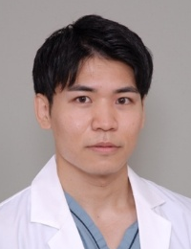 | Family Name (Last Name) | Watanabe
 | Given Name (First Name) | Takane
 | Country | Japan
 | Position / Department | Assistant Professor, Department of Otolaryngology–Head and Neck Surgery
 | Institute / Organization | Tokai University School of Medicine
Education Background | MD, Yokohama City University School of Medicine, 2017.PhD candidate, Juntendo University Graduate School of Medicine, 2023–present.
Professional Career | Since 2019, I have trained in otolaryngology–head and neck surgery. From 2021 to 2025, I received multidisciplinary training in head and neck cancer treatment at the National Cancer Center Hospital, Tokyo, including head and neck surgery, medical oncology, reconstructive surgery, pathology, and intensive care medicine. Since 2025, I have been working at Tokai University School of Medicine.
Research Field | Molecular characterization of TP53 wild-type head and neck squamous cell carcinoma, with a focus on epigenetic dysregulation and genomic instability.
Presentation Topic | Evolution and Contemporary Role of Transoral Videolaryngoscopic Surgery
Abstract | Transoral surgery has become an important minimally invasive approach for selected patients with pharyngolaryngeal cancer, aiming to achieve oncologic control while preserving swallowing, speech, and laryngeal function. In Japan, transoral videolaryngoscopic surgery (TOVS) has developed as a non-robotic transoral resection technique in parallel with advances in endoscopic diagnosis, including narrow-band imaging. In this symposium, we will review the evolution of TOVS at our institution since 2012 and discuss its contemporary role, focusing on technical refinement using three-dimensional endoscopy and salvage surgery after irradiation. Conventional TOVS is performed using a two-dimensional endoscope, whereas three-dimensional (3D) endoscopy provides a stereoscopic view and a sense of distance. In our 3D-TOVS setting, the 3D endoscope is fixed with an endoscope holder to avoid camera shaking caused by hand-held manipulation. This setup allows the surgeon and assistant to share the same operative field through a 3D monitor, while the assistant supports the procedure using suction, forceps, or other instruments. Moreover, we will also briefly discuss our experience with salvage TOVS for hypopharyngeal carcinoma of post-irradiation recurrence. Taken together, TOVS remains a practical, accessible, cost-conscious, and anatomically adaptable surgical platform that can complement transoral robotic surgery. Continued refinement of indications, standardization of techniques, and device innovation will be essential to further improve oncologic and functional outcomes.

Mini Symposium (MS01), Endoscopic & Robotic surgery
MS01_S3
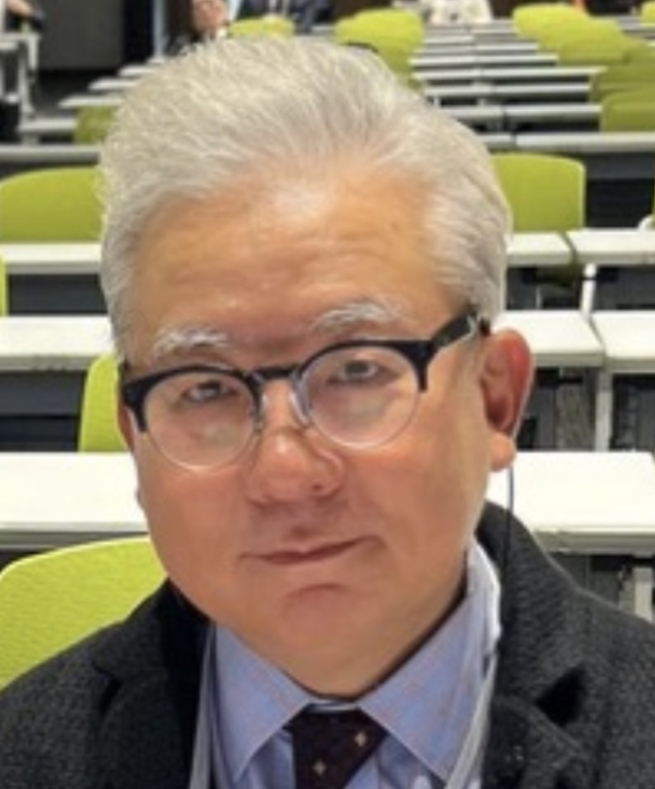 | Family Name (Last Name) | KOH
 | Given Name (First Name) | Yoon Woo
 | Country | South Korea
 | Position / Department | Chairman and Director/Department of ORL-HNS, Yonsei University
 | Institute / Organization | Severance Hospital/Korean Society of Head and Neck Surgery
Education Background | MD. PhD. From Yonsei University College of Medicine
Professional Career | President-Elect, Korean Society of Head and Neck Surgery
Research Field | Single cell genomics, Clinical trials of Neoadjuvant Chemotherapy followed by TORS with Robotic Neck Dissection
Presentation Topic | Prevention of Stenosis and Stricture with Suturing and repairing Pharyngeal Mucosa in TORS
Abstract | Abstract (up to 300 words)

Panel discussion (PS01), Innovative Therapy: Surgery
PS01_S1
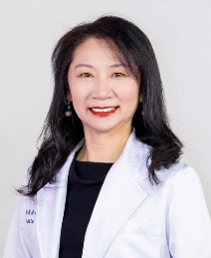 | Family Name (Last Name) | Tsai
 | Given Name (First Name) | Stella
 | Country | Taiwan
 | Position / Department | Vice Superintendent
 | Institute / Organization | Tungs’ Taichung MetroHarbor Hospital
Education Background | MD Brown University, PhD Harvard University
Professional Career | Vice Superintendent, Tungs’ Taichung MetroHarbor HospitalProfessor, College of Medicine, National Chung Hsing University, TaiwanDirector, Da Vinci Surgical Center, Tungs’ Taichung MetroHarbor HospitalSenior Attending Surgeon, Department of Otolaryngology–Head and Neck Surgery, Tungs’ Taichung MetroHarbor Hospital
Research Field | Robotic Surgery; Oral Cancer; Air Pollution and ENT Diseases
Presentation Topic | From Radical Resection to Functional Preservation: The New Era of Robotic Head and Neck Surgery
Abstract | Over the past two decades, the surgical management of head and neck tumors has evolved from extensive radical resection toward approaches that emphasize functional preservation and improved quality of life. Robotic surgery has played a pivotal role in this transformation by enabling precise tumor resection through minimally invasive access while minimizing surgical morbidity.Transoral robotic surgery (TORS) has become an important technique for selected tumors of the oropharynx and oral cavity, allowing surgeons to achieve oncologic safety while preserving critical functions such as speech and swallowing. With ongoing technological advances, including the development of single port robotic platforms, the indications for robotic surgery in head and neck oncology continue to expand.This presentation will review the evolution of robotic head and neck surgery and share clinical experience from a high-volume robotic program with more than 550 TORS procedures. Our institution is also the first national observation site for the da Vinci Single Port system in otolaryngology, providing early clinical experience in the transition from multi-port to single-port robotic surgery.Key topics will include surgical strategies, patient selection, perioperative outcomes, and innovations in minimally invasive and neck-concealed approaches designed to reduce external scarring while maintaining oncologic safety.Robotic surgery represents not only a technological advancement but also a shift in surgical philosophy, redefining the balance between oncologic radicality and functional preservation in modern head and neck surgery.

Panel discussion (PS01), Innovative Therapy: Surgery
PS01_S2
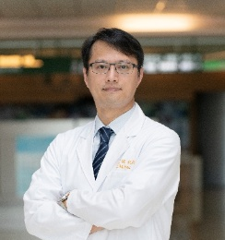 | Family Name (Last Name) | Hsu
 | Given Name (First Name) | Cheng-Ming
 | Country | Taiwan
 | Position / Department | Professor/Otolaryngology
 | Institute / Organization | Chiayi Chang Gung Memorial Hospital
Education Background | PhD
Professional Career | Professor, Department of Medicine, Chang Gung UniversityDirector, Taiwan Society of Otorhinolaryngology–Head and Neck Surgery; Convenor, Da Vinci Surgical and Innovative Medicine CommitteeDirector, Cancer Center, Chiayi Chang Gung Memorial HospitalPhysician, Da Vinci Xi Surgical Observation CenterM.D., Chang Gung University; Recipient of the 20th Distinguished Alumnus Award
Research Field | Laryngology
Presentation Topic | A New Era of Da Vinci Robotic Surgery for Pharyngeal and Laryngeal Tumors: From Xi to SP
Abstract | The anatomical structures of the pharynx and larynx are characterized by their depth and narrowness, surrounded by a complex network of critical nerves and blood vessels. Traditional transoral surgery has historically been hindered by visual blind spots and restricted maneuverability for surgical instruments.With the introduction of the Da Vinci Xi system, Transoral Robotic Surgery (TORS) ushered in a new epoch for the treatment of head and neck cancers and various pharyngeal diseases. Now, the integration of the latest SP (Single Port) system is pushing surgical precision to even greater heights.Prior to the widespread adoption of the SP system, the Xi system served as the primary workhorse for pharyngeal procedures. Its main limitation, however, lies in the cramped oral environment, where multiple robotic arms are prone to external collisions. To prevent these collisions, surgical positioning becomes exceptionally challenging, particularly in patients with a narrow pharyngeal passage.The emergence of the SP system provides a strategic opportunity to overcome these constraints. The transition from Xi to SP represents more than just a hardware upgrade—it is an evolution in surgical thinking. This system allows surgeons to approach lesions from entirely different angles and directions that were previously inaccessible.While the SP system offers significant advantages, further accumulation of clinical experience is essential to refine its application and maximize its effectiveness in the future.

Panel discussion (PS01), Innovative Therapy: Surgery
PS01_S3
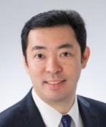 | Family Name (Last Name) | Tsukahara
 | Given Name (First Name) | Kiyoaki
 | Country | Japan
 | Position / Department | Professor/ Department of Otorhinolaryngology, Head and Neck Surgery
 | Institute / Organization | Tokyo Medical University
Education Background | March 1998 Graduated from Tokyo Medical University
Professional Career | November 2004 - The Cancer Institute Hospital of Japanese Foundation for Cancer Research, Head and Neck OncologyJanuary 2008 - Instructor, Department of Otolaryngology/Head and Neck Surgery, Tokyo Medical University Hachioji Medical CenterApril 2010 - Lecturer, Department of Otolaryngology/Head and Neck Surgery, Tokyo Medical University Hachioji Medical CenterJanuary 2014 - Associate Professor, Department of Otolaryngology/Head and Neck Surgery, Tokyo Medical University Hachioji Medical CenterAugust 2015 - present Principal Professor, Department of Otolaryngology, Head and Neck Surgery, Tokyo Medical University
Research Field | April 1998 Entered the Graduate School of Medicine, Tokyo Medical University (Department of Otolaryngology)November 2002 Ph.D., Tokyo Medical University, Ko (the degree obtained during a doctoral program)
Presentation Topic | Quality management of TORS
Abstract | In TORS, the most standard technique is resection of oropharyngeal lateral wall cancer. I perform this technique with the concept of excising a cubic block. As a safety margin, the superior pharyngeal constrictor, stylohyoid, and styloglossus muscles are resected. First, make a mucosal incision, dissect the soft palate at its upper margin, and dissect the superior pharyngeal constrictor from the superior line of the tonsil. Next, identify the parapharyngeal fat tissue and dissect the superior pharyngeal constrictor from the fat tissue. At this stage, care must be taken not to enter the parapharyngeal fat tissue to prevent exposure or rupture of the internal carotid artery. Then, the stylohyoid and styloglossus muscles are identified and dissected. In tumors that have extensively invaded the soft palate, “while resection is possible, postoperative nasopharyngeal insufficiency can lead to dysphagia.” Therefore, “resectable lesions” do not necessarily equate to “indications for resection.” When a certain amount of soft palate can be preserved, I combine the procedure with the Gehanno technique to prevent nasopharyngeal insufficiency. By covering the suture site with a polylactic acid sheet and fibrin glue, I have achieved good nasopharyngeal closure function. TORS with a raw surface has a constant risk of postoperative bleeding. The author has also encountered a case of bleeding from the lingual artery 5 weeks postoperatively. A meta-analysis reported that postoperative bleeding occurred in 5.78% (3.1–19.7%) of cases. Bleeding from the lingual artery and other sources is severe, and because it occurs near the larynx, postoperative hemorrhage can be a life-threatening complication. An adequate backup system is necessary to prepare for this.

Panel discussion (PS01), Innovative Therapy: Surgery
PS01_S4
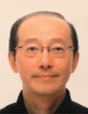 | Family Name (Last Name) | Sugimoto
 | Given Name (First Name) | Taro
 | Country | Japan
 | Position / Department | Director of Department of Otolaryngology – Head and Neck Surgery
 | Institute / Organization | Tokyo Metropolitan Cancer and Infectious Diseases Center Komagome Hospital
Education Background | Graduate of Tokyo Medical and Dental University (TMDU), School of Medicine in 1987 with an M.D. degree
Professional Career | 1987 – 1989: resident at TMDU Hospital1989 – 1994: fellow at affiliated hospitals of TMDU (ENT)1994 – 2000: Instructor of Dept. of Otolaryngology at TMDU2000 – 2004: Chief of Dept. of Otolaryngology at Nakano General Hospital2004 – 2016: Junior Associate Professor of Dept. of Head and Neck Surgery and Chief of inpatient ward at TMDU2016 – present: As above and Clinical Professor of Dept. of Head and Neck Surgery at TMDU (rename to Institute of Science Tokyo from Oct. 2024)
Research Field | Early diagnosis and treatment of pharyngo-laryngeal cancers. In particular, transoral resection for hypopharyngeal cancer.
Presentation Topic | ELPS (Endoscopic Laryngo-Pharyngeal Surgery) for Hypopharyngeal Cancers: How Far Can Surgical Resection Safely Extend?
Abstract | (Could be provided before June 15)

Panel discussion (PS01), Innovative Therapy: Surgery
PS01_S5
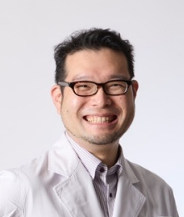 | Family Name (Last Name) | Okada
 | Given Name (First Name) | Ryuhei
 | Country | Japan
 | Position / Department | Assistant professor, Head and Neck Surgery
 | Institute / Organization | E-Mail
Education Background | PhD: Clinical Anatomy, Tokyo Medical and Dental University, 2017MD: Tokyo Medical and Dental University, 2009
Professional Career | 2024-present Assistant Professor, Department of Head and Neck Surgery, Tokyo Medical and Dental University (currently called Institute of Science Tokyo)2021-2024 Specially Appointed Assistant Professor, Department of Head and Neck Surgery, Tokyo Medical and Dental University Hospital2018-2021 Postdoctoral Fellow (visiting), Molecular Imaging Program, Center for Cancer Research, National Cancer Institute, National Institutes of Health, USA
Research Field | Photoimmunotherapy, Fluorescence Imaging
Presentation Topic | Next generation photoimmunotherapy
Abstract | Photoimmunotherapy is a novel treatment modality that utilizes a photoactivatable antibody–drug conjugate. The therapeutic agent consists of a monoclonal antibody targeting a specific cell-surface antigen conjugated to the fluorescent dye IRDye700DX (IR700). The agent is typically administered intravenously, followed by laser illumination of the target lesion under general anesthesia approximately one day later. Upon photoactivation, the conjugate selectively destroys the cells to which it is bound while minimizing damage to surrounding tissues. In Japan, cetuximab-based photoimmunotherapy has been covered by the national health insurance system since 2021 for patients with unresectable head and neck cancer. Clinical studies have demonstrated promising efficacy, and a Phase IIa clinical trial conducted in the United States reported an objective response rate of up to 43.3%. These results have generated considerable interest in expanding the application of this technology to other malignancies.To further enhance therapeutic efficacy, several strategies are currently under investigation. One promising approach is the combination of photoimmunotherapy with immune checkpoint inhibitors, which may augment antitumor immune responses induced by treatment. In addition, photoimmunotherapy can theoretically eliminate any cell type for which an appropriate target antigen and antibody are available. This unique feature enables selective targeting not only of cancer cells but also of cancer stem cells and immunosuppressive cell populations within the tumor microenvironment, including regulatory T cells, which are known to contribute to tumor progression and resistance to therapy.This presentation reviews the current clinical applications of photoimmunotherapy, recent advances in combination and immune-targeted strategies, and future perspectives for expanding its role in cancer treatment.

Panel discussion (PS02), Innovative Therapy: Non-surgery (Proton & Heavy particle)
PS02_S1
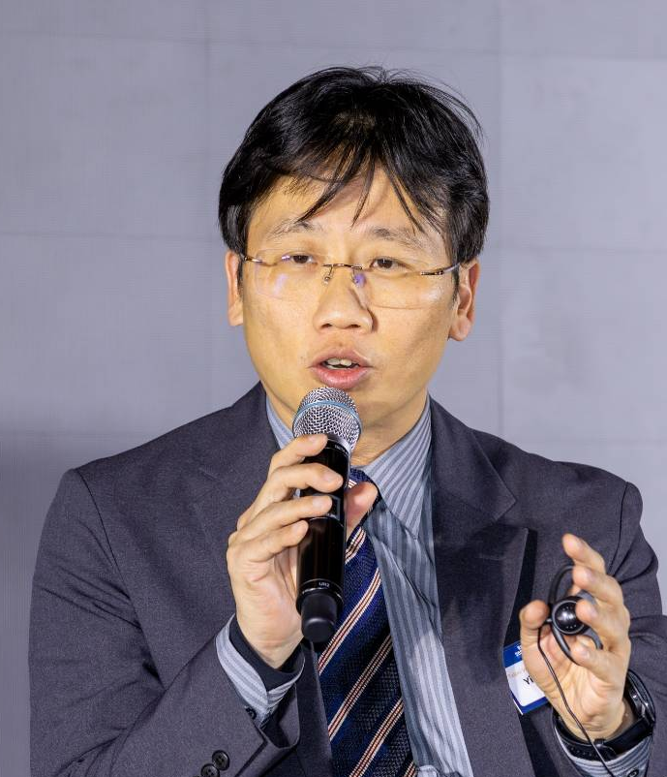 | Family Name (Last Name) | Chen (陳)
 | Given Name (First Name) | Yi-Wei (一瑋)
 | Country | Taiwan
 | Position / Department | Section Chief / Photon Radiotherapy Division, Department of Heavy Particles and Radiation Oncology
 | Institute / Organization | Taipei Veterans General Hospital
Education Background | PhD of Clinical Medicine Department, Yang-Ming Chiao-Tung University
Professional Career | Particle Therapy for Cancer Diseases
Research Field | Boron Neutron Capture Therapy; BNCT
Presentation Topic | Using Salvage BNCT for Recurrent Head and Neck Cancers in Taiwan
Abstract | Boron neutron capture therapy (BNCT) is a special form of targeted particle radiation therapy. It mainly involves the preferential delivery of a boron-10-containing drug specifically to tumor cells followed by irradiation with low-energy thermal neutrons. When boron-10 captures a neutron particle, it undergoes nuclear fission and produces a helium (α particle) and lithium nucleus with strong biological effectiveness. Besides providing excellent tumor destructive effects, they also possess an extremely small field of action (5–10 μM), which limits their effects to a single tumor cell merely. Therefore, BNCT is a targeted particle therapy capable of generating high intra-tumor destructive dosage and effectiveness. BNCT was used for clinical cancer disease for many years, including for recurrent head and neck cancers. Because recurrent head and neck cancers usual Boron neutron capture therapy (BNCT) is a special form of targeted particle radiation therapy. It mainly involves the preferential delivery of a boron-10-containing drug specifically to tumor cells only followed by irradiation with low-energy thermal neutrons. When boron-10 captures a neutron particle, it undergoes nuclear fission and produces a helium (α particle) and lithium nucleus with strong biological effectiveness. Besides providing excellent tumor destructive effects, they also possess an extremely small field of action (5–10 μM), which limits their effects to a single tumor cell merely. Therefore, BNCT is a targeted particle therapy capable of generating high intra-tumor destructive dosage and effectiveness. BNCT was used for clinical cancer disease for many years, including for recurrent head and neck cancers. Because recurrent head and neck cancers are usually located in the surface in head and neck region which can receive sufficient thermal neutron irradiation. Treatment benefit can occur if tumor can also uptake large amount of boron-10 containing drug. Here, we’d like to share our clinical experiences using BNCT for recurrent head and neck cancer patients in Taipei Veterans General Hospital since 2010s. Because tumors locate in the surface of head and neck region which can receive sufficient thermal neutron irradiation. Treatment benefit can occur if tumor can also uptake large amount of boron-10 containing drug. Here, we’d like to share our clinical experiences using BNCT for recurrent head and neck cancer patients in Taipei Veterans General Hospital since 2010.

Panel discussion (PS02), Innovative Therapy: Non-surgery (Proton & Heavy particle)
PS02_S2
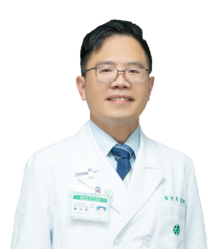 | Family Name (Last Name) | Hsieh
 | Given Name (First Name) | Chen-Hsi
 | Country | Taiwan
 | Position / Department | Professor / Director of Division of Radiation Oncology, Department of Radiology
 | Institute / Organization | Far Eastern Memorial Hospital & National Yang Ming Chiao Tung University
Education Background | Ph.D., School of Medicine, National Yang Ming Chiao Tung University (2011)M.D., China Medical University (2002)
Professional Career | Professor, National Yang Ming Chiao Tung University (2022–Present)Director, Division of Radiation Oncology, Far Eastern Memorial HospitalVisiting Associate Professor, Princess Margaret Hospital, Toronto, Canada (2018)Postdoctoral Fellow, Francis H. Burr Proton Therapy Center, Massachusetts General Hospital, Harvard, USA (2012)Attending Physician, Far Eastern Memorial HospitalAttending Physician / Resident, Department of Radiation Oncology, Mackay Memorial Hospital
Research Field | Image-guided radiotherapy (IGRT)Stereotactic body radiation therapy (SBRT)Interaction between radiation and pharmacokineticsTumor microenvironment response to high-dose irradiationRadiation-induced normal tissue damageImmunity and nature compounds
Presentation Topic | The application of Stereotactic Body Radiation Therapy for head and neck cancers
Abstract | Stereotactic body radiotherapy (SBRT) — high-dose, few-fraction, highly conformal treatment — has become standard in other disease sites but remains comparatively underused in head and neck cancer (HNC), largely due to anatomic complexity and proximity to critical structures such as the carotid artery. However, more evidence indicates that SBRT may be suitable for re-irradiation, palliative symptom control, and treatment of elderly or medically frail patients. In re-irradiation — the setting with the most mature evidence — pooled data from a 2020 meta-analysis of 575 patients show a 61.7% overall response rate, 47.3% 2-year local control, and 30.0% 2-year overall survival, alongside a real but concentrated risk of fatal carotid blowout syndrome (~4.6%). Two very recent publications refine this picture: a 2026 phase 2 trial using automated non-coplanar VMAT achieved 83.8% 1-year local control and 78.8% 1-year overall survival by safely escalating dose, and a 2026 comprehensive review consolidates current practice across all four clinical indications. In elderly/frail patients, prospective cohort data demonstrate that SBRT preserves quality of life while achieving meaningful local control in patients unable to tolerate conventional 6–7 week courses. SBRT offers a technically demanding but increasingly evidence-supported option across the HNC treatment continuum. Careful, multidisciplinary case selection — particularly around carotid-adjacent tumors — remains essential, and the field is shifting from establishing feasibility toward optimizing dose, technique, and patient selection.

Panel discussion (PS02), Innovative Therapy: Non-surgery (Proton & Heavy particle)
PS02_S3
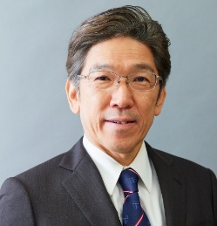 | Family Name (Last Name) | Hirano
 | Given Name (First Name) | Shigeru
 | Country | Japan
 | Position / Department | Professor/Otolaryngology HNS
 | Institute / Organization | Kyoto Prefectural University of Medicine
Education Background | Faculty of Medicine, Kyoto University. April 1984 – March 1990.Residency at Kyoto University Hospital. June 1990 – May 1991.Graduate School of Medicine, Kyoto University. April 1994 – March 1998.
Professional Career | Assistant Professor, Dept of Otolaryngology, Kyoto University, 1998 -2003.Associate Professor, Dept of Otolaryngology-HNS, Kyoto University, 2005- 2016.Professor and chair, Dept of Otolaryngology Head and Neck Surgery, Kyoto Prefectural University of Medicine, 2016 to present
Research Field | Laryngology, Regenerative medicine, anti-aging, head and neck oncology
Presentation Topic | Induction chemotherapy using PCE: current role and impact on advanced head and neck cancer
Abstract | Induction chemotherapy has been used for advanced head and neck squamous cell cancer (HNSCC). The main aim is organ preservation or function preservation treatment for advanced HNSCC. Chemoselection strategy has been used for selection of chemoradiotherapy (CRT) for good responders to avoid extended resection and preserve function for advanced pharyngolaryngeal cancers. Response-adapted surgery is relatively new concept for preserving function in advanced case of HNSCC with insufficient radiosensitivity such as oral cavity cancer and sino-nasal cancer. Induction chemotherapy has been proven to have positive effects for such cancers in terms of function preservation. A critical concern has been the toxicity of chemotherapy which occasionally delays or cancel of operation, or even SAE-related death particularly in use of TPF regimen. PCE regimen has much less toxicity with comparable oncological effects to TPF, thus is can be performed in safe in office without negative issue for following surgery. It has been proven that PCE also have some positive effects on cancer immune environment.

Panel discussion (PS02), Innovative Therapy: Non-surgery (Proton & Heavy particle)
PS02_S4
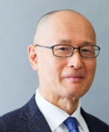 | Family Name (Last Name) | Yoshimoto
 | Given Name (First Name) | Seiichi
 | Country | Japan
 | Position / Department | Department of Head and Neck Surgery
 | Institute / Organization | National Cancer Center Hospital, Tokyo
Education Background | 1991 Graduated from The University of Tokyo, School of Medicine1991-92 Residency, Department of ORL, The University of Tokyo Hospital
Professional Career | 1993-94 Department of Otolaryngology, Takeda General Hospital1994-95 Department of Otolaryngology, NTT Medical Center Tokyo1995-2008 Department of Head and Neck, Cancer Institute Hospital of JFCR(2001. Apr.-Sep. University of Pittsburgh, Otolaryngology, Visiting Fellow)2008- Department of HN Surgery, National Cancer Center Hospital, Tokyo
Research Field | Sentinel node biopsy, Head and neck sarcoma, Skull base surgery, Upper mediastinal surgery, Salvage surgery after CRT, Education, Terminal Care
Presentation Topic | BNCT for recurrent head and neck cancer
Abstract | Boron Neutron Capture Therapy (BNCT) is an advanced radiotherapy that achieves high tumor selectivity through a nuclear reaction between thermal neutrons and the boron-10 isotope. In Japan, BNCT was approved for national health insurance coverage in 2020 for the treatment of locally recurrent head and neck cancer. Between May 2020 and March 2024, 558 patients underwent BNCT nationwide, with clinical outcomes reported in 162 cases. Oral mucositis occurs in about half of patients, reflecting the “fog-like” distribution of neutrons. Grade III or higher toxicity occasionally includes dysphagia. Complete remission was achieved in approximately half of the patients, and the two-year overall survival rate was 60.7%. BNCT may provide a potentially curative option for locally recurrent disease without distant metastases. Similar to photoimmunotherapy (PIT), BNCT is not suitable for tumors invading the carotid artery or skull base. However, BNCT can be applied to non-SCC and to tumors within approximately 7 cm of the body surface, even when PIT is not feasible. Careful patient selection remains essential, and further studies are needed to clarify optimal indications and long-term outcomes.

Panel discussion (PS02), Innovative Therapy: Non-surgery (Proton & Heavy particle)
PS02_S5
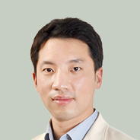 | Family Name (Last Name) | Choi
 | Given Name (First Name) | Nayeon
 | Country | South Korea
 | Position / Department | Institute / Organization
 | Institute / Organization | Samsung Medical Center
Education Background | 2017.3–2025.8 Sungkyunkwan University, College of Medicine, Ph.D., Medicine
Professional Career | 2020.5-2021.2 Clinical assistant professor, Jeju National University Hospital, Jeju, Korea2022.3-2024.2 Clinical assistant professor, Samsung Seoul Hospital, Seoul, Korea2024.3-Assistant professor, Samsung Seoul Hospital, Sungkyunkwan University School of Medicine, Seoul, Korea
Research Field | Head and neck cancer, Image guided surgery
Presentation Topic | Proton Therapy for Oropharynx Cancer: Recent Update.
Abstract | Proton therapy has emerged as a major area of interest in the management of oropharyngeal cancer because of its potential to reduce unnecessary radiation exposure to the salivary glands, oral cavity, pharyngeal constrictors, larynx, and other critical normal structures while maintaining adequate target coverage. Recent randomized data have substantially advanced the field, but they have also highlighted the complexity of translating dosimetric advantages into consistent clinical benefit. In a multicenter U.S. phase III trial, intensity-modulated proton therapy (IMPT) was noninferior to intensity-modulated radiation therapy (IMRT) for progression-free survival and was associated with lower rates of high-grade toxicities, including dysphagia, xerostomia, gastrostomy-tube dependence, and severe lymphopenia; a 5-year overall survival advantage was also reported for IMPT. In contrast, the UK TORPEdO phase III trial showed that modern IMRT and proton therapy yielded similarly excellent tumor control and survival, with no meaningful difference in 1-year patient-reported quality of life, swallowing outcomes, or long-term feeding-tube dependence. Taken together, these results suggest that proton therapy should be viewed not as a universal replacement for IMRT, but as a precision modality whose value depends on patient selection, treatment quality, endpoint selection, and healthcare context.

Panel discussion (PS03), Systemic therapy chemotherapy target immunotherapy
PS03_S1
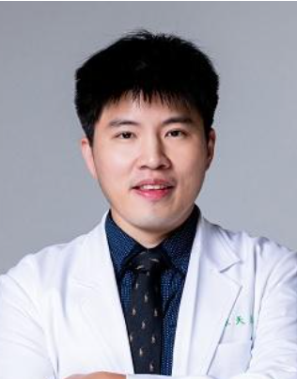 | Family Name (Last Name) | Chen
 | Given Name (First Name) | Tien-Hua
 | Country | Taiwan
 | Position / Department | Attending physician, Division of Medical Oncology, Department of Oncology
 | Institute / Organization | Taipei Veterans General Hospital, Taipei, Taiwan
Education Background | Bachelor of Medicine, National Taiwan University, Taiwan
Professional Career | Attending physician, Division of medical oncology, Taipei Veterans General Hospital, Taipei, Taiwan (R.O.C)Fellow, Division of medical oncology, Department of oncology, Taipei Veterans General Hospital, Taipei, Taiwan (R.O.C) Resident, Department of internal medicine, National Taiwan University Hospital Taipei, Taiwan (R.O.C)
Research Field | Head Neck Cancer, Esophageal Cancer, Nasopharyngeal Carcinoma, Melanoma, Solid Cancers, Immunotherapy, Clinical Trial
Presentation Topic | Bispecific antibodies in HNSCC: opportunities and challenges
Abstract | Outcomes in recurrent or metastatic head and neck squamous cell carcinoma (R/M HNSCC) remain poor, particularly after progression on immune checkpoint inhibition and platinum-based chemotherapy, where cetuximab and taxane-based regimens deliver only modest and short-lived benefit. EGFR remains a validated but incompletely exploited target: monospecific blockade is limited by bypass signalling, an immunosuppressive tumour microenvironment, and weak effector engagement. Bispecific antibodies address these limitations by coupling EGFR inhibition to a second, mechanistically complementary axis.Recently, three agents have generated eye-catching signals in phase II studies. Amivantamab, an EGFR × MET bispecific with Fc-mediated effector function, produced an ORR of 42% by blinded independent review (15% complete responses), a median PFS of 6.8 months and a median OS of 12.5 months in 102 patients with HPV-unrelated R/M HNSCC after checkpoint inhibitor and chemotherapy in the phase 1b/2 OrigAMI-4 study, supported by subcutaneous administration and Breakthrough Therapy designation. Petosemtamab, an ADCC-enhanced EGFR × LGR5 bispecific, achieved a 63% ORR and median PFS of 9 months with pembrolizumab in first-line PD-L1-positive disease, and a 36% ORR with median OS of 11.4 months as monotherapy in previously treated patients; both signals are now being tested in the phase 3 LiGeR-HN1 and LiGeR-HN2 trials. Ficerafusp alfa (BCA101), an EGFR-directed antibody fused to a TGF-β trap, combined with pembrolizumab in first-line HPV-negative disease produced a 54% ORR with 25% complete responses, a median PFS of 9.9 months, median OS of 21.3 months and a 3-year OS rate of 31%, with depth of response emerging as a candidate surrogate; the phase 2/3 FORTIFI-HN01 trial is ongoing.Cross-cutting themes include HPV status and PD-L1 as efficacy modifiers, overlapping dermatologic and infusion-related toxicity, optimal sequencing after checkpoint inhibition, and the biomarkers needed to select among an increasingly crowded field.

Panel discussion (PS03), Systemic therapy chemotherapy target immunotherapy
PS03_S2
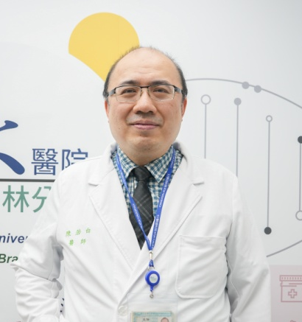 | Family Name (Last Name) | Chen
 | Given Name (First Name) | Jo-Pai
 | Country | Taiwan
 | Position / Department | Oncology
 | Institute / Organization | National Taiwan University Hospital Yun-Lin Branch
Education Background | Oct 1993--- June 2000Department of Medicine, National Taiwan University College of MedicineM. D. awarded in Oct 2000
Professional Career | Attending Physician July 2007---June 2009Department of Oncology, Yun-Lin Branch, National Taiwan University HospitalAttending Physician July 2009---July 2012Department of Oncology, National Taiwan University HospitalDirector of Department of Oncology Aug. 2012 till nowDepartment of Oncology, Yun-Lin Branch, National Taiwan University Hospital
Research Field | HNSCC and NPC
Presentation Topic | From neoadjuvant therapy in locally advanced status to the sequencing of systemic therapy in recurrent/metastatic HNSCC/NPC
Abstract | For locally advanced NPC, how to integrate immunotherapy to neoadjuvant and maintenance setting to facilitate tailored RT strategies will be one treatment option. For R/M NPC, when to introduce immunotherapy for the best outcomes is also an unresolved debate. Besides, for locally advanced HNSCC, well neoadjuvant therapy will maybe bring better oncologic outcomes and more tailored curative treatments preserving survivorship. In our hospital, Erbitux-CT followed by afatinib combined with immunotherapy in R/M OSCC brought encouraging survival; immediate afatinib combined with immunotherapy will rescue poor survival in rapid progression within 3 months after curative or adjuvant chemoradiation for locally advanced HNSCC. Tumor burden, tumor PDL1, and timing of progression will imply treatment sequencing choices.

Panel discussion (PS03), Systemic therapy chemotherapy target immunotherapy
PS03_S3
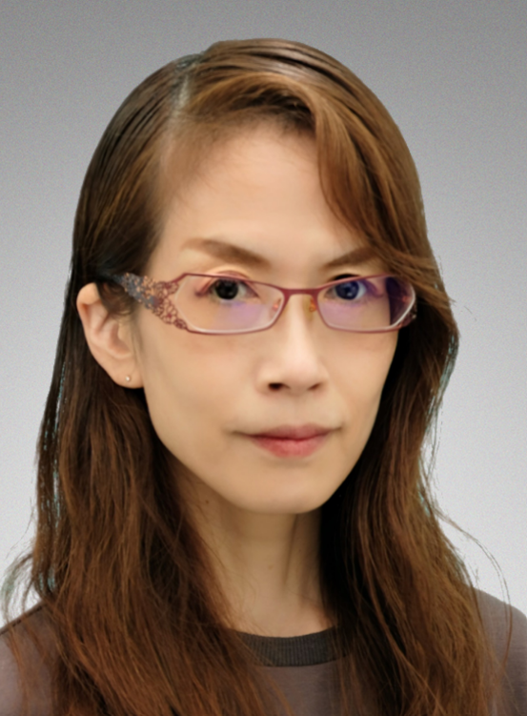 | Family Name (Last Name) | Matsuo
 | Given Name (First Name) | Mioko
 | Country | Japan
 | Position / Department | Otorhinolaryngology
 | Institute / Organization | Graduate School of Medical Sciences Kyushu University
Education Background | Doctor of Philosophy
Professional Career | Mioko Matsuo, MD, PhD, is an Associate Professor in the Department of Otorhinolaryngology–Head and Neck Surgery at Kyushu University Hospital in Fukuoka, Japan. She graduated from Oita University of Medicine in 1998 and subsequently joined the Department of Otorhinolaryngology at Kyushu University. She has worked at multiple major institutions, including Kyushu Medical Center and Kyushu Cancer Center, where she specialized in the treatment of head and neck cancers. Dr. Matsuo has been a faculty member at Kyushu University Hospital since 2018, and her clinical and research interests focus on head and neck oncology.
Research Field | head and neck oncology
Presentation Topic | Biomarkers and Systemic Therapy in Patients with Head and Neck Squamous Cell Carcinoma
Abstract | Introduction：  Recurrent or metastatic head and neck squamous cell carcinoma (R/M HNSCC) carries a poor prognosis, with an untreated survival of only 3–6 months. Systemic therapy is essential to improve outcomes. Cytotoxic chemotherapy and molecular targeted agents can provide modest survival benefits but rarely achieve long-term survival. In contrast, immune checkpoint inhibitors (ICIs) have demonstrated long-term survival in approximately 20% of patients in real world data, although this benefit is limited to a small subset. Most patients show insufficient response and require transition to second-line therapy. A unique feature of ICIs is that even when their direct antitumor effect is limited, they may enhance the efficacy of subsequent treatments. Therefore, ICIs are generally administered as part of sequential therapy, even in cases where their benefit is expected to be minimal. Given this situation, the necessity of selecting patients for ICI administration may be questioned. However, for long-term responders, identifying patients in whom treatment can be safely discontinued remains an important clinical issue. Currently, no clear criteria exist for treatment discontinuation in R/M HNSCC, making this a challenging problem. In clinical practice, biomarkers are commonly used to guide patient selection for systemic therapy. Biomarkers function as diagnostic, prognostic, or predictive markers, forming the basis of companion diagnostics.Materials & Methods：  We report two real world studies evaluating biomarker significance: one examining PD L1 and another assessing inflammation based prognostic scores (IBPS), including the neutrophil to lymphocyte ratio (NLR). We also present exploratory data on circulating tumor DNA (ctDNA) as a minimal residual disease (MRD) test, which may serve as an objective biomarker for ICI discontinuation in the future.Results：  Based on our institutional findings, current biomarkers have limited utility in guiding systemic therapy for HNSCC.Conclusion(OA)：  This highlights the need for further development of effective clinical biomarkers.

Panel discussion (PS03), Systemic therapy chemotherapy target immunotherapy
PS03_S4
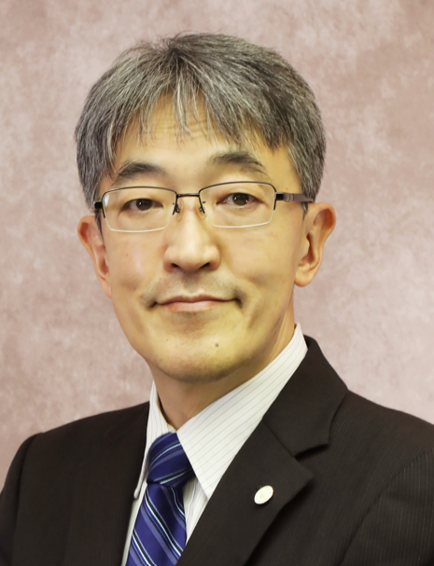 | Family Name (Last Name) | Nobuhiko
 | Given Name (First Name) | Oridate
 | Country | Japan
 | Position / Department | Otolaryngology-Head & Neck Surgery
 | Institute / Organization | Yokohama City University
Education Background | Nobuhiko Oridate, M.D., Ph.D. graduated Hokkaido University School of Medicine in 1988 and Hokkaido University Graduate School of Medicine in 1997.
Professional Career | Nobuhiko Oridate, M.D., Ph.D. stayed at the University of Texas M.D. Anderson Cancer Center twice in 1993-1996 and 2002-2003. Currently, he is Professor and Chair of the Department of Otolaryngology-Head and Neck Surgery, Yokohama City University, Japan. He has published 210 PubMed cited articles.
Research Field | His main areas of interest include multidisciplinary approaches to head and neck cancer, biological/clinical research in this fields, and laryngology.
Presentation Topic | The addition of perioperative immunocheckpoint inhibitors in locally advanced head and neck squamous-cell carcinoma: Asian Subgroup of KEYNOTE-689
Abstract | In the phase 3 KEYNOTE-689 trial (NCT03765918), neoadjuvant plus adjuvant pembrolizumab (pembro) added to standard of care (SOC) significantly improved event-free survival (EFS) vs SOC alone in participants (pts) with resectable locally advanced HNSCC, with hazard ratios of 0.66 (PD-L1 CPS ≥10), 0.70 (CPS ≥1), and 0.73 (ITT). We report results from pts enrolled in Asia. Pts with resectable SCC of the oral cavity, oropharynx, larynx, or hypopharynx were randomized 1:1 to 2 cycles neoadjuvant pembro plus 15 cycles adjuvant pembro (200 mg IV Q3W) with SOC (surgery and adjuvant RT ± 3 cycles concomitant cisplatin 100 mg/m2 Q3W), or SOC alone. Primary end point was EFS per RECIST v1.1 by BICR; major pathologic response (mPR) was a key secondary end point. In Asia, 87 pts were randomized (48 pembro, 39 SOC), median follow-up was 38.9 mo, and 43 pts completed neoadjuvant pembro and underwent in-study surgery. Median EFS was not reached with pembro vs 51.5 mo with SOC in the CPS ≥10 (HR 0.45, 95% CI 0.2–1.4), CPS ≥1 (HR 0.86, 95% CI 0.4–1.8), and all-pt (HR 0.95, 95% CI 0.5–1.9) populations; estimated mPR differences were 14.8%, 9.1%, and 8.3%, respectively. Grade ≥3 treatment-related AEs occurred in 51.1% (pembro) and 41.7% (SOC) of pts. EFS in the Asian subgroup was generally consistent with the primary analysis, with the most pronounced benefit in CPS ≥10 and CPS ≥1 populations; safety was in line with the global population. Neoadjuvant pembro did not interfere with surgery. Results should be interpreted with caution given the small sample size.

Panel discussion (PS03), Systemic therapy chemotherapy target immunotherapy
PS03_S5
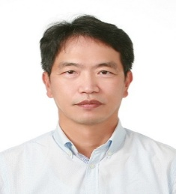 | Family Name (Last Name) | PARK
 | Given Name (First Name) | JUNG JE
 | Country | Republic of Korea
 | Position / Department | Professor/Otorhinolaryngolgoy-H&N surgery
 | Institute / Organization | Gyeongsang National University & Hospital
Education Background | M.D. Ph.D, Gyeongsang National University College of Medicine.,
Professional Career | Professor, Department of Otorhinolaryngology–Head and Neck Surgery, Gyeongsang National University, Republic of KoreaDirector, Institute for Biomedical Research, Gyeongsang National University HospitalClinical Fellow, Department of Otolaryngology–Head and Neck Surgery, Asan Medical Center, Seoul, Republic of Korea  Research Fellow, Comprehensive Cancer Center Head and Neck Oncology Laboratory, Department of Otolaryngology–Head and Neck Surgery, University of Michigan
Research Field | Head and Neck Oncology,Molecular Biology of Head and Neck CancerTranslational Research in Head and Neck Tumors
Presentation Topic | Recent Advances and Future Perspectives of Systemic Therapy in Recurrent or Metastatic Head and Neck Cancer
Abstract | The systemic treatment landscape for recurrent or metastatic head and neck squamous cell carcinoma (R/M HNSCC) has entered a rapidly evolving era. Pembrolizumab-based therapy has become a cornerstone of first-line treatment, while immune checkpoint inhibitors (ICIs), including pembrolizumab and nivolumab, have substantially improved outcomes across different clinical settings. Nevertheless, primary and acquired resistance to immunotherapy remain major clinical challenges.Recent advances have focused on improving therapeutic efficacy through rational combination strategies and novel targeted modalities. Bispecific and bifunctional antibodies targeting pathways such as EGFR/LGR5 or EGFR/TGF-β are demonstrating encouraging antitumor activity and may provide new strategies to enhance or restore sensitivity to immunotherapy. In parallel, antibody-drug conjugates (ADCs) targeting tumor-associated antigens are emerging as promising therapeutic options that selectively deliver potent cytotoxic payloads to tumor cells. Advances in personalized medicine, including genomic profiling and biomarker-based patient selection, are also contributing to increasingly individualized treatment strategies. Novel drug-delivery platforms, including nanoparticle-based approaches, may further improve tumor-selective drug delivery while reducing systemic toxicity.Looking ahead, the future of systemic therapy in HNSCC will involve further integration of immunotherapy into earlier disease stages, refinement of predictive biomarkers for patient selection, and development of biomarker-driven, multi-targeted combination regimens. This presentation will review current clinical evidence, highlight emerging therapeutic modalities, and discuss future strategies to overcome treatment resistance and improve survival in patients with recurrent or metastatic head and neck cancer.

Symposium (S01), Oral Cavity ca
S01_S1
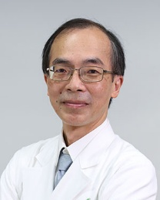 | Family Name (Last Name) | Tai
 | Given Name (First Name) | Shyh-Kuan
 | Country | Taiwan
 | Position / Department | Chief/ Department of Otolaryngology
 | Institute / Organization | Taipei Veterans General Hospital
Education Background | 1986.6 – 1993.6 MD, National Yang-Ming University, School of Medicine2004.9 – 2012.1 PhD, National Yang-Ming University, Institute of Clinical Medicine
Professional Career | Chief/Professor, Department of Otolaryngology, School of Medicine, National Yang Ming Chiao Tung University Chief/Staff physician, Department of Otolaryngology, Taipei Veterans General Hospital
Research Field | Head and Neck Surgical Oncology
Presentation Topic | Mandible management in surgery for oral squamous cell carcinoma
Abstract | Management of mandible is an important surgical component in the treatment for oral squamous cell carcinoma. The mandible is an important facial bony structure relating to cosmesis and functions, but it can also block the surgical access and surgical view, especially in approach posterior part of oral cavity. Mandibulotomy or mandibulectomy is applied for good surgical access and/or oncologic safe surgical margin. With modern energy devices and endoscopy, mandibulotomy can be avoided in selected cases to enhance rapid postoperative recovery. Mandibulectomy, however, is still required for tumors that invade or abutting the mandible bone. With advances in computer technologies, virtual surgical planning can be applied to reduce surgical disruption and operative labor, enhance precision of mandible resection/reconstruction, and minimize bony non-union. Representative cases with the use of virtual surgical planning and cutting guide in segmental mandibulectomy will be demonstrated.

Symposium (S01), Oral Cavity ca
S01_S2
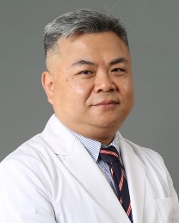 | Family Name (Last Name) | Cheng
 | Given Name (First Name) | Chisheng
 | Country | Taiwan
 | Position / Department | Director/ Division of Oral and Maxillofacial Surgery
 | Institute / Organization | Veterans General Hospital Taichung
Education Background | 1992: DDS. National Defense Medical College, Taipei2002: MMSci. The University of Sheffield, UK.2022: PhD. Tunghai University, Taichung, Taiwan
Professional Career | 1993- now: Division of Oral and Maxillofacial Surgery, Taichung Veterans General Hospital, Taichung, Taiwan
Research Field | Oral cancer
Presentation Topic | Evolution of Neck Dissection for Oral Squamous Cell Carcinoma (VGHTC—OMS)
Abstract | The management of the cervical lymphatics in oral squamous cell carcinoma (OSCC) has evolved substantially over the past four decades, progressing from radical en bloc neck dissection to function-preserving selective procedures. This review study aims to review the historical evolution of neck dissection for OSCC at our institution, the Division of Oral and Maxillofacial Surgery, Veterans General Hospital, and to evaluate its impact on patient outcomes across successive surgical eras. The findings are expected to illustrate how consecutive generations of surgeons refined neck dissection toward optimal management while preserving oncologic safety, providing both a historical perspective and a benchmark for future quality improvement and clinical research.

Symposium (S01), Oral Cavity Cancer
S01_S3
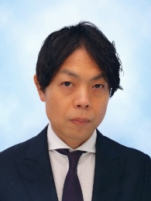 | Family Name (Last Name) | Hanai
 | Given Name (First Name) | Nobuhiro
 | Country | Japan
 | Position / Department | Vice Director; Chief of Department / Department of Head and Neck Surgery
 | Institute / Organization | Aichi Cancer Center Hospital
Education Background | M.D., Nagoya City University School of Medicine, Nagoya, Japan, 1996Ph.D. (Medical Science), Nagoya City University Graduate School of Medical Sciences, Nagoya, Japan, 2004
Professional Career | Vice Director; Chief, Department of Head and Neck Surgery  Aichi Cancer Center Hospital, Nagoya, Japan (2022–Present)Previous positions include:  Chief / Physician-in-Chief, Department of Head and Neck Surgery, Aichi Cancer Center HospitalAssistant Professor, Nagoya City University
Research Field | Head and Neck Cancer SurgeryMultidisciplinary Treatment for Head and Neck MalignanciesClinical Trials and Investigational Studies (e.g., ICOG, therapeutic trials)
Presentation Topic | Neck dissection/Oral cavity cancer surgery
Abstract | (Could be provided before June 15)

Symposium (S01), Oral Cavity Cancer
S01_S4
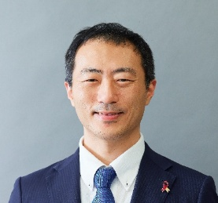 | Family Name (Last Name) | Takahiro
 | Given Name (First Name) | Tsujikawa
 | Country | Japan
 | Position / Department | Associate Professor, Otolaryngology-HNS
 | Institute / Organization | Kyoto Prefectural University of Medicine
Education Background | 2004 MD, Kyoto Prefectural University of Medicine2013 PhD, Graduate school, Kyoto Prefectural University of Medicine2014 Postdoctoral Researcher, Department of Cell, Developmental & Cancer Biology/Otolaryngology–Head & Neck Surgery, Oregon Health & Science University
Professional Career | 2017 Assistant Professor, Department of Otolaryngology-Head and Neck Surgery, Kyoto Prefectural University of Medicine2020 Associate Professor, Department of Otolaryngology-Head and Neck Surgery, Kyoto Prefectural University of Medicine
Research Field | Tumor microenvironment, Photoimmunotherapy
Presentation Topic | Neoadjuvant treatment related biomarker in locally advanced oral cancer
Abstract | Neoadjuvant therapy is increasingly incorporated into the management of locally advanced oral cancer, yet reliable biomarkers to guide patient selection and predict therapeutic benefit remain limited. To address this unmet need, we have applied a chromogenic multiplex immunohistochemistry (mIHC) platform capable of spatially resolving immune and stromal cell populations within the tumor microenvironment. This approach, originally established in our prior work and subsequently optimized for higher throughput and analytical flexibility, enables quantitative assessment of immune architecture at single‑cell resolution.Using this platform, we have investigated spatial immune features associated with response to neoadjuvant chemotherapy and immunotherapy in head and neck squamous cell carcinoma. Our findings indicate that the organization of lymphoid and myeloid lineages, as well as proximity‑based interaction metrics, correlate with treatment sensitivity more robustly than conventional density‑based parameters. These spatial biomarkers provide insight into tumor–immune dynamics that influence therapeutic responsiveness.

Symposium (S01), Oral Cavity Cancer
S01_S5
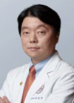 | Family Name (Last Name) | PARK
 | Given Name (First Name) | IL-SEOK
 | Country | South Korea
 | Position / Department | Professor/ Otolaryngology Head and Neck Surgery
 | Institute / Organization | Hallym University College of Medicine
Education Background | M.D., PhD.
Professional Career | Professor, Department of Otolaryngilogy – Head & Neck Surgery, Dongtan Sacred Heart Hopital, College of Medicine, Hallym UniversityChairman, Department of Otolaryngilogy – Head & Neck Surgery, College of Medicine, Hallym UniversityDirector, Cancer Center, Department of Otolaryngilogy – Head & Neck Surgery, Dongtan Sacred Heart Hopital, College of Medicine, Hallym University
Research Field | Head and Neck Oncology, HPV related H&N cancer, Minimal Invasive Head & Neck Surgery(Robotic)
Presentation Topic | Surgical management of recurrent oral cavity cancer
Abstract | Oral cavity cancer (OCC) is characterized by high recurrence rates ranging from 15% to 48%. Recurrent OCC (rOCC) has a very guarded prognosis, with a 5-year survival rate ranging from only 21% to 40%. Even among patients who undergo salvage surgery, the survival rate modestly increases to 43%–50%. These outcomes markedly differ from cases of OCC that do not recur after initial treatment, highlighting the significantly worse prognosis in recurrent cases. Unlike the common practice of complete resection in primary treatment, there is currently no established consensus on the most effective approach in the salvage setting. Various treatment options are considered for rOCC, including chemotherapy, immunotherapy, radiation therapy, and salvage surgery. In this complex therapeutic landscape, salvage surgery has emerged as an important treatment option despite its risks of morbidity and complications. Salvage surgery becomes particularly relevant when dealing with resectable recurrent cancer, providing a potentially curative treatment path that is not hampered by the resistance issues frequently encountered in chemotherapy or radiation therapy. Despite its critical role, however, there remains a gap in comprehensive research comparing the outcomes of salvage surgery to other treatment modalities in the context of rOCC. In this lecture, we are going to investigate the effectiveness of salvage surgery in improving overall survival (OS). And to explore the impact of salvage surgery on OS, thus contributing to a deeper understanding of its role in the management of rOCC.

Symposium (S01), Oral Cavity Cancer
S01_S6
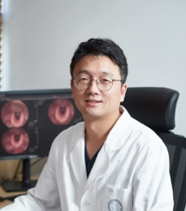 | Family Name (Last Name) | Young-Gyu
 | Given Name (First Name) | Eun
 | Country | Korea, Republic of
 | Position / Department | Professor/ Otolaryngology-Head and Neck Surgery
 | Institute / Organization | Kyung Hee University
Education Background | 1. Feb, 2010: Kyung Hee University Graduate School, SeoulMajor: Medicine (Otolaryngology-Head and Neck Surgery)Degree: Ph.D. 2. Feb., 2006: Kyung Hee University Graduate School, SeoulMajor: Medicine (Otolaryngology-Head and Neck Surgery)Degree: M.S.3. Feb., 1999: college of medicine, Kyung Hee University, SeoulMajor: MedicineDegree: M.D.
Professional Career | 1. March 2018 – presentJob title: ProfessorDepartment of Otolaryngology – Head and Neck Surgery, Kyung Hee University, School of Medicine, Seoul, Korea2. March 2014 – Feb 2018Job title: Associate ProfessorDepartment of Otolaryngology – Head and Neck Surgery, Kyung Hee University, School of Medicine, Seoul, Korea3. August 2015 – July 2016Job title: Visiting Associate professorDepartment of Systems biology, MD Anderson Cancer Center, TX, USA 4. March 2012 – February 2014Job title: Assistant ProfessorDepartment of Otolaryngology – Head and Neck Surgery, Kyung Hee University, School of Medicine, Seoul, Korea5. March 2010 – February 2012Job title: Assistant ProfessorDepartment of Otolaryngology-Head and Neck Surgery, Samsung Changwon Hospital, Sungkyunkwan University School of Medicine, Changwon, Korea6. March 2009 – February 2010Job title: Clinical Assistant ProfessorDepartment of Otolaryngology-Head and Neck Surgery, Samsung Changwon Hospital, Sungkyunkwan University School of Medicine, Changwon, Korea7. March 2007-Feb. 2009Job title: Fellowship and Instructor (Head and Neck Surgery)Department of Otolaryngology-Head and Neck Surgery, Kyung Hee University Hospital, Seoul8. May 2003-Feb. 2007Job title: ResidentDepartment of Otolaryngology-Head and Neck Surgery, Kyung Hee University Hospital, Seoul9. March 2000-April 2003Enlisted in the Republic of Korea Army as a medical officer.
Research Field | Radioresistance, Genomic analysis, Head and neck cancer
Presentation Topic | Difficult to Get an Optimal Surgical Margins in Oral Cancer Surgery
Abstract | Achieving an adequate surgical margin remains one of the most critical yet elusive goals in the surgical management of oral squamous cell carcinoma (OSCC). Although a "clear" margin is conventionally defined as ≥5 mm of tumor-free tissue, a substantial proportion of patients undergoing curative-intent resection still show close (<5 mm) or involved margins on final pathology, and margin status remains one of the strongest independent predictors of local recurrence and overall survival.Several factors make intraoperative margin control especially challenging. Anatomically, proximity to the mandible, tongue base, floor of mouth, and neurovascular structures forces surgeons to balance oncologic radicality against functional preservation. Biologically, field cancerization means that histologically normal-appearing mucosa may already harbor molecular alterations invisible to standard histology. Intraoperatively, frozen section analysis—the current gold standard—is limited by sampling error, interobserver variability, and specimen shrinkage after excision, which can cause a measured in vivo margin to appear significantly smaller ex vivo. Discordance between specimen-driven and tumor bed–driven sampling strategies further complicates cross-institutional comparison of outcomes.Emerging approaches—intraoperative ultrasound, optical coherence tomography, fluorescence-guided surgery, three-dimensional specimen mapping, and molecular margin assessment—show promise but have not yet achieved widespread adoption due to cost, workflow barriers, and limited validation.This lecture reviews the anatomic, pathologic, and technical obstacles to achieving optimal margins in oral cancer surgery, critically evaluates current intraoperative assessment tools, and discusses evolving technologies that may improve future margin control, supported by a practical, case-based decision-making framework.Keywords: oral squamous cell carcinoma, surgical margin, frozen section, specimen shrinkage, intraoperative assessment

Symposium (S02), Salivary gland ca
S02_S1
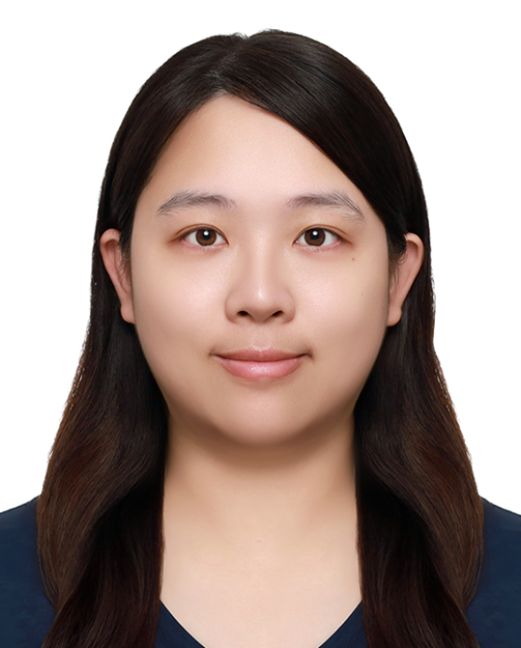 | Family Name (Last Name) | Mingyu
 | Given Name (First Name) | Hsieh
 | Country | Taiwan
 | Position / Department | Otolaryngology
 | Institute / Organization | Changhua Christian hospital
Education Background | National Defense Medical CenterChung Shan Medical University (CSMU) , Graduate Institute of Clinical Medicine
Professional Career | Research Field
Research Field | Head and neck, ultrasound, Pediatric otolaryngology
Presentation Topic | Repositioning Core Needle Biopsy: Key Timing Beyond FNA in Salivary Gland Tumor Diagnosis
Abstract | Fine-needle aspiration (FNA) has long been the first-line diagnostic tool for salivary gland tumors, valued for its simplicity and safety. However, its diagnostic performance is limited by high non-diagnostic rates and modest sensitivity, particularly for malignant and large tumors. Recent evidence has renewed interest in ultrasound-guided core needle biopsy (CNB) as an alternative or complementary approach. This presentation synthesizes data from studies published in the past three years to define when CNB should be prioritized over FNA in clinical practice.A 2025 meta-analysis of 15 studies (3,669 patients, 4,000 biopsies) found that CNB achieved markedly higher sensitivity (approximately 99%) than FNA (approximately 68%), with comparable specificity and fewer non-diagnostic or repeat procedures, while carrying only a slightly increased, rare risk of hematoma. A separate multicenter analysis of 1,331 patients demonstrated that FNA sensitivity dropped to 50% overall, with diagnostic accuracy declining further in tumors exceeding 4 cm, underscoring the limitations of cytology alone in larger or more heterogeneous lesions. A retrospective cohort of 485 parotid mass biopsies further showed that CNB provided superior tissue-specific diagnostic accuracy without increasing complication rates, operative delay, or nerve injury risk compared with FNA.Drawing on these findings, this talk proposes a practical, evidence-based framework for selecting CNB over FNA based on tumor size, imaging suspicion of malignancy, need for histologic subtyping to guide surgical planning, and limited on-site cytopathology support. By repositioning CNB from a rescue strategy for inconclusive FNA to a proactively selected first-line modality in defined clinical scenarios, this presentation aims to help otolaryngologists refine preoperative decision-making and optimize surgical planning for salivary gland tumors.

Symposium (S02), Salivary gland cancer
S02_S2
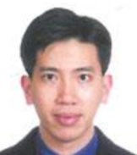 | Family Name (Last Name) | FANG
 | Given Name (First Name) | KU-HAO
 | Country | TAIWAN
 | Position / Department | ASSOCIATE PROFESSOR
 | Institute / Organization | CHANG GUNG MEMORIAL HOSPITAL
Education Background | Sep/1995~Jul/2002, Taipei Medical University, Taipei, Taiwan
Professional Career | Associate Professor, Chang Gung Memorial HospitalAssitant Professor, Chang Gung University
Research Field | Oral cavity cancers, Nasopharyngeal carcinoma, Head and neck cancers
Presentation Topic | Salivary gland cancers and special cases sharing
Abstract | (Could be provided before June 15)

Symposium (S02), Salivary Gland Cancer
S02_S3
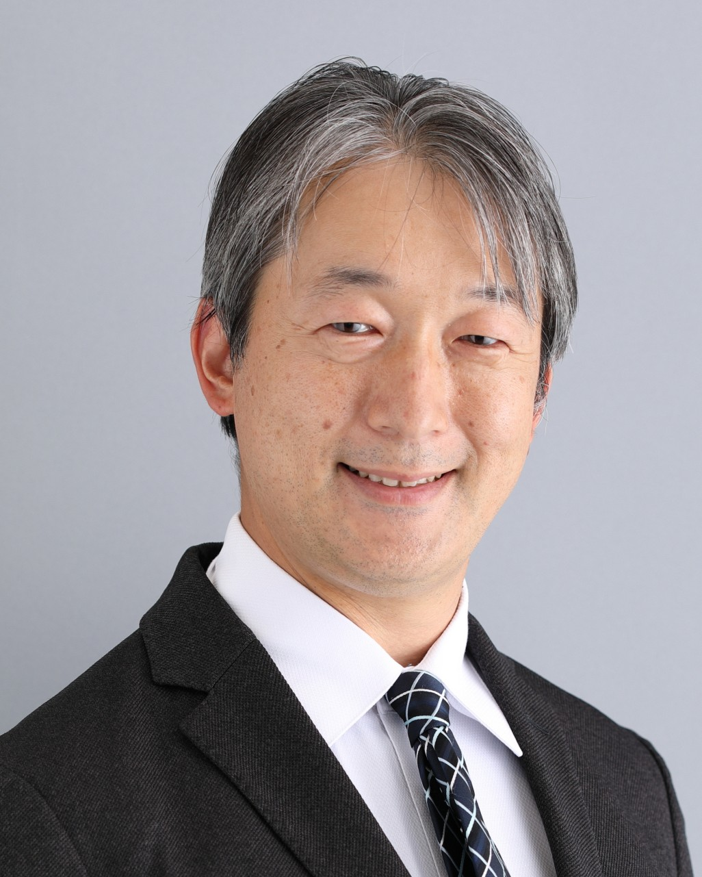 | Family Name (Last Name) | Takahashi
 | Given Name (First Name) | Hideaki
 | Country | Japan
 | Position / Department | Staﬀ, Department of Head and Neck, Esophageal Medical Oncology
 | Institute / Organization | National Cancer Center Hospital, Japan
Education Background | M.D. (2009) and Ph.D. (2013) from Yokohama City University School of Medicine.
Professional Career | Medical oncologist at National Cancer Center Hospital; former Assistant Professorat Yokohama City University and Postdoctoral Fellow at MD Anderson Cancer Center.
Research Field | Head and neck oncology, focusing on targeted therapy for salivary gland cancer and cancer neuroscience.
Presentation Topic | Advancement of Targeted Therapy for Salivary Gland Cancer
Abstract | Salivary gland carcinomas (SGCs) are rare and biologically heterogeneous malignancies for which robust evidence-based thera- peutic strategies have long been lacking. To overcome these challenges, the Japanese Consortium for Salivary Gland Carcinoma has established a nationwide collaborative research platform that integrates clinicopathological investigation, molecular profiling, translational research, and investigator-initiated clinical trials, supported by centralized pathology review and nationwide data integration.This presentation summarizes key findings generated by the Consortium across the continuum of SGC research, from diagnostic refinement to biomarker-driven therapeutic development. Large-scale epidemiologic and clinicopathological analyses have clarified subtype-specific prognostic factors and enabled refined histology-oriented risk stratification across major subtypes.Comprehensive molecular studies have delineated distinct genomic landscapes, including HER2 amplification and androgen receptor pathway activation in salivary duct carcinoma, MYB rearrangements and NOTCH1 mutations in adenoid cystic carcinoma, and CRTC1/3–MAML2 fusions in mucoepidermoid carcinoma, thereby establishing a molecularly informed disease classification.These molecular insights have been successfully translated into prospective clinical trials. Phase II studies demonstrated substan- tial efficacy of trastuzumab-based therapy in HER2-positive disease and combined androgen blockade in AR-positive salivary duct carcinoma, findings that have influenced international treatment guidelines and reshaped systemic treatment algorithms for biomarker-selected patients. Nationwide comprehensive genomic profiling of salivary duct carcinoma further revealed actionable alterations in approximately 30% of patients, highlighting both the opportunities and current limitations of precision oncology in this setting.In parallel, the Consortium has developed patient-derived xenograft and organoid models to functionally validate driver alterations, identify novel therapeutic targets, and facilitate next-generation drug development, including antibody–drug conju- gates, with the aim of translating newly identified targets into clinical investigations.Collectively, the Japanese experience illustrates how sustained national collaboration can bridge basic science and clinical application, advancing biomarker-driven treatment strategies specifically for salivary gland carcinoma and establishing a globally relevant framework for translational research in this rare disease entity.

Symposium (S02), Salivary Gland Cancer
S02_S4
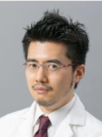 | Family Name (Last Name) | Kobayashi
 | Given Name (First Name) | Kenya
 | Country | Japan
 | Position / Department | Lecturer / Department of Otolaryngology–Head and Neck Surgery
 | Institute / Organization | The University of Tokyo
Education Background | Apr 2000 – Mar 2006 M.D., Saitama Medical University, Japan  Oct 2019 Ph.D., The University of Tokyo, Japan
Professional Career | 2021 – 2025 Assistant Professor, Department of Otolaryngology – Head and Neck Surgery, The University of Tokyo  2014 – 2021 Medical staff/Chief Surgeon, Department of Head and Neck Surgery, National Cancer Center Hospital, Japan
Research Field | Head and Neck Oncology, Translational Cancer Research
Presentation Topic | Genomic Insights and Molecular Evolution in Salivary Gland Carcinoma: From Diagnosis to Therapeutic Targets
Abstract | Salivary gland carcinomas comprise a heterogeneous group of rare malignancies with diverse histological subtypes, clinical behaviors, and molecular backgrounds. Because histopathological classification forms the foundation of precision oncology in salivary gland carcinomas, close collaboration among clinicians, pathologists, and researchers is essential for accurate diagnosis, genomic profiling, and translational research. Recent advances in genomic and spatial technologies have further accelerated our understanding of tumor biology and therapeutic opportunities.This presentation will first introduce our experience with ultrasound-guided core needle biopsy and an integrated diagnostic algorithm combining morphology, immunohistochemistry, and molecular biomarkers, providing a practical platform for precision diagnosis and treatment planning. It will then highlight Japan's national comprehensive genomic profiling database, demonstrating how large-scale real-world genomic analyses can identify prognostic biomarkers and potential therapeutic targets in high-grade salivary gland carcinoma. Finally, the presentation will illustrate how we apply cutting-edge genomic technologies to elucidate the molecular pathogenesis of salivary gland carcinoma. By integrating analyses of longitudinal patient specimens and patient-derived xenograft models using whole-exome sequencing and spatial transcriptomics, we demonstrate how epithelial–myoepithelial remodeling, dynamic remodeling of MYB and NOTCH signaling, and whole-genome doubling drive malignant progression and high-grade transformation in fusion-driven salivary gland carcinoma, particularly adenoid cystic carcinoma.Overall, these studies demonstrate how multidisciplinary collaboration integrating clinical questions, expert pathological evaluation, and advanced genomic technologies can accelerate precision diagnosis, deepen our understanding of tumor pathogenesis and progression, and facilitate the development of novel therapeutic strategies for patients with salivary gland carcinoma.

Symposium (S02), Salivary Gland Cancer
S02_S5
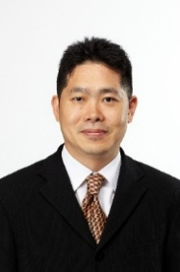 | Family Name (Last Name) | Chung
 | Given Name (First Name) | Eun-Jae
 | Country | Korea
 | Position / Department | Professor/ Department of otolaryngology-H&N surgery
 | Institute / Organization | Seoul National University, College of Medicine, Seoul National University Hospital
Education Background | 1994. 3 – 2000. 2 Korea University, College of Medicine, Seoul, Korea – M.D.2001. 9 – 2003. 2 Korea University, College of Medicine, Seoul, Korea –Master’s degree 2008. 3 – 2010. 8 Korea University, College of Medicine, Seoul, Korea – Ph.D.
Professional Career | 2011.3-2015.2 Assistant professor, Department of Otolaryngology-Head and Neck Surgery, HallymUniversity Medical Center, Seoul, Korea2015.3- 2021.8 Associate professor, Department of Otolaryngology-Head and Neck Surgery, Seoul National University College of Medicine, Seoul, Korea2018.3-2019.6 Clinical fellowship, Microvascular & Reconstructive Surgery, Western University, London, Ontario, Canada2021.9- Professor, Department of Otolaryngology-Head and Neck Surgery, Seoul National University College of Medicine, Seoul, Korea2023.9 – Director, Head & Neck cancer center, Seoul National University Hospital, Seoul, Korea
Research Field | Tissue engineering
Presentation Topic | Oncological and functional outcomes after single-stage dual/triple facial nerve reinnervation for advanced parotid cancer
Abstract | Facial nerve management is pivotal in parotid cancer surgery because tumors may necessitate sacrifice of one or more branches—or even the main trunk—to achieve oncologic clearance. While loss of a single distal branch usually causes limited morbidity, extensive resection produces major functional deficits, making decision-making challenging. This topic presents an experience-based framework for selecting oncologically safe, function-oriented strategies. When preoperative facial paralysis is present, malignancy and nerve invasion should be presumed, and involved segments resected en bloc. Reconstruction is primarily determined by paralysis duration: reinnervation is favored within 12–18 months, using interposition grafts for limited defects and single-stage dual/triple reinnervation for major sacrifice. The author prioritizes restoring key vectors by coapting the proximal facial nerve for periocular function (7–7) and the masseteric nerve to the zygomatic/buccal branch for smile restoration (5–7), with optional ansa cervicalis transfer to improve resting symmetry. In patients without preoperative paralysis, preservation is preferred, but nerve sacrifice is required when encased. Reinnervation is the best option, but being prepared to use various facial reanimation surgical techniques is also essential.

Symposium (S02), Salivary Gland Cancer
S02_S6
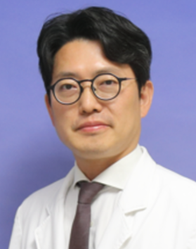 | Family Name (Last Name) | CHOI
 | Given Name (First Name) | IKJOON
 | Country | Republic of KOREA
 | Position / Department | Faculty/Department of Otorhinolaryngology-Head and Neck Surgery
 | Institute / Organization | KOREA CANCER CENTER HOSPITAL
Education Background | 2010.9 ~ 2016.8 Ph.D. Seoul National University, College of Medicine, Seoul, Korea2008.9 ~ 2010.8 M.S. Seoul National University, College of Medicine, Seoul, Korea 1995.3 ~ 2001.2 M.D Seoul National University, College of Medicine, Seoul, Korea
Professional Career | 2010.3 ~ Faculty, Department of Otorhinolaryngology & Head and Neck surgery, Korea Cancer Center Hospital, Seoul, Korea2025.2~ Chair, Thyroid committee, Korean Society of Head and Neck Surgery2014.3 ~2023.2 Adjunct professor, Convergence institute of Biomedical Engineering & Biomaterials, Seoul National University of Science & Technology2023.4~2024.4 University of California, San Diego, Moores Cancer center, postdoctor researcher2009.3~2010.2 Clinical & Research Fellow, Department of Otorhinolaryngology & Head and Neck surgery, Seoul National University Hospital, Seoul, Korea
Research Field | Thyroid cancer, Head and neck cancer
Presentation Topic | Prognostic factors in patients with high-risk locally advanced salivary gland cancers treated with surgery and postoperative radiotherapy
Abstract | BackgroundHigh-risk, locally advanced salivary gland cancers (SGCs) are rare but aggressive malignancies with heterogeneous histopathologic features and clinical outcomes. Despite multimodal treatment including surgery and postoperative radiotherapy (PORT), recurrence rates remain substantial. Identification of prognostic factors is essential for risk stratification and optimization of adjuvant treatment strategies.MethodsWe retrospectively reviewed 128 patients with high-risk, locally advanced SGCs who underwent curative-intent surgery followed by PORT between 2010 and 2022 at a tertiary referral center. High-risk features included T3–T4 disease, high-grade histology, positive or close (<1 mm) surgical margins, perineural invasion (PNI), lymphovascular invasion (LVI), and/or nodal metastasis. Overall survival (OS) and disease-free survival (DFS) were analyzed using the Kaplan–Meier method, and prognostic factors were evaluated using Cox proportional hazards regression models.ResultsThe median follow-up duration was 62 months (range, 12–148 months). The cohort included 52 patients (40.6%) with mucoepidermoid carcinoma, 39 (30.5%) with adenoid cystic carcinoma, and 37 (28.9%) with other histologies. Advanced T stage (T3–T4) was observed in 81 patients (63.3%), and nodal metastasis in 54 (42.2%). Positive or close surgical margins were present in 47 patients (36.7%), PNI in 72 (56.3%), and LVI in 49 (38.3%). The 5-year OS and DFS rates were 71.8% and 64.5%, respectively. On univariate analysis, advanced T stage (p=0.012), high-grade histology (p=0.004), positive/close margins (p=0.001), extranodal extension (ENE) (p<0.001), and PNI (p=0.018) were significantly associated with worse OS and DFS. Multivariate analysis demonstrated that positive/close surgical margins (HR 2.34, 95% CI 1.28–4.26, p=0.005), ENE (HR 2.91, 95% CI 1.56–5.41, p=0.001), and high-grade histology (HR 2.12, 95% CI 1.15–3.89, p=0.015) were independent predictors of poor OS. Similar results were observed for DFS. Patients with ≥2 high-risk factors had significantly worse 5-year OS compared to those with ≤1 factor (58.2% vs. 84.7%, p<0.001).ConclusionIn patients with high-risk, locally advanced SGCs treated with surgery and PORT, positive surgical margins, ENE, and high-grade histology are key independent prognostic factors. These findings highlight the need for intensified adjuvant treatment strategies and closer surveillance in high-risk subsets. Future prospective studies are warranted to refine risk-adapted therapeutic approaches.

Symposium (S03), Oropharyngeal cancer
S03_S1
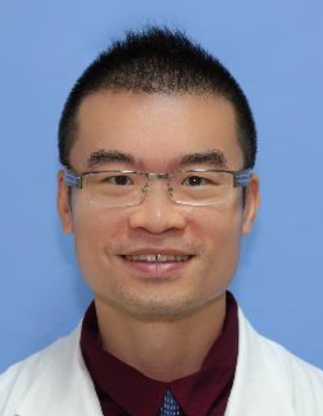 | Family Name (Last Name) | Lee
 | Given Name (First Name) | Tsung-Lun
 | Country | Taiwan
 | Position / Department | Attending physician/ Otorhinolaryngology
 | Institute / Organization | Taipei Veterans General Hospital
Education Background | M.D., National Yang Ming Chiao Tung University
Professional Career | Assistant professor
Research Field | Head and neck oncology
Presentation Topic | The Renaissance of the Surgery in Era of Neoadjuvant Therapies for Oropharyngeal Squamous Cell Carcinoma
Abstract | The treatment landscape of oropharyngeal squamous cell carcinoma (OPSCC) is undergoing another major transformation. After decades in which concurrent chemoradiotherapy dominated organ-preservation strategies, advances in neoadjuvant systemic therapy have reignited interest in surgery—not as an alternative to nonsurgical treatment, but as an integral component of personalized multidisciplinary care.Emerging evidence suggests that neoadjuvant therapy—including chemotherapy, immunotherapy, and combination approaches—may reduce tumor burden, improve resectability, facilitate minimally invasive transoral surgery, and enhance functional preservation in appropriately selected patients. Together with advances in transoral robotic surgery, molecular profiling, advanced imaging, and refined patient selection, these developments are reshaping surgical decision-making and expanding opportunities for individualized treatment.This lecture will review the evolving role of surgery in OPSCC, highlighting current evidence for neoadjuvant therapy and its impact on patient selection, surgical planning, and multidisciplinary management. Representative clinical cases will demonstrate how treatment response can influence the extent of resection, functional preservation, and overall therapeutic strategy.Rather than representing a return to historical surgical practice, the current renaissance reflects a fundamental shift in the role of surgery. Neoadjuvant therapy is redefining when, why, and for whom surgery should be performed, positioning surgery as a response-adapted, function-preserving partner in precision multidisciplinary cancer care.

Symposium (S03), Oropharyngeal cancer
S03_S2
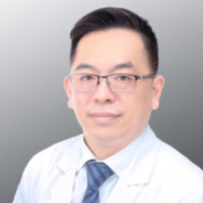 | Family Name (Last Name) | Ching-Chih
 | Given Name (First Name) | Lee
 | Country | Taiwan
 | Position / Department | Department of Otolaryngology-Head and Neck Surgery
 | Institute / Organization | Kaohsiung Veterans General Hospital
Education Background | MD, PhD
Professional Career | Professor, National Yang Ming Chiao Tung University Division Chief of Rhinology, Department of Otolaryngology-Head and Neck Surgery, Kaohsiung Veterans General Hospital
Research Field | Tumor microenvironement in head and neck cancer
Presentation Topic | Reframing the Ideal Treatment of Oropharyngeal Cancer: Moving Beyond NCCN Guidelines
Abstract | Induction therapy is considered a Category 3 treatment option for advanced oropharyngeal cancer (OPC), regardless of p16 status. According to the updated NCCN guidelines, combined-modality treatment—such as surgery with or without adjuvant chemoradiotherapy, or definitive chemoradiotherapy—is recommended for locally advanced disease. Neoadjuvant and adjuvant immunotherapy have been incorporated into treatment strategies for patients with p16-negative OPC. Treatment-related toxicities, particularly dysphagia and xerostomia, are commonly observed in patients receiving multimodality therapy. De-escalation strategies have therefore been developed for HPV-related (p16-positive) OPC to reduce long-term functional impairment while maintaining oncologic outcomes. In Taiwan, up to 70% of OPC cases are p16-negative, making direct application of HPV-positive de-escalation strategies potentially inappropriate for the majority of patients. Patients who demonstrate a favorable response to induction chemotherapy followed by transoral surgery (TOS) achieve excellent survival outcomes and optimal swallowing function, as evaluated by the MD Anderson Dysphagia Inventory (MDADI).. Furthermore, we aim to develop a treatment selection algorithm to identify appropriate candidates for NAC, thereby optimizing oncologic control while preserving functional outcomes.

Symposium (S03), Oropharyngeal Cancer
S03_S3
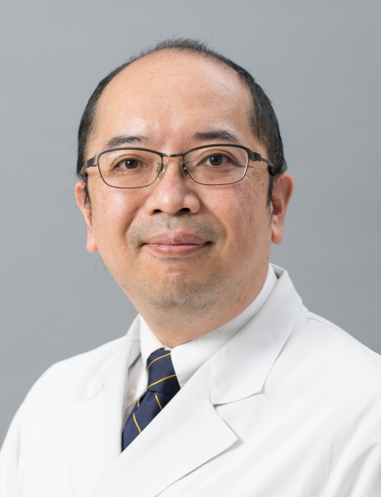 | Family Name (Last Name) | Saito
 | Given Name (First Name) | Yuki
 | Country | Japan
 | Position / Department | Associate Professor / Otolaryngology
 | Institute / Organization | The University of Tokyo
Education Background | Residency at Cancer Institute Hospital (2008-2011)Visiting Scholar at UC San Didego (2017-2018)
Professional Career | 2002 Graduated from the the Faculty of Medicine, the University of Tokyo2011 Assistant Professor at the University of Tokyo2020 Associate Professor at the University of Tokyo
Research Field | Surgical oncology, HNSCC and thyroid carcinoma
Presentation Topic | Biomarker of oropharyngeal carcinoma
Abstract | Oropharyngeal squamous cell carcinoma (OPSCC) is a biologically heterogeneous disease where both tumor-specific factors and host-related factors critically influence clinical outcomes. Among established biomarkers, p16 immunohistochemical staining serves as a surrogate marker for HPV-associated disease and is strongly associated with favorable prognosis.Tumor-infiltrating lymphocytes (TILs) reflect the local host immune response to cancer and have been reported to correlate with prognosis in OPSCC. Conversely, extranodal invasion (ENE) in metastatic lymph nodes indicates tumor aggressiveness and remains one of the strongest poor prognostic factors, independent of HPV status. Beyond tumor-related features, systemic host immune status also influences outcomes. The easily accessible neutrophil-lymphocyte ratio (NLR), an indicator of systemic inflammation and immune balance, has been associated with prognosis and treatment response in multiple malignancies, including head and neck cancer.This presentation discusses the clinical significance of p16 status, immune-related features including TILs and NLR, ENE-positive lymph node metastasis, proposing an integrated framework for biomarker-driven risk stratification in OPSCC. (Could be provided before June 15)

Symposium (S03), Oropharyngeal Cancer
S03_S4
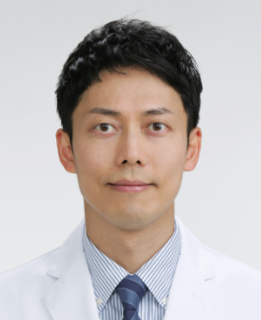 | Family Name (Last Name) | Shibata
 | Given Name (First Name) | Hirofumi
 | Country | Japan
 | Position / Department | Professor/ Otorhinolaryngology HN surgery
 | Institute / Organization | Mie University
Education Background | 2004-2009 Gifu University Department of Medicine, Japan2013-2018 Graduate Student, Gifu University Graduate School of Medicine
Professional Career | 2013-2017 Special Research Student, Center for iPS research and application (CiRA), Kyoto University, Japan2019.7- 2021.7 Research Fellow of Dana Farber Cancer Institute, Harvard University, Medical Oncology Department, USA
Research Field | Cancer epigenetics, cancer immunology
Presentation Topic | Advances in Transoral Surgery and Translational Research for Oropharyngeal Cancer
Abstract | Introduction：  Transoral surgery has become a standard minimally invasive treatment for early-stage oropharyngeal and pharyngeal cancers, providing excellent functional preservation while maintaining oncologic efficacy. Concurrently, advances in immunogenomic technologies have enabled detailed characterization of tumor-specific immune responses in human papillomavirus (HPV)-associated oropharyngeal squamous cell carcinoma (OPSCC). This presentation summarizes our clinical and translational research efforts to optimize personalized treatment for oropharyngeal cancer.Materials & Methods：  Clinical outcomes and pathological risk factors were retrospectively analyzed in 70 patients with early-stage pharyngeal and laryngeal cancers treated with transoral videolaryngoscopic surgery (TOVS). In parallel, comprehensive immunogenomic analyses were performed in HPV-positive OPSCC using bulk RNA sequencing (n=56), single-cell RNA/T-cell receptor sequencing of tumor-infiltrating CD8+ T cells, and longitudinal analysis of matched primary and metastatic tumors. Functional validation of HPV-reactive T-cell receptors (TCRs) was performed using TCR-engineered reporter assays.Results：  Transoral surgery achieved favorable oncologic outcomes, with 5-year overall survival, disease-specific survival, and local control rates of 77.1%, 89.7%, and 85.3%, respectively. Positive horizontal surgical margins were associated with poorer prognosis, highlighting the importance of pathological risk stratification. Immunogenomic analyses identified clonally expanded HPV-specific CD8+ T-cell populations within exhausted T-cell clusters. Nine HPV16 E6/E7-reactive TCRs were functionally validated. High-avidity HPV-specific T-cell clones persisted in metastatic lesions, whereas low-avidity clones were lost during disease progression. Persistent HPV-reactive T cells exhibited a KLRB1-positive tissue-resident memory-like phenotype, suggesting a role in durable antitumor immunity.Conclusion(OA)：  Integration of minimally invasive transoral surgery with translational immunogenomic research provides new insights into both local tumor control and systemic antitumor immunity in oropharyngeal cancer. Precise pathological assessment and characterization of persistent HPV-specific T-cell responses may contribute to improved risk stratification, biomarker development, and future immunotherapeutic strategies.

Symposium (S03), Oropharyngeal Cancer
S03_S5
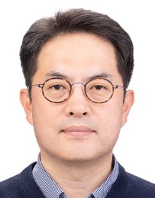 | Family Name (Last Name) | LEE
 | Given Name (First Name) | SEI YOUNG
 | Country | KOREA
 | Position / Department | PROFESSOR / DEPARTMENT OF OTOLARYNGOLOGY-HEAD AND NECK SURGERY
 | Institute / Organization | CHUNG-ANG UNIVERSITY HOSPITAL
Education Background | Ph.D. degree from Yonsei University Graduate School M.D degree from Yonsei University College of Medicine
Professional Career | Professor, Department of Otolaryngology-Head and Neck Surgery, Chung-Ang University College of Medicine
Research Field | Cancer Stem Cell, Treatment Resistance, HPV
Presentation Topic | The Present and Future of HPV Vaccination in Preventing Oropharyngeal Cancer
Abstract | While cervical cancer incidence has declined due to successful vaccination and screening, the burden of HPV-related oropharyngeal squamous cell carcinoma (OPSCC) is rising globally, particularly among men. This presentation reviews recent evidence (2024–2026) regarding HPV vaccine efficacy and its evolving clinical role. Recent studies have shifted the vaccination paradigm toward direct oncogenic prevention in males, with clinical data confirming significant reductions in oral HPV 16/18 infection rates. Additionally, the global move toward single-dose schedules, supported by long-term follow-up data, is improving vaccine accessibility and public health strategies. Future HPV management may involve integrating vaccines with immunotherapy; specifically, Phase II data suggest that therapeutic HPV vaccines combined with immune checkpoint inhibitors in the perioperative setting can enhance immune responses and clinical outcomes. Furthermore, non-invasive monitoring tools, such as oral rinse-based circulating tumor HPV DNA (ctHPVDNA), are gaining attention for early detection and surveillance. By analyzing these layered approaches, this presentation provides an objective assessment of how preventive and investigational therapeutic strategies can be integrated to manage the impact of HPV-driven oropharyngeal cancers.

Symposium (S03), Oropharyngeal Cancer
S03_S6
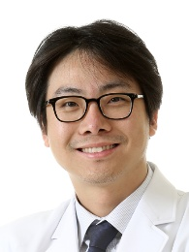 | Family Name (Last Name) | Cha
 | Given Name (First Name) | Wonjae
 | Country | Republic of Korea
 | Position / Department | Professor/Department of Otorhinolaryngology-Head and Neck Surgery
 | Institute / Organization | Seoul National University Bundang Hospital
Education Background | 1997-2003 M.D. degree from Seoul Nat’l Univ. College of Medicine, Korea2006-2012 Master’s degree from Seoul Nat’l Univ. College of Medicine, Korea2013-2015 PhD from Seoul Nat’l Univ. College of Medicine, Korea
Professional Career | 2003.3-2004.2 Internship at Seoul Nat’l University Hospital (SNUH)2004.3-2008.2 Residency of Department of Otorhinolaryngology-Head and Neck Surgery (ORL-HNS) at SNUH2011.5-2012.12 Fellowship of Department of ORL-HNS at SNUH 2012.12~2013.9 Assistant Professor, Department of ORL-HNS, SNUH2013.9~2020.2 Assistant Professor, Department of ORL-HNS, PNUH2020.3~ 2020.8 Associate Professor, Department of ORL-HNS, Seoul Nat’l Univ. Bundang Hospital (SNUBH)2024.9~ Clinical Professor, Seoul Nat’l Univ. College of Medicine2025.9~ Professor, Department of ORL-HNS, SNUBH
Research Field | Head and Neck Cancer, Thyroid Cancer, Laryngology
Presentation Topic | Symposium : Oropharyngeal Cancer, Topic : Not All HPV Is the Same: Discrepancies between HPV Subtypes and Treatment Outcomes in OPSCC
Abstract | Human papillomavirus (HPV)-positive oropharyngeal squamous cell carcinoma (OPSCC) has emerged as a distinct disease entity with rising incidence, male predominance, younger age at diagnosis, and more favorable prognosis than HPV-negative OPSCC. While HPV-16 is overwhelmingly the dominant genotype worldwide, growing evidence indicates that non-HPV-16 genotypes also represent a clinically meaningful subset of HPV-positive OPSCC.This lecture reviews the literature on genotype distribution, clinical presentation, prognostic relevance, and prevention implications in HPV-positive OPSCC. Western studies consistently report HPV-16 in the vast majority of cases, with HPV-33 and HPV-35 as the most frequently identified non-HPV-16 genotypes. In contrast, East Asian cohorts show broader genotype heterogeneity, with HPV-58 and HPV-18 more often reported in addition to HPV-33 and HPV-35. Although many studies have found no significant survival difference between HPV-16 and non-HPV-16 tumors, other reports and meta-analyses suggest that selected non-HPV-16 genotypes may be associated with poorer outcomes. These inconsistencies indicate that genotype-specific rather than grouped analysis may be more informative.The lecture also addresses the limitations of p16 immunohistochemistry as a surrogate marker, particularly in non-HPV-16 tumors, where HPV DNA-positive/p16-negative discordance may be more frequent. In addition, unlike cervical cancer, HPV-positive OPSCC lacks an effective population-based screening paradigm because of its crypt-based anatomy, absence of a recognized precursor lesion, and the transient nature of oral HPV infection.Overall, the literature suggests that genotype heterogeneity in HPV-positive OPSCC has important implications for diagnosis, prognostic stratification, and public health policy, particularly in support of broader and gender-neutral HPV vaccination strategies.

Symposium (S04), Skull base or parapharyngeal space surgery
S04_S1
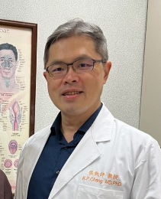 | Family Name (Last Name) | Kai-Ping
 | Given Name (First Name) | Chang
 | Country | Taiwan
 | Position / Department | Vice Chair & Professor
 | Institute / Organization | Dept. of Otolaryngology - Head & Neck Surgery. Linkou Medical Center, Chang Gung Medical Foundation
Education Background | MD & PhD degree, Chang Gung University
Professional Career | Vice Chair, Department of Otolaryngology–Head and Neck Surgery, Linkou Chang Gung Memorial HospitalProfessor, College of Medicine, Chang Gung UniversityAssociate Editor, Head & NeckExecutive Board Member, Taiwan Head and Neck Society (THNS)Board Member, Taiwan Society for Skull Base Surgery
Research Field | oral cancer, nasopharyngeal cancer, salivary gland neoplasm
Presentation Topic | Surgical Management of Sinonasal and Parapharyngeal Space Neoplasms – an MDT treatment in Linkou CGMH
Abstract | Sinonasal cancer is relatively rare in Taiwan. Over the past 20 years, I have surgically managed more than 150 sinonasal neoplasms. The major histopathological types included squamous cell carcinoma (26%), olfactory neuroblastoma (16%), adenoid cystic carcinoma (10%), sarcoma (9%), adenocarcinoma (NOS) (3%), atypical meningioma (3%), and melanoma (3%). Surgical approaches were tailored to individual cases and categorized as transcranial, transfacial, or endoscopic approaches. The neoplasms of parapharyngeal space are rare and usually insidious. I will also share our surgical approaches and outcomes of managing these tumors. This presentation will outline our treatment strategies, multidisciplinary collaboration with medical oncologists, radiation oncologists, neurosurgeons and reconstructive surgeons, and long-term oncologic outcomes, emphasizing the importance of individualized management to improve survival and quality of life.

Symposium (S04), Skull base or parapharyngeal space surgery
S04_S2
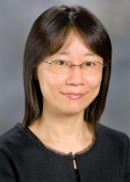 | Family Name (Last Name) | Chuang
 | Given Name (First Name) | Hui-Ching
 | Country | Taiwan
 | Position / Department | MD, PhD, FACS, Department of Otolaryngology, Head and Neck Surgery
 | Institute / Organization | Kaohsiung Chang Gung Memorial Hospital, Kaohsiung, Taiwan
Education Background | 1992-1999 Chung Shan Medical University, Taichung, Taiwan, MD2007- 2012 The Graduate Institute of Clinical Medical Science, Chang Gung University College of Medicine, Taiwan, PhD2012 ~ 2013 Department of Head and Neck, MD Anderson Cancer Center, Houston, Texas, USA, Visiting Scientist
Professional Career | 2020-2026 Chair, Department of Otolaryngology, Kaohsiung Chang Gung Memorial Hospital, Taiwan2024 – Present Director, Taiwan Head and Neck Society2022 – 2025 Deputy Secretary General, Taiwan Society of Otolaryngology Head and Neck Surgery2016 – Present Associate Professor, School of Medicine, College of Medicine, Chang Gung University, Taoyuan, Taiwan 2023 – Present Associate Professor, School of Medicine, College of Medicine, National SunYat-sen University, Kaohsiung, Taiwan
Research Field | Head and Neck cancer, Salivary gland disease, Molecular Translational Medicine Research
Presentation Topic | Into the Devil’s Triangle: Surgical Strategies for the Parapharyngeal Space
Abstract | (Could be provided before June 15)

Symposium (S04), Skull Base or Parapharyngeal Space Surgery
S04_S3
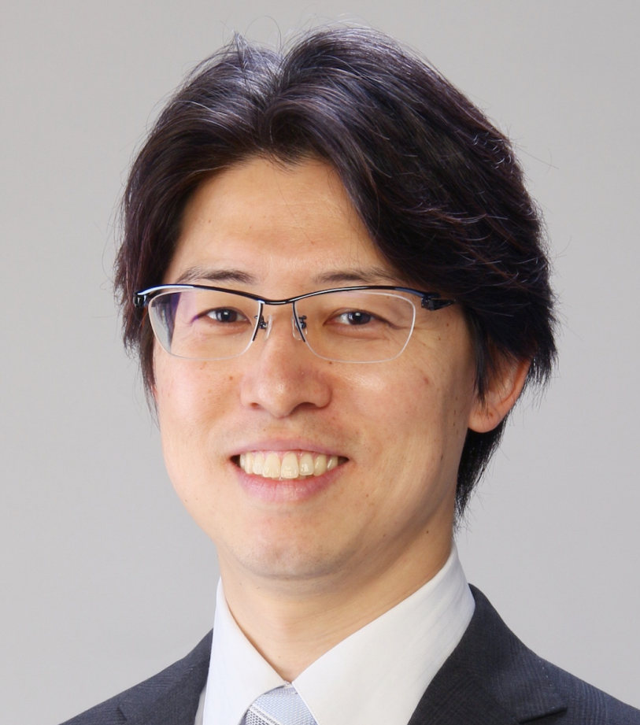 | Family Name (Last Name) | Nishio
 | Given Name (First Name) | Naoki
 | Country | Japan
 | Position / Department | Associate Professor / Otorhinolaryngology
 | Institute / Organization | Nagoya University
Education Background | 2013 Ph.D., Nagoya University Graduate School of Medicine, Japan2005 M.D., Nagoya University Graduate School of Medicine, Japan
Professional Career | 2025 – Present: Associate Professor, Nagoya University, Japan2021 – 2024: Lecturer, Nagoya University, Japan2020 – 2021: Assistant Professor, Nagoya University, Japan2018 – 2020: Visiting Scholar, Stanford University, CA, USA
Research Field | Fluorescence Imaging, Voice Conversion, Skull Base Surgery, Head and Neck Oncology
Presentation Topic | 3D virtual simulation for skull base surgery
Abstract | In skull base surgery for head and neck cancer, achieving en bloc resection with adequate surgical margins is essential.At our institution, we employ a multidisciplinary team approach involving head and neck surgeons, neurosurgeons, and plastic surgeons, utilizing a novel 3D virtual surgical simulation for skull base surgery. A key feature of this system is the detailed segmentation and color-coding of individual anatomical structures, including the tumor, arteries, veins, and nerves at the skull base. This enables surgeons to comprehensively analyze complex anatomy from any perspective on a computer. Furthermore, the platform allows surgeons to perform virtual bone resections on the computer, facilitating realistic virtual osteotomies during the planning phase.This simulation technology offers significant benefits beyond oncological outcomes. By fostering a shared surgical vision within the multidisciplinary team, it substantially reduces operative time and blood loss. Furthermore, it serves as an effective educational tool for younger surgeons, enhancing their understanding of complex anatomy and surgical strategies.

Symposium (S04), Skull Base or Parapharyngeal Space Surgery
S04_S4
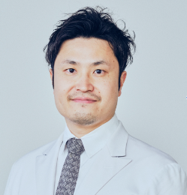 | Family Name (Last Name) | Takeda
 | Given Name (First Name) | Teppei
 | Country | Japan
 | Position / Department | Assistant Professor
 | Institute / Organization | The Jikei University School of Medicine
Education Background | Ph.D. in Medicine, The Jikei University School of Medicine, Tokyo, Japan (2023)M.D., The Jikei University School of Medicine, Tokyo, Japan (2013)
Professional Career | 2025–PresentAssistant Professor, Department of Otorhinolaryngology, The Jikei University School of Medicine, Tokyo, Japan2023–2025Visiting Scholar, Department of Otolaryngology–Head & Neck Surgery, University of North Carolina at Chapel Hill, USA2019–2023Assistant Professor, Department of Otorhinolaryngology, The Jikei University School of Medicine, Tokyo, Japan2015–2019Resident, Department of Otorhinolaryngology, Toho University Omori Medical Center, Tokyo, Japan2015Resident, Department of Otorhinolaryngology, The Jikei University School of Medicine, Tokyo, Japan
Research Field | Endoscopic skull base and nasal surgery; nasal and paranasal sinus tumors; olfactory neuroblastoma; surgical approaches preserving nasal structure and olfactory function; translational research integrating clinical outcomes with molecular analysis.
Presentation Topic | Endoscopic Surgical Strategy for En bloc Resection of Olfactory Neuroblastoma
Abstract | Objectives: Achieving oncological en bloc resection of olfactory neuroblastoma (ONB) while preventing tumor disruption and postoperative complications remains a critical challenge. We present our standardized endoscopic surgical strategy for genuine en bloc resection, precise margin control, and robust skull base reconstruction.Surgical Strategy & Methods:Anterior Margin: Endoscopic Modified Lothrop Procedure (EMLP, outside-in approach) secures the anterior corridor without disturbing the tumor. The first olfactory fila is identified on the non-tumor side via Draf 2B to evaluate the skull base depth, followed by Draf 3. On the tumor side, mucosal incisions are extended laterally to the agger nasi and medially down the septum to the nasal floor.Posterior Margin: A transseptal approach is utilized. Subperichondrial dissection preserves septal cartilage/bone for reconstruction. The sphenoid anterior wall is widely drilled to expose the planum sphenoidale. The non-tumor side septal branch of the sphenopalatine artery (SPA) is meticulously preserved, whereas the tumor-side mucosa is transected with the SPA.Inferior Margin: Defined by connecting anterior and posterior septal incisions horizontally and transecting the basal lamellae of the middle/superior turbinates.Dural Resection & En bloc Delivery: Crista galli resection facilitates anterior dural exposure. Anterior/posterior ethmoidal arteries are cauterized before skull base osteotomies. Circumferential dural incision and olfactory nerve transection achieve complete en bloc removal.Multilayer Reconstruction & Margin Assessment: A 4-layer reconstruction is performed: watertight 360-degree sutured intradural fascia lata, inlay fascia lata, rigid septal cartilage, and a vascularized contralateral septal flip flap. Comprehensive circumferential intraoperative and permanent margin evaluations are conducted.Conclusion: This systematic endoscopic approach ensures safe en bloc resection with negative surgical margins and effective defect closure, maintaining a 0% postoperative CSF leak rate.

Symposium (S04), Skull Base or Parapharyngeal Space Surgery
S04_S5
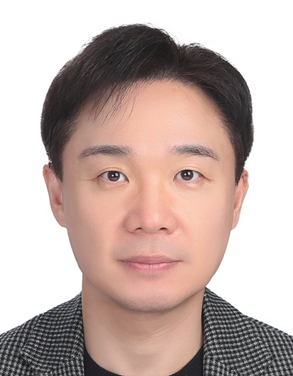 | Family Name (Last Name) | Jun-Ook
 | Given Name (First Name) | Park
 | Country | Republic of Korea
 | Position / Department | Professor / Department of Otolaryngology – Head and Neck Surgery
 | Institute / Organization | Seoul St. Mary's Hospital, The Catholic University of Korea
Education Background | 2001 MD, The Catholic University of Korea College of Medicine  2014 PhD (Medical Science), The Catholic University of Korea College of Medicine
Professional Career | 2025–Present Professor & Head of Head and Neck Cancer Center, Seoul St. Mary's Hospital, The Catholic University of Korea  2019–2025 Professor & Clinical Chief, Eunpyeong St. Mary's Hospital, The Catholic University of Korea  2014–2019 Associate Professor, Inje University Haeundae Paik Hospital  2009–2014 Clinical Assistant Professor, Seoul St. Mary's Hospital, The Catholic University of Korea  2001–2006 Intern & Resident, Seoul St. Mary's Hospital, The Catholic University of Korea
Research Field | Head and neck oncology; robotic and endoscopic head and neck surgery; skull base and parapharyngeal space surgery; soft tissue reconstruction; laryngeal cancer
Presentation Topic | Transoral Robotic Surgery for Parapharyngeal Tumor
Abstract | Transoral robotic surgery (TORS) has emerged as a minimally invasive approach for parapharyngeal space (PPS) tumors, offering direct visualization and precise dissection through the oral cavity. However, patient selection remains critical to ensure oncological safety and minimize complications.  We present our institutional experience with TORS for PPS tumors at Seoul St. Mary's Hospital (n=111). Preoperative evaluation included CT/MRI to assess tumor location (prestyloid vs. retrostyloid), vascularity, and proximity to major vessels. A stepwise decision algorithm was applied: (1) malignant or highly vascular tumors were excluded from TORS; (2) retrostyloid tumors were considered for TORS only in selected cases; (3) tumors with lateral extension or parotid involvement underwent combined TORS with a transcervical approach; and (4) benign, non-vascular, prestyloid tumors without lateral extension were treated with TORS alone (82%).  All tumors were successfully resected. Mean operative time was 147.3 minutes. Median hospitalization was 3 days, and 68% of patients tolerated oral diet from postoperative day 1. Complications included dysphagia (4.5%), hematoma (3.6%), Horner's syndrome (2.7%), and pharyngeal dehiscence (1.8%).  TORS is a safe and effective approach for carefully selected PPS tumors. A structured decision algorithm based on tumor nature, location, vascularity, and anatomical extent is essential to optimize outcomes and minimize the risk of major complications.

Symposium (S04), Skull Base or Parapharyngeal Space Surgery
S04_S6
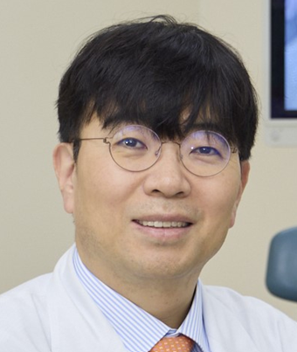 | Family Name (Last Name) | Yoon Se
 | Given Name (First Name) | Lee
 | Country | Republic of Korea
 | Position / Department | Professor / Otolaryngology-Head and Neck Surgery
 | Institute / Organization | Asan Medical Center / University of Ulsan College of Medicine
Education Background | Mar. 1994 to Feb. 2000 B.A. Medicine, University of Ulan, Seoul KoreaMar. 2004 to Feb. 2006 M.S. Otolaryngology, University of Ulsan, Seoul KoreaMar. 2006 to Aug. 2011 Ph.D. Otolaryngology, University of Ulsan, Seoul Korea
Professional Career | Apr. 2008 to Feb. 2009 Clinical fellow, Asan Medical Center, University of Ulsan, College of MedicineMar. 2009 to Feb. 2013 Clinical assistant professor, Pusan National University Yangsan HospitalMar. 2013 to Associate professor, professor, Asan Medical Center, University of Ulsan, College of Medicine
Research Field | Immunotherapy, robotic surgery, phonosurgery
Presentation Topic | Choosing the Optimal Surgical Corridor: An Algorithmic Approach to Skull Base and Parapharyngeal Tumors
Abstract | Tumors arising in the skull base and parapharyngeal space (PPS) present significant surgical challenges due to their deep location, complex anatomy, and proximity to critical neurovascular structures. A wide range of surgical approaches has been described; however, selecting the optimal approach remains highly dependent on surgeon experience and preference. This study aims to propose a structured, algorithmic strategy to guide surgical decision-making based on anatomical compartment, tumor characteristics, and extent of disease.The PPS is classically divided into prestyloid and poststyloid compartments, each associated with distinct tumor origins and surgical implications. Preoperative evaluation using high-resolution imaging allows assessment of tumor location, size, vascular involvement, and skull base extension. Surgical approaches—including transcervical, transparotid, transoral (including transoral robotic surgery), transmandibular, and lateral skull base approaches—offer different advantages and limitations in terms of exposure, morbidity, and oncologic safety.We propose a stepwise decision-making algorithm incorporating (1) compartment-based classification, (2) tumor size and medial–lateral extension, (3) suspected pathology and need for margin control, and (4) involvement of the skull base or major vascular structures. This framework facilitates selection of the most appropriate surgical corridor while minimizing morbidity and ensuring adequate oncologic resection.Case-based applications are presented to demonstrate the practical utility of this algorithm in various clinical scenarios. By shifting the paradigm from approach-based to corridor-based thinking, this strategy promotes reproducibility, improves surgical planning, and enhances functional outcomes. This algorithmic approach may serve as a practical guide for both trainees and experienced surgeons managing complex skull base and PPS tumors.

Symposium (S05), Basic & Translational Research
S05_S1
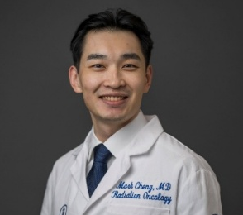 | Family Name (Last Name) | Cheng
 | Given Name (First Name) | Hao-Shen
 | Country | Taiwan
 | Position / Department | Attending Physician/ Radiation Oncology
 | Institute / Organization | Taichung Veterans General Hospital (TCVGH)
Education Background | MD, National Yang Ming University
Professional Career | Attending Physician, Department of Radiation Oncology, TCVGH (03/2023 - Present)Proton Fellowship, Department of Radiation Oncology, Memorial Sloan Kettering Cancer Center, New York, NY (07/2025-06/2026).Fellowship, Department of Radiation Oncology, TCVGH (08/2021-02/2023).Residency, Department of Radiation Oncology, TCVGH (08/2017-07/2021).
Research Field | Head and Neck Cancer, Radiotherapy
Presentation Topic | From Tumor Hypoxia to Circulating HPV DNA: Precision De-escalation in Oropharyngeal Cancer
Abstract | The favorable prognosis of HPV-associated oropharyngeal squamous cell carcinoma (OPSCC) has stimulated efforts to reduce treatment-related toxicity while maintaining excellent disease control. Precision de-escalation strategies based on biological characteristics are emerging as promising approaches to achieve this goal.Tumor hypoxia is a key determinant of radioresistance. Functional imaging with fluoromisonidazole positron emission tomography (FMISO-PET) allows assessment of intratumoral hypoxia during treatment. Studies have shown that patients demonstrating early hypoxia resolution may achieve excellent outcomes with reduced radiation intensity, supporting the concept of biologically adaptive radiotherapy.In the postoperative setting, circulating HPV tumor DNA (ctHPV-DNA) has emerged as a sensitive biomarker for minimal residual disease. Following transoral robotic surgery (TORS), HPV-DNA testing may help identify patients at low risk of recurrence who could safely receive less intensive adjuvant treatment.These advances reflect a shift from conventional anatomy-based treatment decisions toward biomarker-guided precision radiotherapy. By integrating functional imaging and molecular diagnostics, clinicians may better individualize treatment intensity and improve long-term quality of life for patients with HPV-associated OPSCC.

Symposium (S05), Basic & Translational Research
S05_S2
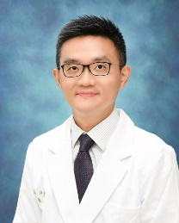 | Family Name (Last Name) | Kao
 | Given Name (First Name) | Hsiang-Fong
 | Country | Taiwan
 | Position / Department | Clinical Assistant Professor, Graduate Institute of Oncology  Attending Physician, Department of Oncology
 | Institute / Organization | National Taiwan University  National Taiwan University Hospital
Education Background | M.D., College of Medicine, National Taiwan University (1997-2004)  Ph.D., Graduate Institute of Immunology, National Taiwan University (2015-2022)
Professional Career | 2023-present Clinical Assistant Professor, Graduate Institute of Oncology, NTU  2025-present Attending Physician, Department of Oncology, NTUH  2021-2025 Attending Physician, Department of Medical Oncology, NTU Cancer Center  2006-2020 Internal Medicine and Medical Oncology training/appointments, NTUH and Yun-Lin Branch
Research Field | Head and neck cancer and nasopharyngeal carcinoma; tumor immunology, biomarkers, and cancer immunotherapy
Presentation Topic | Recent Novel Treatment Advances in HNSCC
Abstract | Treatment for head and neck squamous cell carcinoma (HNSCC) is rapidly evolving beyond conventional cytotoxic therapy, cetuximab, and immune-checkpoint blockade. This presentation will review three emerging areas. First, new-generation EGFR-directed agents, including bispecific and multifunctional antibodies, are producing encouraging response and durability signals and may complement PD-1 blockade, while raising questions about biomarkers and toxicity. Second, antibody-drug conjugates offer a strategy to deliver potent cytotoxic payloads selectively to tumor-associated targets; early clinical activity supports further study of target selection, resistance, sequencing, and safety. Third, induction and perioperative approaches are reshaping the management of locally advanced, resectable disease. Recent data with neoadjuvant pembrolizumab and combinations of PD-1 blockade with platinum-taxane chemotherapy show improvements in event-free and pathological response endpoints, although the optimal regimen, duration, surgical implications, and validity of pathological response as a surrogate remain unsettled. Together, these advances highlight a shift toward biologically informed combinations across recurrent/metastatic and curative-intent settings. Patient selection, durable benefit, toxicity, and integration with surgery and radiotherapy will determine how these strategies enter routine care.

Symposium (S05), Basic & Translational Research
S05_S3
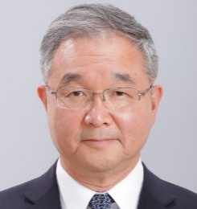 | Family Name (Last Name) | Ogawa
 | Given Name (First Name) | Tetsuya
 | Country | Japan
 | Position / Department | Professor/Head and Neck Surgery
 | Institute / Organization | Nippon Medical School
Education Background | Head and Neck Surgical Oncology, Molecular biology, Immuno-oncology
Professional Career | 1992: Gifu University, M.D. 1999: Ph.D., Research Fellow, University of Michigan and NIDCR, NIH2002-2007: Physician in Chief, Aichi Cancer Center Hospital.2010: Memorial Sloan-Kettering Cancer Center (Dr. Jatin P. Shah)2023~: Active Member, American Head and Neck Society (AHNS)2025~: Nippon Medical School
Research Field | Intraarterial immunotherapy, Immuno-oncology
Presentation Topic | Development of Intra-Arterial Immunotherapy for the Head and Neck Cancer
Abstract | Introduction Molecular targeted drugs and immune checkpoint inhibitors (ICIs) are designed to act specifically on tumor-target molecules. We advocate for the clinical superiority of intraarterial (IA) administration via tumor-feeding arteries.Basic Research: Local Administration of Nivolumab Using mice bearing head and neck cancer cell lines, we evaluated the anti-tumor immunological effects of: (1) saline control, (2) systemic administration of 100 µg Nivolumab, and (3) local administration of 10 µg Nivolumab. Both (2) and (3) showed significant tumor growth inhibition compared to (1). Notably, (3) demonstrated non-inferiority to (2). Furthermore, the infiltration of CD8+ T cells in (3) was same of (2), demonstrating the efficacy of low-dose local Nivolumab administration (JP Patent 2024-102980; Anticancer Res. 2022).Clinical Research: First-in-Human Trial of Intraarterial Nivolumab We conducted a clinical trial of IA immunotherapy (jRCTs041220157), preceding a prospective Advanced Medicine B study by the Ministry of Health, Labour and Welfare. The patient was 67-year-old female with p16-positive oropharyngeal cancer (T4N2M1) who had previously treated with Pembrolizumab. A catheter was inserted via the superficial temporal artery into the tumor-feeding artery, and IA Nivolumab (20 mg × 2 doses) was administered. The binding of Nivolumab to tumor-infiltrating lymphocytes even at the 20 mg IA dose was seen (Patent Pending 2024-102980). Following additional treatment, the patient achieved a complete response (CR).Development of Intraarterial Photoimmunotherapy (PIT) The current approved protocol for Cetuximab Sarotalocan Sodium (Akalux®) requires an IV infusion of 640 mg/m² over 24 hours, followed by laser irradiation under general anesthesia the next day. Refined protocol involves IA administration of Akalux® at 1/100 to 1/10 of the standard dose, followed immediately laser irradiation under local anesthesia, with subsequent outpatient IV Pembrolizumab seven days later. This innovative method reached an agreement with PMDA (Japanese government), and an investigator-initiated clinical trial is approved by AMED (Japanese government) for Phase I/II.

Symposium (S05), Basic & Translational Research
S05_S4
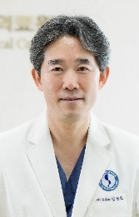 | Family Name (Last Name) | Kim
 | Given Name (First Name) | Chul-Ho
 | Country | Republic of Korea
 | Position / Department | Professor / Dept. of Otorhinolaryngology-Head and Neck Surgery
 | Institute / Organization | Ajou University, School of Medicine
Education Background | 1993: Graduated from College of Medicine, InHa University, Incheon, Korea2004: Acquisition of Ph.D in the Dept of Otorhinolaryngology, Yonsei University2002 : Memorial Sloan Kettering Cancer Center, MD Anderson Cancer Center 2008 – 2010 : Dept of Biomedical & Diagnostic Sciences, Univ. of Tennessee
Professional Career | 2018 – 2020 : Vice President, Korean Society of Pediatric Otorhinolaryngology2020 – 2022 : President, Korean Society of Pediatric Otorhinolaryngology2020 – 2024 : Vice President, Korean Society for Head and Neck Oncology2025 – Present : President, Korean Society for Head and Neck Oncology2020 – Present : Vice President Korea Doctor preneur2012 – Present : Vice Editor, Tissue Engineering and Regenerative Medicine2024 – Present : Chairman of the Council of Korea’s Research-Driven Hospitals
Research Field | Development of patient-specific therapeutic antibody and CAR-T in HNC Plasma medicine for inflammation and cancer
Presentation Topic | Understanding HNSCC-specific metabolic pathways using Single-cell & Spatial transcriptome profiling
Abstract | Alterations of metabolic pathways that sustain cancer cell survival often offer promising therapeutic avenues. Here, we show that enhanced de novo cholesterol biosynthesis is crucial for the survival of head and neck squamous cell carcinoma (HNSCC). Transcriptomic analysis of HNSCC tissues identified profound dysregulation in steroid and cholesterol metabolism compared to normal tissues. Inhibition of two key enzymes, DHCR7 and DHCR24, which mediate cholesterol biosynthesis, induced apoptosis in HNSCC cells, even when cholesterol levels were restored. Metabolomic profiling revealed the accumulation of 7-dehydrocholesterol (7-DHC) upon DHCR7 or DHCR24 inhibition, triggering endoplasmic reticulum (ER) stress and promoting further cell death. These findings suggest that HNSCC cells adapt to ER stress by modulating 7-DHC levels through enhancing DHCR7 and DHCR24 levels, highlighting a metabolic vulnerability in HNSCC and demonstrating a direct link between cholesterol metabolism and ER stress in cancer cell viability.

Symposium (S05), Basic & Translational Research
S05_S5
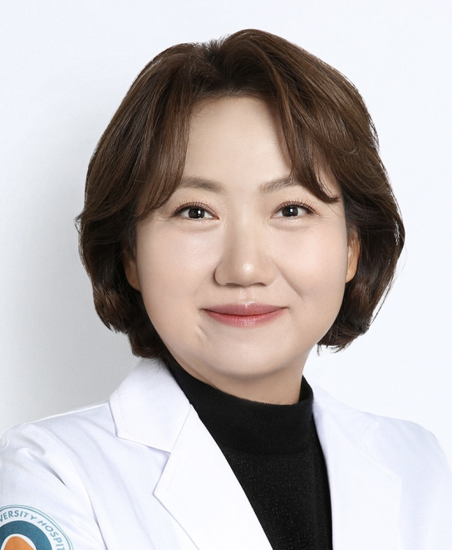 | Family Name (Last Name) | Myung Woul
 | Given Name (First Name) | Han
 | Country | South Korea
 | Position / Department | Professor, Otolaryngology Head and Neck Surgery
 | Institute / Organization | Ulsan University hospital, Ulan University College of medicine
Education Background | 2004 M.D. Ulsan University College of Medicine, Seoul, Korea2009 M.S. Ulsan University Graduate School, Seoul, Korea2011 Ph.D. Ulsan University Graduate School, Seoul, Korea
Professional Career | 2009-2012 Head and Neck Fellow, Department of Otolaryngology-Head and Neck Surgery, Asan Medical Center, Seoul, Korea2012-2013 Instructor, Department of Otorhinolaryngology-Head and Neck Surgery, College of Medicine, Ulsan University, Ulsan University Hospital, Ulsan, Korea2013-2018 Assistant Professor, Department of Otorhinolaryngology-Head and Neck Surgery, College of Medicine, Ulsan University, Ulsan University Hospital, Ulsan, Korea2019-2024 Associate Professor, Director of Thyroid and Head and Neck Cancer Center, Department of Otorhinolaryngology-Head and Neck Surgery, College of Medicine, Ulsan University, Ulsan University Hospital, Ulsan, Korea2025- Professor, Director of Thyroid and Head and Neck Cancer Center, Department of Otorhinolaryngology-Head and Neck Surgery, Vice president, College of Medicine, Ulsan University, Ulsan University Hospital, Ulsan, Korea
Research Field | 1. Radioresistance Mechanism in Head and Neck Cancer2. Tumor microenvironment in Head and Neck Cancer3. Mechanisms of ENE in Head and Neck Cancer
Presentation Topic | EphA3-Mediated TAM Repolarization: A Key to Enhancing CD47-mediated Phagocytosis in Recurrent Head and Neck Cancer
Abstract | Background: Head and neck squamous cell carcinoma (HNSCC) is characterized by a highly immunosuppressive tumor microenvironment (TME), with tumor-associated macrophages (TAMs) playing a central role in resistance to therapy. The immune checkpoint molecule CD47, known for its "don't eat me" signal, and EphA3, a receptor tyrosine kinase, are both upregulated in radiation-resistant HNSCC. However, their cooperative role in regulating TAMs and therapeutic resistance remains poorly understood.Methods: We established a radiation-resistant HNSCC model (MOC2R) using repeated irradiation and confirmed increased expression of CD47 and EphA3 in these cells. The effects of single and dual blockade of CD47 and EphA3 were evaluated through in vitro phagocytosis assays, Western blot, co-immunoprecipitation, and in vivo tumor models. Transcriptomic analysis and immunofluorescence staining were performed to elucidate molecular pathways involved in TAM modulation. We demonstrated in three independent experiments (n = 3) with statistical significance (P < 0.05). Results: CD47 and EphA3 were upregulated in radioresistant HNSCC and recurrent tumors. Dual blockade synergistically enhanced macrophage-mediated phagocytosis (P < 0.01) and significantly reduced clonogenic tumor cell survival compared to single blockade (P < 0.0001). EphA3 inhibition reprogrammed tumor-associated macrophages toward an M1-like phenotype, with increased expression of pro-inflammatory markers and decreased M2-associated markers. In vivo, combination therapy significantly reduced tumor volume and weight and increased M1 macrophage infiltration, while reducing M2 macrophages. Mechanistically, EphA3 regulated macrophage polarization via the β-catenin/FOSL2/ARID5A axis, enhancing the efficacy of CD47 blockade.Conclusion: Our findings demonstrate that EphA3, in cooperation with CD47, promotes an immunosuppressive TME by modulating β-catenin/FOSL2/ARID5A signaling in TAMs. Dual targeting of EphA3 and CD47 represents a promising strategy to reprogram macrophages and enhance anti-tumor immunity in radiation-resistant HNSCC.

Symposium (S05), Basic & Translational Research
S05_S6
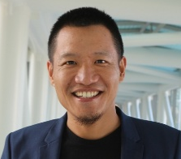 | Family Name (Last Name) | Lin
 | Given Name (First Name) | De-Chen
 | Country | USA
 | Position / Department | Associate Professor, School of Dentistry
 | Institute / Organization | University of Southern California
Education Background | Cancer genomics and gene regulation
Professional Career | Associate Director, USC Head and Neck Center
Research Field | Head and Neck Cancer, genomics, organoid modeling, single cell genomics
Presentation Topic | Precision immunotherapy for head and neck cancer
Abstract | Head and neck squamous cell carcinoma (HNSCC) remains a high-risk malignancy with limited ability to predict recurrence or response to therapy. Despite extensive genomic data, translation into clinically actionable biomarkers has been slow, largely due to the lack of human models that capture patient-specific tumor biology.We developed clinically relevant organoid platforms, including patient-derived organoids (PDOs) spanning normal tissue to tumor and genetically engineered models targeting key drivers (TP53, CDKN2A, PIK3CA). These systems recapitulate early disease progression and enable direct linkage between tumor genotype and functional behavior.Using these models, we identified a clinically relevant “Oral-Immune” epithelial program that is associated with CD8⁺ T-cell infiltration and improved immunotherapy response. This program outperforms established biomarkers such as PD-L1. Importantly, PIK3CA mutations suppress this immune program, leading to reduced T-cell infiltration and potential resistance to immunotherapy—an effect that can be reversed with PI3K inhibition.These findings define a targetable mechanism of immune evasion and support the use of organoid-based assays to guide patient stratification and therapeutic decision-making in HNSCC.

Symposium (S06), Laryngeal cancer
S06_S1
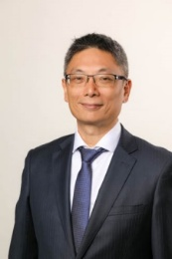 | Family Name (Last Name) | Fang
 | Given Name (First Name) | Tuan-Jen
 | Country | Taiwan
 | Position / Department | Professor and Chair/ Department of Otorhinolaryngology Head & Neck Surgery
 | Institute / Organization | Linkou Chang Gung Memorial Hospital
Education Background | 1.Taipei Medical University2.Voice and Swallowing Center, University of California San Francisco Medical Center, Fellow3.Department of Otolaryngology, Louvine University, Belgium, FellowPhonosurgery course, Keio University, Tokyo, Japan, Fellow
Professional Career | 1. Professor, Department of Otorhinolaryngology Head & Neck Surgery 2.Corresponding fellow, American Laryngological Association3.President, The 5th Taiwan Voice Society4.President, 12th East Asia conference on Phonosurgery5.Director, Division of Laryngology, Department of Otolaryngology, Chang Gung Memorial Hospital, Linkou and Taipei, Taiwan6.Chairman, Keelung Chang Gung Memorial Hospital, Taiwan
Research Field | 1. Phonosurgery2.Neurolaryngology3. Head and neck cancer (Laryngopharyngeal cancer) 4. Laser surgery6. Office based surgery
Presentation Topic | Functional Voice Outcomes After Microsurgery, Partial Laryngectomy, and Post-Laryngectomy Reconstruction
Abstract

Symposium (S06), Laryngeal cancer
S06_S2
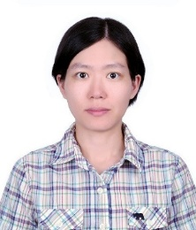 | Family Name (Last Name) | Wen-Chun
 | Given Name (First Name) | Lin
 | Country | Taiwan
 | Position / Department | Attending physician/ Otolaryngology Head and neck Surgery
 | Institute / Organization | Taichung Veterans General Hospital
Education Background | 1. Chung Shan Medical University, School of Medicine, Medical doctor (2002~2009)2. Tunghai University, Master of Healthcare Administration (2016~2018)3. PhD, Institute of Clinical Medicine, Chung Shan Medical University (2022~2025)
Professional Career | 1. Resident, Department of Otolaryngology Head & Neck surgery2. Chief Resident, Department of Otolaryngology Head & Neck surgery3. Attending Physician, Department of Otolaryngology Head & Neck surgery
Research Field | 1. Head and neck cancer diagnosis and treatment2. Neck ultrasound 3. Robotic surgery
Presentation Topic | Transoral Robotic Surgery for Laryngeal cancer
Abstract | Transoral robotic surgery (TORS) provides significant clinical advantages in the surgical management of both early and advanced laryngeal carcinoma by overcoming traditional line-of-sight constraints through three-dimensional panoramic visualization, angled optics, wristed instrumentation, and multi-handed robotic-assistant coordination. In early-stage glottic carcinoma, particularly lesions involving the anterior commissure where conventional transoral laser microsurgery (TLM) encounters exposure limitations, TORS facilitates meticulous endoscopic cordectomies. In our experience, we demonstrates negative surgical margins and a local control rate more than 70%, promoting de-escalation of adjuvant radiotherapy while preserving functional vocal and swallowing outcomes. In advanced, locally extensive, or recurrent laryngeal cancer failing prior radiotherapy, concurrent chemoradiotherapy, or TLM, transoral total laryngectomy (TORS-TL) serves as a feasible, minimally invasive salvage alternative to traditional open surgery. By avoiding extended open cervical skin incisions, TORS-TL achieves maximal pharyngeal mucosal sparing, minifies wound morbidity, reduces risks of pharyngocutaneous fistula and extensive fibrosis, and substantially shortens postoperative rehabilitation. In our single institutional salvage cases (ages 59–79 years; stages yrT1N0 to rpT4aN2), all patients demonstrated uneventful wound recovery and achieved good functional swallowing status, confirmed by flexible endoscopic evaluation of swallowing (FEES). Overall, TORS represents an oncological effective and functional advantageous treatment modality across early organ-preservation and advanced salvage indications. Comprehensive preoperative patient evaluation—specifically addressing adequate mouth opening (requiring 3.5 to 4.0 cm clearance) and cervical spine mobility—combined with a multidisciplinary approach is critical for optimizing surgical feasibility and treatment outcomes.

Symposium (S06), Laryngeal Cancer
S06_S3
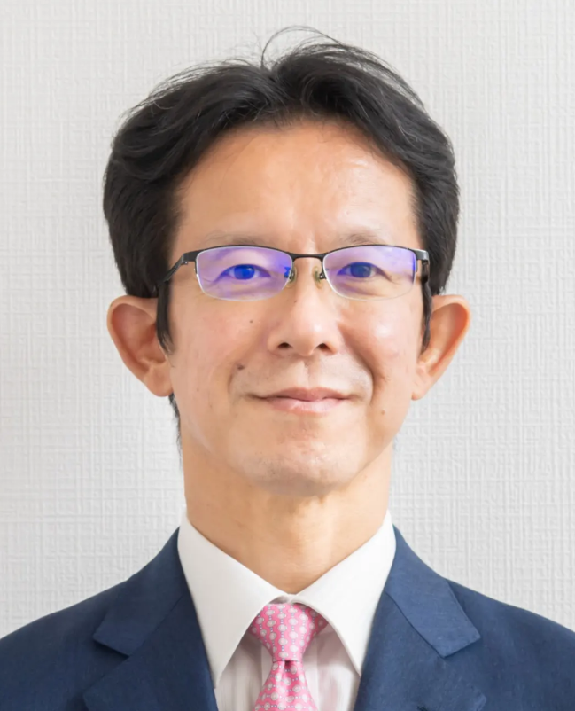 | Family Name (Last Name) | Tateya
 | Given Name (First Name) | Ichiro
 | Country | Japan
 | Position / Department | Professor/Otolaryngology-Head and Neck Surgery
 | Institute / Organization | Kyoto University
Education Background | 1994 M.D. Faculty of Medicine, Kyoto University2003 Ph.D. Graduate School of Medicine, Kyoto University
Professional Career | 2003-2006 Postdoctoral Fellow, Division of Head & Neck Surgery,  University of Wisconsin-Madison, USA2006-2008 Chief Physician, Department of Otolaryngology, Kyoto Katsura Hospital2008-2013 Assistant professor, Department of Otolaryngology-Head & Neck Surgery, Kyoto University2013-2019 Associate professor, Department of Otolaryngology-Head & Neck Surgery, Kyoto University2019-2026 Professor and Chairman, Department of Otolaryngology – Head and Neck Surgery, School of Medicine, Fujita Health University2021-2026 Director, Center of Head and Neck Endoscopic Surgery, Fujita Health University Hospital2026-present Professor and Chairman, Department of Otolaryngology – Head and Neck Surgery, Graduate School of Medicine, Kyoto University
Research Field | Phonosurgery, Head and Neck Surgery
Presentation Topic | Usefulness of the Exoscope in Phonomicrosurgery
Abstract | (Could be provided before June 15)

Symposium (S06), Laryngeal Cancer
S06_S4
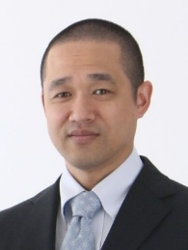 | Family Name (Last Name) | Miyamoto
 | Given Name (First Name) | Shunsuke
 | Country | Japan
 | Position / Department | Associate Prof. / Dept. of Otorhinolaryngology-Head & Neck Surgery
 | Institute / Organization | Kitasato University
Education Background | Hokkaido University, Japan M.D. 1993-2000University of Pennsylvania, USA Visiting Research Fellow 2009-2011Kitasato University, Japan Ph.D. 2014
Professional Career | Associate Professor Kitasato University, Japan 2025-present Lecturer Kitasato University, Japan 2014-2025Assistant Professor Kitasato University, Japan 2007-2014Resident Kitasato University, Japan 2000-2006
Research Field | Head and neck cancer, laryngeal cancer, function-preservation surgery
Presentation Topic | Salvage open partial horizontal laryngectomy after radiation failure
Abstract | Total laryngectomy has long been considered the standard salvage procedure for recurrent laryngeal cancer after radiotherapy. Although oncologically reliable, this procedure results in permanent tracheostoma and loss of natural voice, substantially affecting patients’ quality of life and social participation. As survivorship becomes increasingly important in head and neck oncology, function-preserving salvage strategies warrant greater attention.Open partial horizontal laryngectomy (OPHL) type II/III offers the possibility of achieving adequate oncologic resection while preserving key laryngeal functions. However, its role in the salvage setting remains debated because irradiated tissues may obscure tumor boundaries and raise concerns regarding postoperative complications and functional outcomes.Our institutional experience evaluating long-term outcomes of OPHL type II/III demonstrates that carefully selected patients undergoing salvage surgery after radiation failure can achieve durable oncologic control comparable to that of previously untreated patients. Importantly, functional outcomes were favorable, with most patients maintaining effective swallowing and intelligible speech, and the need for secondary total laryngectomy remaining uncommon. Beyond conventional oncologic endpoints, social reintegration emerged as a key outcome. The majority of patients were able to resume normal daily activities, and return-to-work rates exceeded 80%, highlighting the substantial benefit of preserving laryngeal function.Salvage OPHL type II/III represents a valuable alternative to total laryngectomy in selected patients with radiation-recurrent laryngeal cancer, enabling not only oncologic safety but also long-term functional preservation and meaningful social reintegration.

Symposium (S06), Laryngeal Cancer
S06_S5
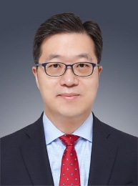 | Family Name (Last Name) | Kwon
 | Given Name (First Name) | Seong Keun
 | Country | Korea
 | Position / Department | Vice President & CSO of SNUHDirector of Biomedical Research InstituteProfessor / Otorhinolaryngology-Head & Neck Surgery
 | Institute / Organization | Seoul National University Hospital (SNUH)
Education Background | MD, MS, & PhD degrees from SNU College of MedicineInternship, Residency, Fellowship from SNUH
Professional Career | President-Elect of Korean Tissue Engineering & Regenerative Medicine Society
Research Field | Tissue engineering, Biomaterials, Airway stenosis, Laryngeal cancer
Presentation Topic | Strategic Management of Laryngeal Leukoplakia: From Surgical Decision-Making to Onco-Functional Balance
Abstract | The management of laryngeal leukoplakia is complicated by a critical trade-off: under-treatment hazards malignant progression or recurrence, whereas over-treatment inevitably compromises vocal quality. To navigate this dilemma, a meticulous preoperative and intraoperative approach is essential.In the diagnostic phase, we strongly emphasize the mandatory inclusion of a videostroboscopic examination; a reduction or absence of the mucosal wave on stroboscopy serves as a highly reliable indicator of invasive deep tissue infiltration, signaling a high probability of laryngeal cancer and justifying the decision for operative intervention. Intraoperatively, achieving complete exposure by the routine use of a 30-degree angled endoscope to thoroughly inspect anatomical "blind spots," specifically the laryngeal ventricle and the subglottic area.The core of the surgical discussion focuses on CO2 laser techniques designed to maximize oncological clearance while minimizing collateral damage to the vocal fold's vibratory structure to ensure optimal voice preservation. Furthermore, we address the complex decision-making process following reports of positive surgical margins, evaluating the trade-off between immediate re-intervention and close surveillance. We emphasize the clinical importance of the surgeon’s direct confirmation of histological slides to correlate intraoperative findings with microscopic data. This integrated, risk-adapted approach aims to optimize both oncological safety and the quality of life for patients with laryngeal premalignant lesions.

Symposium (S06), Laryngeal Cancer
S06_S6
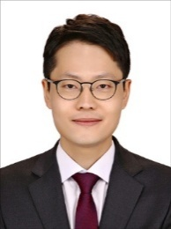 | Family Name (Last Name) | Park
 | Given Name (First Name) | Young Min
 | Country | Korea
 | Position / Department | Professor / Otorhinolaryngology-HNS
 | Institute / Organization | Yonsei University
Education Background | 2012.9 – 2015.8: Graduate School, Course in the degree of Doctor of Philosophy, Yonsei University College of Medicine
Professional Career | 2025.3 – Present: Professor, Department of Otorhinolaryngology, Yonsei University College of Medicine
Research Field | Head and Neck Cancer
Presentation Topic | “Beyond Clinical and Histologic Predictors: Spatial Resolved Insights into Treatment Response in Advanced Laryngopharyngeal Cancer”
Abstract | TBD

Symposium (S07), Thyroid cancer
S07_S1
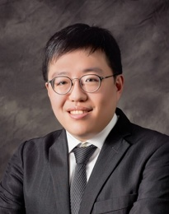 | Family Name (Last Name) | Huang
 | Given Name (First Name) | Tzu-Yen
 | Country | Taiwan
 | Position / Department | Assistant Professor, Department of Otolaryngology-Head and Neck
 | Institute / Organization | Kaohsiung Medical University
Education Background | - M.D., Graduate Institute of Medicine, National Taiwan University, Taipei, Taiwan- Ph.D., Department of Biological Science and Technology, National Yang Ming Chiao Tung University, Taiwan
Professional Career | - Assistant professor, Department of Otorhinolaryngology, School of Post-Baccalaureate Medicine and School of Medicine, College of Medicine, Kaohsiung Medical University, Kaohsiung, Taiwan- Chief, Department of Otolaryngology-Head and Neck Surgery, Kaohsiung Medical University Gangshan Hospital, Kaohsiung Medical University, Kaohsiung, Taiwan- Attending Physician, Otolaryngology – Head and Neck Surgery, Kaohsiung Medical University Hospital, Kaohsiung, Taiwan
Research Field | Thyroid and parathyroid surgery, Thyroid ablation, Laryngology, Intraoperative Neuromonitoring Assisted Surgery, Head and Neck Ultrasonography
Presentation Topic | Functional Safety in Thyroid Cancer Surgery: Voice and Parathyroid Preservation
Abstract | Thyroid cancer surgery has traditionally focused on complete oncologic resection; however, preservation of critical functions has become increasingly important in modern thyroid surgery. Injury to the recurrent laryngeal nerve or parathyroid glands can lead to postoperative voice impairment and hypocalcemia, significantly affecting patients’ quality of life. Intraoperative neuromonitoring (IONM) provides real-time functional assessment of the recurrent laryngeal nerve during thyroidectomy, allowing early detection of traction or thermal stress and enabling timely surgical adjustment. In addition, near-infrared autofluorescence (NIRAF) has emerged as a useful technique for intraoperative identification of parathyroid glands, facilitating their preservation and potentially reducing postoperative hypocalcemia. Beyond technological assistance, the concept of voice-centered thyroidectomy emphasizes meticulous surgical techniques aimed at protecting the neural and muscular structures involved in phonation. This presentation reviews current strategies for functional preservation in thyroid cancer surgery, focusing on the complementary roles of IONM, NIRAF-guided parathyroid preservation, and voice-centered surgical approaches.

Symposium (S07), Thyroid cancer
S07_S2
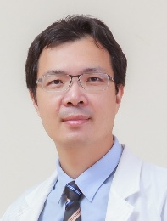 | Family Name (Last Name) | Wang
 | Given Name (First Name) | Chih-Chun
 | Country | Taiwan
 | Position / Department | Chair of Department of Otolaryngology-Head and Neck Surgery
 | Institute / Organization | E-Da Hospital
Education Background | M.S.in Clinical Medicine, Kaohsiung Medical University
Professional Career | Assistant professor
Research Field | Head and Neck, Robotic Surgery
Presentation Topic | Strategies to Preserve Parathyroid Function in Total Thyroidectomy
Abstract | Introduction：  Postsurgical hypoparathyroidism remains a prevalent complication of total thyroidectomy, occurring transiently in up to 30% of cases and permanently in 4%. Given its significant impact on patient quality of life, surgical strategies must shift from simple identification to a comprehensive "identify, preserve, and confirm viability" approach including meticulous capsular dissection, preservation of parathyroid blood supply, and confirmation of parathyroid viability.  Materials & Methods：  We describe a standardized approach used during BABA robotic thyroidectomy. Key components include meticulous capsular dissection with preservation of the thymus–blood vessel–parathyroid (TBP) layer, Near-Infrared Autofluorescence (NIRAF) for gland identification, Indocyanine Green (ICG) angiography for vascular assessment, and the stabbing test using a 23-gauge needle to confirm gland viability and guide selective autotransplantation.  Results：  Between March 2023 and July 2026, 60 patients underwent BABA total thyroidectomy using this triple-assessment strategy. The combination of anatomical preservation, NIRAF, ICG angiography, and the stabbing test enabled reliable intraoperative evaluation of parathyroid viability. Permanent hypoparathyroidism was effectively eliminated in this patient cohort.Conclusion(OA)：  Successful parathyroid preservation extends beyond gland identification. Integrating NIRAF, ICG angiography, and the stabbing test provides a practical and comprehensive method to assess viability, optimize autotransplantation decisions, and improve functional outcomes after total thyroidectomy.

Symposium (S07), Thyroid cancer
S07_S3
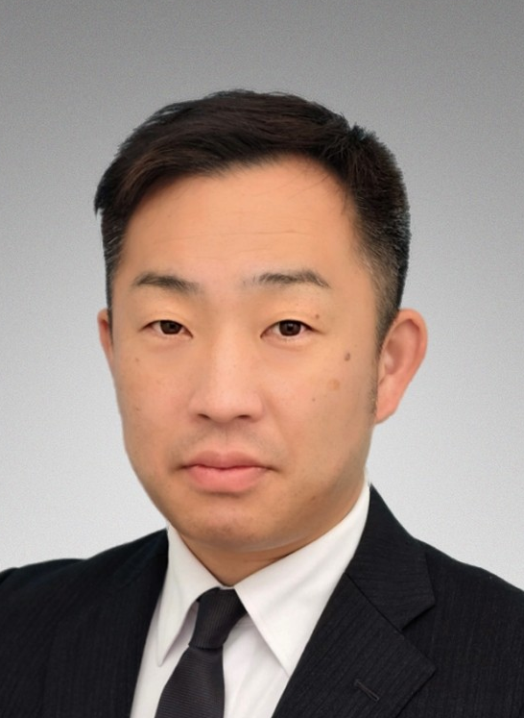 | Family Name (Last Name) | Teshima
 | Given Name (First Name) | Masanori
 | Country | Japan
 | Position / Department | Associate Professor, Otolaryngology-Head and Neck Surgery
 | Institute / Organization | Kobe University Hospital
Education Background | 2000 – 2006 Kochi University School of Medicine, Kochi, Japan2015－2019 Kobe University graduate school of medicine, Kobe, Japan
Professional Career | Research Field
Research Field | Presentation Topic
Presentation Topic | Active Surveillance for Thyroid Microcarcinoma and Thyroid Surgery.
Abstract | This presentation outlines evolving management strategies for thyroid cancer, from low-risk microcarcinomas to locally advanced and anaplastic carcinomas, guided by the 2024 revised clinical guidelines on the management of thyroid tumors by the Japan Association of Endocrine Surgery. Increased detection of micropapillary carcinomas has raised significant concerns about overtreatment, establishing active surveillance (AS) as a standard international option for tumors 10 mm or smaller. AS is especially recommended for older patients, given minimal long-term tumor growth (exceeding 3 mm in only 8% of cases over 10 years) and a low rate of neck lymph node metastasis (4%). However, immediate surgery remains necessary if metastasis is present or if the tumor critically borders the trachea or recurrent laryngeal nerve. For locally advanced cancers, surgical interventions aim to balance oncological curability with preservation of the patient's quality of life, particularly voice and swallowing functions. Surgeons should employ nerve-sparing techniques or immediate nerve reconstruction when nerve resection is unavoidable, alongside tailored resections and reconstructions for tracheal or esophageal invasion. Furthermore, treating highly aggressive undifferentiated (anaplastic) carcinomas requires a multidisciplinary approach. The recent introduction of BRAF/MEK inhibitors for BRAF V600E mutation-positive cases has facilitated dramatic tumor shrinkage. Combining these targeted therapies with timely salvage surgery and postoperative radiation therapy can significantly enhance local disease control. Ultimately, otolaryngologists and head and neck surgeons must provide highly individualized care through careful tumor risk stratification, applying minimally invasive AS for low-risk cases while reserving comprehensive, multidisciplinary treatments for high-risk and anaplastic thyroid cancers.

Symposium (S07), Thyroid cancer
S07_S4
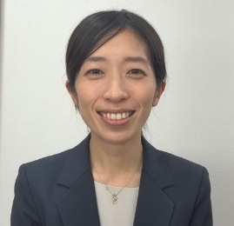 | Family Name (Last Name) | Saburi
 | Given Name (First Name) | Sumiyo
 | Country | Japan
 | Position / Department | Assistant Professor/Otolaryngology-HNSv
 | Institute / Organization | Kyoto Prefectural University of Medicine
Education Background | 2012 MD, University of Tsukuba, Faculty of Medicine2023 PhD, Graduate school, Kyoto Prefectural University of Medicine
Professional Career | 2024 Assistant Professor, Department of Otolaryngology–Head and Neck Surgery, Kyoto Prefectural University of Medicine
Research Field | Tumor microenvironment
Presentation Topic | Immune Microenvironment Heterogeneity in Thyroid Cancer.
Abstract | Most thyroid cancers have a favorable prognosis; however, a subset exhibits aggressive behavior, reflecting the biological heterogeneity of this disease.Accumulating evidence indicates that the tumor immune microenvironment is associated with disease progression, clinicopathological characteristics, and therapeutic response. Nevertheless, the immune mechanisms underlying thyroid cancer aggressiveness remain incompletely understood. To better understand the immune characteristics, our group has utilized multiplex immunofluorescence and image cytometry, enabling spatially resolved characterization of immune cell populations. Through these approaches, we have demonstrated heterogeneity of the tumor immune microenvironment and identified distinct immune profiles associated with tumor progression and invasive behavior. Our findings suggest that tumor-immune interactions play important roles in the biological behavior of thyroid cancer and that spatial immune profiling may provide insights into the mechanisms underlying tumor development and progression. In addition, systemic inflammatory and nutritional biomarkers, including the neutrophil-to-lymphocyte ratio (NLR), may complement tissue-based immune analyses and contribute to a more comprehensive understanding of tumor biology. This presentation will summarize our recent findings and discuss future perspectives on immune microenvironment heterogeneity in thyroid cancer.

Symposium (S07), Thyroid cancer
S07_S5
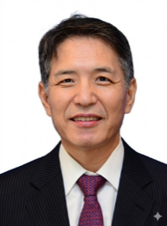 | Family Name (Last Name) | Kang-Dae
 | Given Name (First Name) | Lee
 | Country | South Korea
 | Position / Department | Director / Otolaryngeology-HNS
 | Institute / Organization | ISAM Hospital
Education Background | 1984 : graduated from Pusan National University College of Medicine1989 : Korean board of otolaryngology-head and neck surgery
Professional Career | Emeritus Professor, Kosin University College of Medicine (2025– 2030)Professor, Kosin University College of Medicine (1989 – 2025)Past President, Korean Thyroid Association (2019-20) Past President, Korean Intraoperative Neural Monitoring Society (2019-20)Past President, Korean Society of Thyroid-Head and Neck Surgery (2015-16) Inaugural Congress President, 1st Asia Pacific Society of Thyroid Surgery (2015)
Research Field | Thyroid, Parathyroid Surgery
Presentation Topic | Management of Functioning Recurrent Laryngeal Nerve Invaded by Papillary Thyroid Carcinoma
Abstract | Whether to sacrifice or spare a functioning recurrent laryngeal nerve involved by papillalry thyroid cancer remains a critical clinical dilemma. The long-term oncological outcomes after shaving PTC with gross remnant on the RLN have been rarely reported. In this presentation the long-term follow-up data demonstrating the oncological safety of maximal tumor shaving to a minimal gross remnant (R2 resection) to preserve vocal cord function based on our experience will be discussed. This nerve-sparing approach prioritizes the preservation of nerve integrity when R0/R1 resection is unattainable without nerve sacrifice. It can serve as a vital alternative for patients, especially professional voice users, to maintain their quality of life.

Symposium (S07), Thyroid cancer
S07_S6
 | Family Name (Last Name) | KOH
 | Given Name (First Name) | Yoon Woo
 | Country | South Korea
 | Position / Department | Chairman and Director/Department of ORL-HNS, Yonsei University
 | Institute / Organization | Severance Hospital/Korean Society of Head and Neck Surgery
Education Background | MD. PhD. From Yonsei University College of Medicine
Professional Career | President-Elect, Korean Society of Head and Neck Surgery
Research Field | Single cell genomics, Clinical trials of Neoadjuvant Chemotherapy followed by TORS with Robotic Neck Dissection
Presentation Topic | “Gas-less” Transoral Robotic Thyroidectomy (TORT) and Transoral Robotic Neck Dissection (TORND) Using the Da Vinci SP System
Abstract | The use of gas-less Transoral Robotic Thyroidectomy (TORT) and Transoral Robotic Neck Dissection (TORND) via the Da Vinci SP system at Severance Hospital showcases a valuable alternative to traditional approaches in thyroid and neck surgeries. With further study, these techniques could become standard practices in the surgical management of thyroid diseases and related neck conditions.Continued research is warranted to refine these techniques, expand the patient selection criteria, and enhance long-term follow-up data. Multi-centered studies could provide additional insights into the overall efficacy and scalability of the gas-less approach in diverse populations.This presentation offers a comprehensive overview of the first 300 cases and sets a groundwork for future surgical advancements in the field of robotic surgery.

Symposium (S08), Hypopharyngeal cancer
S08_S1
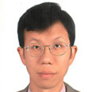 | Family Name (Last Name) | Wang
 | Given Name (First Name) | Chingping
 | Country | Taiwan
 | Position / Department | Attending Surgeon
 | Institute / Organization | Taichung Veterans General Hospital
Education Background | M.D. NATIONAL YANGMING UNIVERSITY
Professional Career | Chief of Laryngology, Head and Neck Surgery, Department of Otolaryngology, Head and Neck Surgery, Taichung Veterans General, Clinical Professor, National Defense UniversityLecturer, National Yang Ming Ciao Tong UniversitySupervisor, Taiwan Head and Neck SocietyDirector, Taiwan Voice Society
Research Field | Head and Neck Cancer Surgery. Oral Oncology.
Presentation Topic | High Resolution UGI Scope Assisted ELM CO2 for Hypopharyngeal Cancer and High Grade Dysplasia
Abstract | Transoral laser microsurgery (TLM) has become a well-established treatment for early-stage pharyngeal and laryngeal cancers since the introduction of carbon dioxide (CO₂) laser surgery by Strong and Jako in 1972. Advances in surgical techniques and instrumentation have expanded its indications, while high-definition narrow-band imaging (NBI) has markedly improved the detection of superficial neoplastic lesions through enhanced visualization of mucosal microvascular patterns.Patients with head and neck cancer have an annual risk of approximately 3% of developing a second primary malignancy. Consequently, routine upper gastrointestinal endoscopic surveillance has become increasingly common, resulting in a growing number of NBI-detected superficial pharyngeal lesions. Although TLM provides excellent surgical exposure, accurate localization of these subtle lesions under conventional white-light laryngoscopy remains challenging.We propose a multidisciplinary strategy combining the expertise of gastroenterologists and otolaryngologists. Suspicious lesions are first identified and localized using NBI endoscopy by gastroenterologists, followed by Lugol’s iodine staining to define lesion margins. Otolaryngologists then perform CO₂ laser resection using TLM, and subsequent treatment is guided by the pathological findings.Based on our clinical experience, this collaborative approach enables precise localization and complete excision of early pharyngeal cancers and precancerous lesions. Most patients achieve satisfactory local disease control with surgery alone, thereby avoiding or delaying radiotherapy and preserving laryngeal function and quality of life. This multidisciplinary treatment model offers a safe, minimally invasive, and effective strategy for the management of early pharyngeal neoplasia.

Symposium (S08), Hypopharyngeal cancer
S08_S2
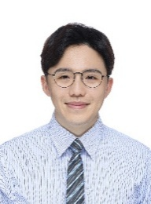 | Family Name (Last Name) | Lin
 | Given Name (First Name) | Chien-Fu
 | Country | Taiwan
 | Position / Department | Head and Neck Surgeon, Department of Otorhinolaryngology - Head & Neck Surgery
 | Institute / Organization | Mackay Memorial Hospital
Education Background | 2015 M.D., National Yang-Ming Chiao-Tong University
Professional Career | Attending Surgeon, Department of Otorhinolaryngology - Head & Neck Surgery, Mackay Memorial HospitalResidency in Otolaryngology – Head & Neck Surgery, Mackay Memorial Hospital
Research Field | Conventional and robotic surgical management of head & neck cancers
Presentation Topic | TORS for Supraglottic and Hypopharyngeal Cancer: Seeking the Balance Point Between Oncological Safety and Functional Preservation.
Abstract | Background: While Transoral Robotic Surgery (TORS) is well-established for oropharyngeal cancers, its application in deeper sites like the supraglottis (SGC) and hypopharynx (HPC) presents unique challenges due to difficult exposure and limited surgical space. This presentation shares our clinical experience at MacKay Memorial Hospital in optimizing outcomes for these complex cases.Methods & Surgical Tips: Effective management begins with rigorous patient selection and Exploration under Anesthesia (EUA) using Narrow Band Imaging (NBI) for precise tumor mapping. For advanced lesions (cT3-4, cN1-3), Neoadjuvant Chemotherapy (NACT) is integrated to shrink tumor volume, facilitating en bloc resection while increasing the feasibility of de-escalating adjuvant radiotherapy. Furthermore, we emphasize the importance of prophylactic ligation of external carotid artery branches to minimize postoperative hemorrhage.Innovation & Case Series: Our current surgical repertoire has expanded beyond standard robotic instrumentation. To reduce thermal injury and achieve precise dissection, we have successfully integrated laser into transoral robotic surgery.Results & Conclusion: Our experience demonstrates that a multidisciplinary approach combining NACT and TORS—complemented by versatile tools like laser—allows for excellent oncological margins and rapid functional recovery. By carefully balancing radical resection with the preservation of functional organs, TORS serves as a powerful tool for achieving optimal quality of life in patients with SGC and HPC.

Symposium (S08), Hypopharyngeal Cancer
S08_S3
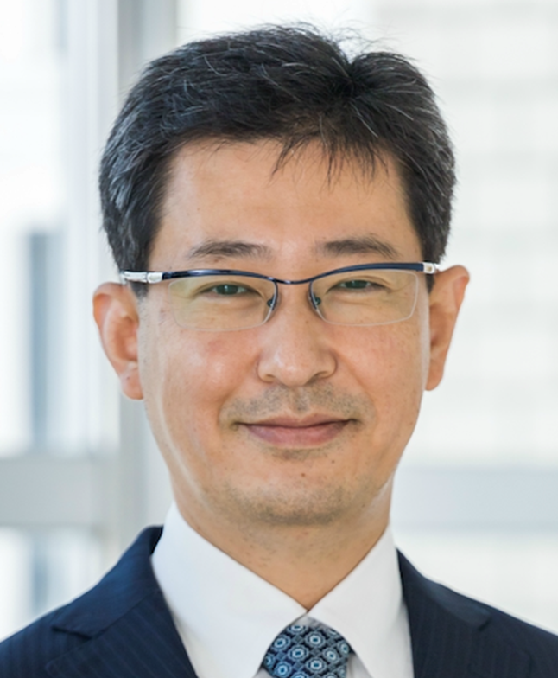 | Family Name (Last Name) | Fujiwara
 | Given Name (First Name) | Kazunori
 | Country | Japan
 | Position / Department | Professor
 | Institute / Organization | Tottori University
Education Background | M.D. 2001 Tottori UniversityPh.D. 2011 Tottori University
Professional Career | 2001 Tottori University Hospital2002 Otolaryngology- Head and Neck Surgery Matsue Red Cross Hospital2004 Otolaryngology- Head and Neck Surgery National Hospital Organization, Kyoto Medical Center2006 Department of Otolaryngology, Head and Neck Surgery, Tottori University2007 Assistant Professor: Division of Clinical Laboratory Medicine and Hematology Oncology, Tottori University2008 Assistant Professor: Department of Otolaryngology, Head and Neck Surgery, Tottori University2012 Observer: Memorial Sloan Kettering Cancer Center, NY, USA2012 Observer: The University of Pennsylvania, PENN, USA2012 Assistant Professor: Department of Otolaryngology, Head and Neck Surgery, Tottori University2015 Junior Associated Professor: Department of Otolaryngology Head and Neck Surgery, Tottori University2017 Associated Professor: Department of Otolaryngology, Head and Neck Surgery, Tottori University2021 Professor: Department of Otolaryngology, Head and Neck Surgery, Tottori University2023 Special assistant to hospital director: Tottori university hospital2023 Director of center for minimally invasive surgery: Tottori university hospital2025 Director of center for Tottori University Robotic Surgery Training and Medical Device Innovation Center
Research Field | Head and neck cancer, dysphagia
Presentation Topic | Percutaneous laryngeal elevation technique in transoral surgery for hypopharyngeal cancer
Abstract | Transoral resection techniques, including transoral robotic surgery (TORS) have emerged as highly effective curative treatments for early-stage hypopharyngeal cancer while successfully preserving the patient's swallowing function. However, achieving adequate visualization of the hypopharynx remains a significant clinical challenge in certain patient populations. Specifically, patients presenting with conditions such as trismus or difficulties in cervical retroflexion often present a limited surgical field, which can unfortunately lead to the abandonment of the transoral surgical approach. To overcome this critical limitation, we have developed a novel technique termed the "Percutaneous Laryngeal Elevation Technique (PLET)". PLET was designed to dramatically improve the surgical visualization and exposure of the hypopharynx for transoral surgeries, including TORS. This highly innovative yet remarkably simple method involves the percutaneous placement of a suture at the superior border of the thyroid cartilage, allowing the larynx to be manually pulled and elevated ventrally. The application of PLET not only dramatically improves the direct line of sight to the hypopharynx but also significantly expands the available working space. This enhancement directly translates to improved surgical operability, ensuring that surgeons can perform safe and complete oncological resections. Furthermore, the clinical utility of PLET extends beyond conventional transoral resections to include novel treatments such as photoimmunotherapy. In this context, PLET facilitates optimal exposure, enabling far more precise and effective laser irradiation of the targeted tissues. Ultimately, PLET represents a simple, safe, and highly effective surgical adjunct for improving hypopharyngeal visualization. By resolving the anatomical challenges that previously precluded surgical access, PLET holds great promise for expanding the indications for transoral surgery to cases that were formerly considered difficult or unfeasible.

Symposium (S08), Hypopharyngeal Cancer
S08_S4
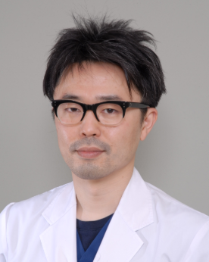 | Family Name (Last Name) | Omura
 | Given Name (First Name) | Go
 | Country | Japan
 | Position / Department | Department of Head and Neck Surgery
 | Institute / Organization | National Cancer Center Hospital
Education Background | 03/31/2005 Graduated from the University of Tokyo, School of Medicine
Professional Career | 04/01/2005-03/31/2008 Resident, Department of Otolaryngology and Head and Neck Surgery, the University of Tokyo Hospital.04/01/2008-07/31/2009 Staff, Department of Head and Neck Surgery, Gunma Prefectural Cancer Center.08/01/2009-03/31/2011 Assistant Professor, Department of Head and Neck Surgery, Saitama Medical University International Medical Center04/01/2011-12/31/2015 Assistant Professor, Department of Otolaryngology and Head and Neck Surgery, the University of Tokyo Hospital.01/01/2016-03/31/2017 Staff, Department of Otolaryngology and Head and Neck Surgery, NTT Medical Center Tokyo04/01/2017-03/31/2020 Staff, Department of Head and Neck Surgery, National Cancer Center Hospital04/01/2021- Assistant chief, Department of Head and Neck Surgery, National Cancer Center Hospital
Research Field | Transoral robotic surgery, hypopharyngeal cancer, mucosal melanoma
Presentation Topic | Survival outcome superiority of total pharyngolaryngectomy in comparison with chemoradiotherapy for T4aM0 hypopharyngeal squamous cell carcinoma: A nationwide database study of Japan
Abstract | Background. For patients with T4aM0 HPSCC, the guidelines of the National Comprehensive Cancer Network recommend TPL (as category 2A), induction chemotherapy followed by TPL or CRT (as category 3), and CRT (as category 3). 8 However, a previous report described that treatment of T4aM0 HPSCC with CRT results in a low laryngeal preservation rate compared with T1-3 disease. 9 A prospective randomized trial to compare these treatments is practically impossible because of the patient’s request for laryngeal preservation. The purpose of this study is to elucidate whether total pharyngolaryngectomy (TPL) or chemoradiotherapy (CRT) provides a better prognostic outcome in patients with T4aM0 hypopharyngeal carcinoma (HPSCC) using a nationwide database.Methods. All data were obtained from the Head and Neck Cancer Registry of Japan, and information from patients who were newly diagnosed with T4aM0 HPSCC between 2011 and 2015 was extracted. The primary endpoint was disease-specific survival (DSS), and the secondary endpoint was overall survival (OS). The inverse probability of treatment weighting (IPTW) adjustments was used for survival analyses.Results. Our cohort included 1,143 patients. The TPL and CRT groups included 724 and 419 patients, respectively. Following IPTW adjustments, both the OS and DSS of the TPL group were significantly longer than those of the CRT group (P = .02 and P = .002, respectively).Conclusions. Survival superiority was demonstrated for patients with T4aM0 HPSCC treated with TPL compared with those treated with CRT.

Symposium (S08), Hypopharyngeal cancer
S08_S5
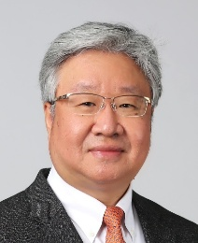 | Family Name (Last Name) | Kim
 | Given Name (First Name) | Se-Heon
 | Country | Korea
 | Position / Department | Professor/Dept. of Otorhinolaryngology
 | Institute / Organization | Yonsei University College of Medicine
Education Background | 1988. 3. : Received the Academic Degree of M.D. from Yonsei University College of Medicine1995. 2. : Received the Academic Degree of Master of Science from Yonsei University College of Medicine2000. 2. : Received the Academic Degree of PhD. from Yonsei University College of Medicine
Professional Career | Former President of The Korean Society of Head and Neck SurgeryFormer Chairman, Board of Directors ofThe Korean Society of Otorhinolaryngology-Head and Neck SurgeryChair of the Congress 2023 IAOOPresident Elect of IAOODirector of International Robotic Surgery Symposium (IRSS)
Research Field | Robotic Surgery for Head & Neck Cancer
Presentation Topic | ‘Transcending the Limitation of TORS for Hypopharyngeal Cancer’
Abstract | From October 2018 to Oct 2025, we retrospectively reviewed the medical records of 480 patients who underwent TORS using the da Vinci SP system. Among them hypopharyngeal cancer occupied 20%During TORS, three robotic arms could be used to perform a geometric resection of the lesion in a narrow working space. All robotic arms were inserted through a single port, which widened the working space around the patient's head and allowed for the operative assistant to easily approach the patient during operation. The joggle joint of the robotic arms aided in easy manipulation within the confined working space. Joggle joints of the endoscopic arm were controlled through the navigation system, which was very helpful in securing the superior visualization of the surgical site, especially in the area of larynx and hypopharynx.

Symposium (S08), Hypopharyngeal cancer
S08_S6
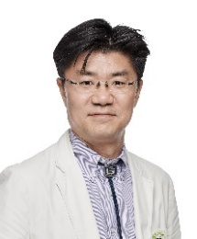 | Family Name (Last Name) | Joo
 | Given Name (First Name) | Young-Hoon
 | Country | Korea, Republic of
 | Position / Department | Professor at Department of Otolaryngology-Head and Neck Surgery
 | Institute / Organization | The Catholic University of Korea
Education Background | Mar 1992 ~ Feb 1998 The Catholic University of Korea, School of Medicine, Seoul, KoreaGraduated with a Degree of Medical Doctor Sep 2008 ~ Feb 2012 The Catholic University of Korea, Graduate School, Seoul, KoreaIn a Degree of Doctor of Philosophy in Medical Science /Otolaryngology
Professional Career | Mar 2017 ~ present Professor at Department of Otolaryngology-Head and Neck Surgery, Bucheon St. Mary’s Hospital, The Catholic University of Korea, School of Medicine
Research Field | Head and neck oncological surgery & reconstruction
Presentation Topic | Open vs. transoral surgery for hypopharyngeal cancer
Abstract | The optimal surgical approach for hypopharyngeal cancer remains controversial. While open surgery has traditionally been the standard treatment, transoral techniques have emerged as minimally invasive alternatives with potential functional advantages. Both surgical approaches achieved comparable oncologic outcomes in terms of local control and overall survival. However, transoral surgery was associated with shorter hospital stay, lower morbidity, and improved functional outcomes, particularly in swallowing function. Open surgery demonstrated advantages in selected cases with limited exposure or unfavorable anatomy. Transoral surgery is a safe and effective alternative to open surgery for early hypopharyngeal cancer, offering comparable oncologic outcomes with improved functional preservation. Careful patient selection remains essential to optimize treatment outcomes.

Symposium (S09), Nasopharyngeal Cancer
S09_S1
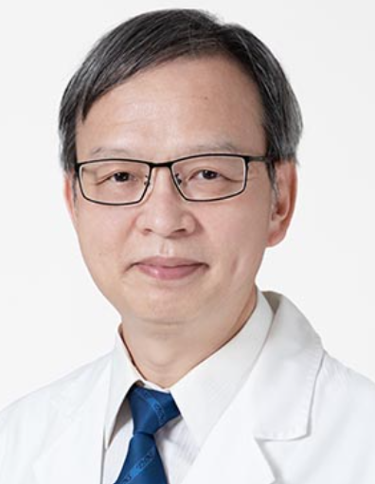 | Family Name (Last Name) | FU-MIN
 | Given Name (First Name) | FANG
 | Country | Taiwan
 | Position / Department | Professor/Radiation Oncology
 | Institute / Organization | Kaohsiung Chang Gung Memorial Hospital
Education Background | MD. Department of Medicine, Taipei Medical University, Taipei, TaiwanPhD. Graduate Institute of Medicine, Kaohsiung Medical University, Kaohsiung, Taiwan
Professional Career | Professor, Department of Radiation Oncology, Kaohsiung Chang Gung Memorial Hospital.Professor, Chang Gung University College of Medicine, Taoyuan, Taiwan.
Research Field | Head and Neck Radiotherapy, Quality of Life Research
Presentation Topic | From IMRT to Proton Therapy: Do Technological Advances in Radiotherapy Translate into Better Patient-Reported Outcomes in Nasopharyngeal Carcinoma?
Abstract | Radiotherapy remains the cornerstone of treatment for nasopharyngeal carcinoma (NPC). The transition from conventional techniques to intensity-modulated radiotherapy (IMRT) has improved tumor control and reduced xerostomia; however, long-term functional impairment persist among survivors. As survival outcomes plateau, the focus has shifted from cure alone to functional preservation and patient-reported outcomes (PROs). Proton therapy, now widely adopted globally, offers dosimetric advantages through the Bragg peak effect, enabling reduced radiation exposure to surrounding normal tissues. Intensity-modulated proton therapy (IMPT) further enhances precision and may better spare specific critical organs at risk. This presentation reviews current evidence comparing photon- and proton-based radiotherapy in NPC, with emphasis on patient-reported outcomes. We will examine whether technological advances in radiotherapy truly translate into meaningful functional benefit and improved survivorship for patients.

Symposium (S09), Nasopharyngeal Cancer
S09_S2
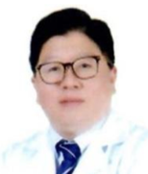 | Family Name (Last Name) | Chen
 | Given Name (First Name) | Jia-Hong
 | Country | Taiwan
 | Position / Department | Doctor/Division of Hematology-Oncology
 | Institute / Organization | Tri-service general hospital
Education Background | doctor
Professional Career | cancer
Research Field | Cancer treatment
Presentation Topic | New immunotherapy for metastatic and recurrent nasopharyngeal carcinoma
Abstract | The landscape for treating recurrent or metastatic nasopharyngeal carcinoma (R/M-NPC) has shifted from chemotherapy alone to immuno-chemotherapy combinations as the preferred first-line standard of care. Because nasopharyngeal carcinoma is highly associated with the Epstein-Barr Virus (EBV) and features a heavily immune-infiltrated tumor microenvironment, it is highly receptive to immunotherapy.The newest FDA-approved treatments, emerging dual immunotherapies, and advanced cell therapies for R/M-NPC include:1. Newly Approved PD-1 Inhibitors (First-Line Standard)Instead of using chemotherapy alone, clinical guidelines now recommend pairing standard chemotherapy (Gemcitabine + Cisplatin) with a Programmed Death-1 (PD-1) inhibitor.Toripalimab (Loqtorzi): This became the first immunotherapy specifically approved by the FDA for advanced, recurrent, or metastatic NPC. Long-term clinical data from the JUPITER-02 trial showed that adding toripalimab to chemotherapy extended median progression-free survival (mPFS) to 21.4 months (compared to just 8.2 months with chemotherapy alone) and dramatically reduced the risk of death.Tislelizumab & Camrelizumab: Other newer anti-PD-1 monoclonal antibodies heavily validated in Phase 3 global trials (such as RATIONALE-309 and CAPTAIN-1st) show similar powerful survival extensions when combined with front-line platinum chemotherapy.2. Dual Immunotherapy & Immune Checkpoint Combinations To counter immune resistance, clinical trials are actively exploring combinations of multiple distinct immune checkpoints:PD-1 + CTLA-4 Inhibition: A collaborative trial led by the National Cancer Centre Singapore evaluated combining Nivolumab and Ipilimumab. This dual-checkpoint strategy marks the first time this combination has proven effective globally for advanced NPC without relying entirely on traditional chemotherapy backbone toxicities.

Symposium (S09), Nasopharyngeal Cancer
S09_S3
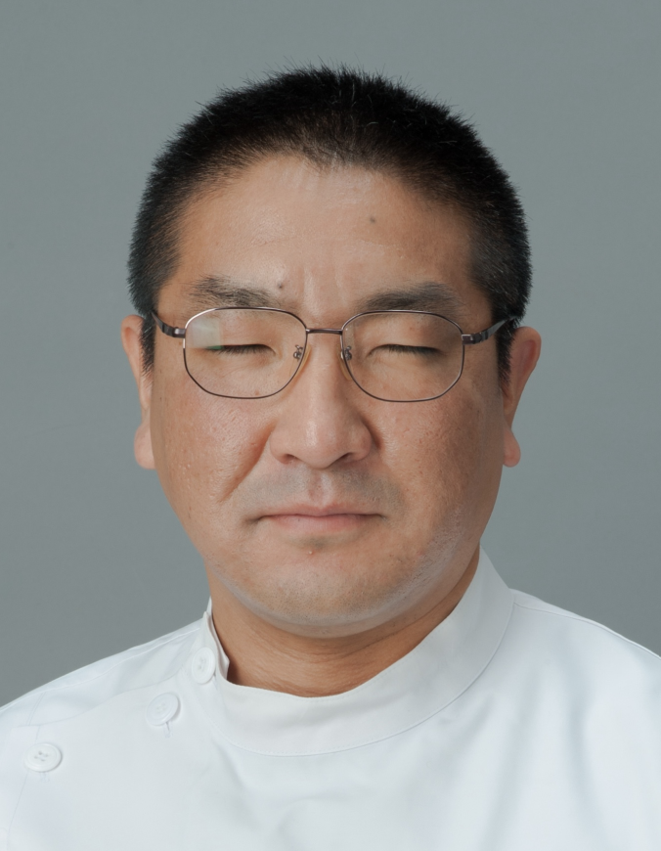 | Family Name (Last Name) | Takeshi
 | Given Name (First Name) | Shinozaki
 | Country | JAPAN
 | Position / Department | Department of Head and Neck Surgery
 | Institute / Organization | National Cancer Center Hospital East JAPAN
Education Background | 1999 M.D., Faculty of Medicine, Hirosaki University, Japan  2017 Ph.D., Jichi Medical University, Japan
Professional Career | 1999 Department of Otolaryngology–Head and Neck Surgery, Jichi Medical University, Japan  2007–Present Department of Head and Neck Surgery, National Cancer Center Hospital East, Japan  2016–Present Chief Physician, National Cancer Center Hospital East, Japan  2021–2025 Vice Chair, Aluminox (Photoimmunotherapy) Steering Committee, Japan Society for Head and Neck Surgery
Research Field | Head and Neck Surgery  Photoimmunotherapy for Head and Neck Cancer  Perioperative Management in Head and Neck Surgery
Presentation Topic | Photoimmunotherapy for Recurrent Nasopharyngeal Carcinoma: A New Local Treatment Strategy from a Nationwide Japanese Cohort
Abstract | Background  Recurrent or residual nasopharyngeal carcinoma (NPC) after definitive radiotherapy remains a major therapeutic challenge. Photoimmunotherapy (PIT) is a novel locoregional treatment that combines cetuximab sarotalocan sodium with near-infrared light illumination. We evaluated the real-world efficacy and safety of PIT for recurrent or residual NPC in a nationwide Japanese cohort.Methods  Patients with recurrent or residual NPC treated with PIT to the nasopharynx were retrospectively enrolled from participating institutions across Japan. Clinical outcomes, treatment-related adverse events, and survival were analyzed. Serial Epstein–Barr virus (EBV)-DNA measurements were also explored in a subset of patients.Results  Among 46 enrolled patients, 43 with sufficient follow-up were included in the current analysis. The median follow-up was 18.6 months. A complete local response lasting ≥2 months was achieved in 31 patients (72.1%), and the overall local response rate was 86.0%. At the last follow-up, 22 patients (51.2%) were alive with no evidence of disease. The estimated 2-year overall survival rate was 89.2%. Grade ≥3 treatment-related adverse events occurred in 7 of 43 patients. Two fatal carotid hemorrhages occurred, highlighting the importance of careful patient selection and management of infection and skull-base osteomyelitis. Preliminary serial analyses showed transient increases in EBV-DNA after PIT, potentially reflecting acute tumor disruption.Conclusions  PIT demonstrated high local response rates in recurrent or residual NPC and may provide a valuable locoregional treatment option, particularly when salvage surgery or re-irradiation is difficult. Further studies are needed to refine patient selection, mitigate vascular and infectious risks, and evaluate EBV-DNA as a biomarker of treatment response.

Symposium (S09), Nasopharyngeal Cancer
S09_S4
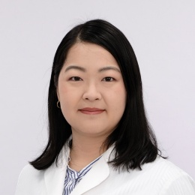 | Family Name (Last Name) | Mizokami
 | Given Name (First Name) | Harue
 | Country | Japan
 | Position / Department | Otolaryngology, head and neck surgery
 | Institute / Organization | Kanazawa University
Education Background | Graduate School of Medical Science, Kanazawa University
Professional Career | Otolaryngologist
Research Field | Epigenome
Presentation Topic | Heterochromatin activation induced by EBV–host genomic interactionsin nasopharyngeal carcinoma
Abstract | Nasopharyngeal carcinoma (NPC) is one of the Epstein–Barr virus (EBV)-associated cancers. The virus genome forms an episome and exists as extrachromosomal DNA in the host nucleus. We previously reported that EBV genome rewires the host heterochromatin to activate repressed enhancers in EBV(+) gastric cancer (“enhancer infestation” Okabe et al, Nat Genet 2020). To elucidate epigenetic aberrations induced by genomic interactions between EBV episomal DNA and NPC host genome, we performed comprehensive epigenomic analysis using next generation sequencing techniques. First, we detected 50 genomic regions where EBV and host genome directly interact in EBV(+) NPC cell lines C666-1 by 4C-seq and termed them EBV interacting regions (EBVIRs). They contained a significantly rich of A and T bases, significantly lower number of genes, and significantly lower levels of active histone marks compared with the background regions. Hi-C analysis showed that 89% of EBVIRs were inactive heterochromatin in normal nasopharyngeal epithelial cell lines NP69T. EBV–host genomic interactions were also detected in clinical biopsy samples and the in vitro EBV infection model, and these EBVIRs overlapped with the EBVIRs of C666-1. Most of them were also heterochromatin. In C666-1, some parts of EBVIRs acquire active enhancers and changed to euchromatin. Around the EBVIRs, there were 14 H3K4me3(+) genes whose expression was upregulated in C666-1. PLA2G4A was one of the upregulated genes in NPC, and its promoter was approaching activated enhancers within EBVIRs in C666-1. The cell proliferation of C666-1 was significantly reduced by its knockdown. These results indicate that EBV episomal DNA interacts with host heterochromatin and activates them. “Enhancer infestation” occurs in NPC by EBV infection. Furthermore, this chromatin rewiring around EBVIRs contributes to carcinogenesis of NPC by upregulating the expression of PLA2G4A.

Symposium (S09), Nasopharyngeal Cancer
S09_S5
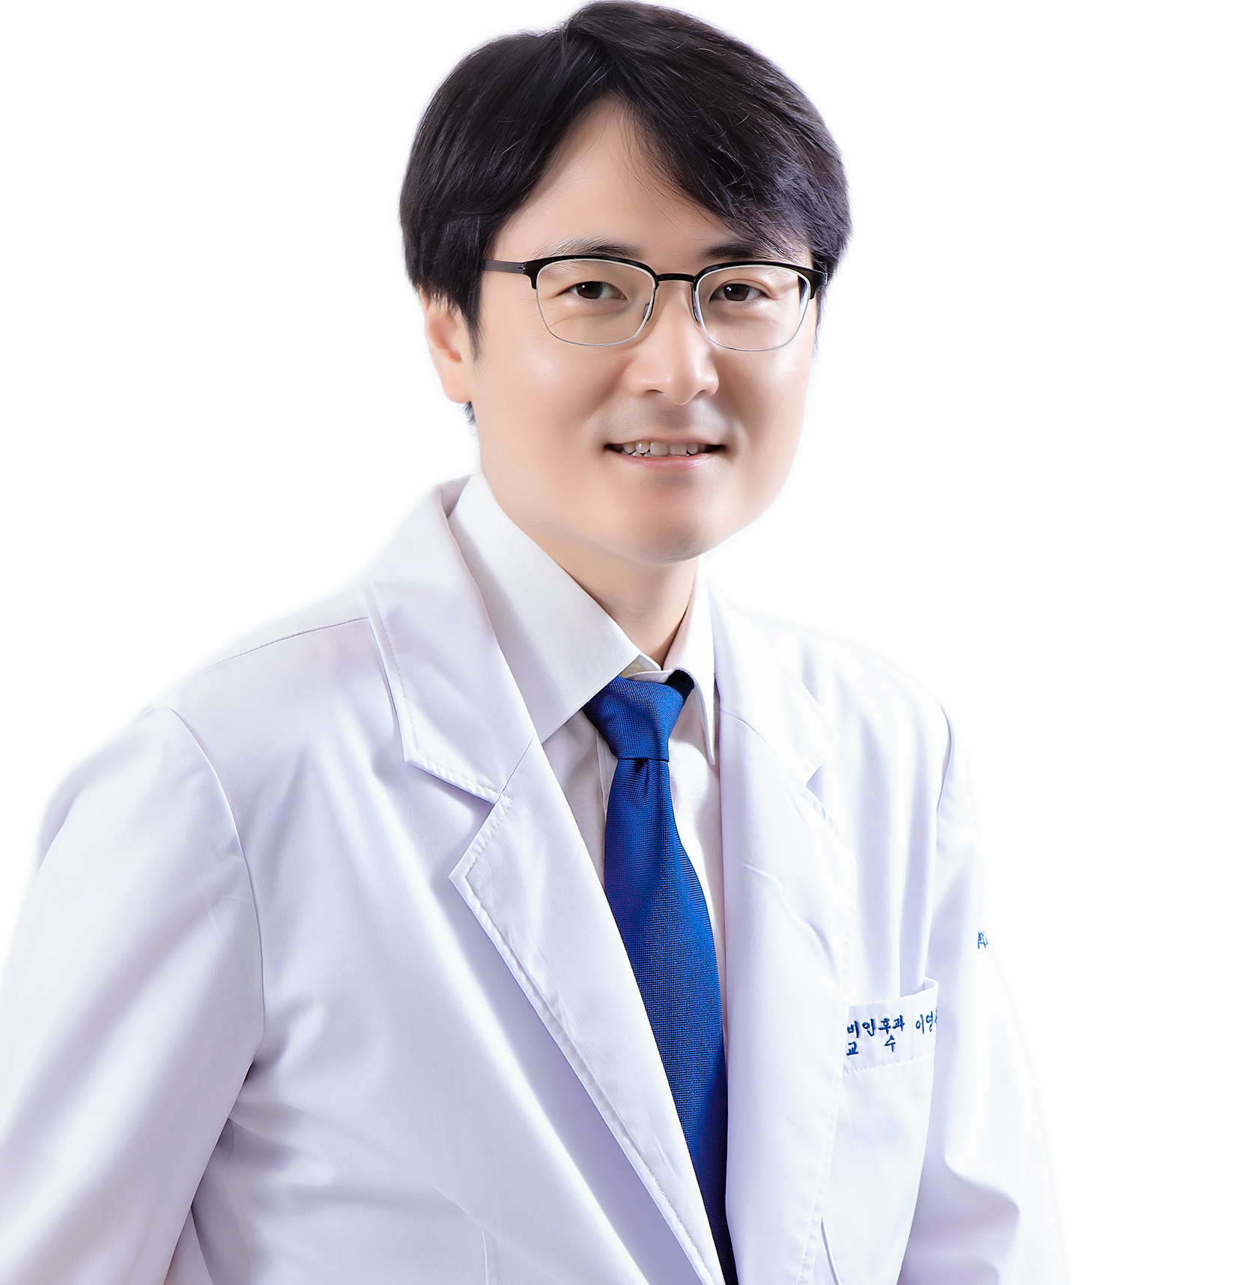 | Family Name (Last Name) | Young Chan
 | Given Name (First Name) | Lee
 | Country | Republic of Korea
 | Position / Department | Professor/ Department of Otolaryngology-Head & Neck Surgery
 | Institute / Organization | School of Medicine, Kyung Hee University, Kyung Hee University Hospital at Gangdong
Education Background | 2014 Ph.D. Kyung Hee University, School of Medicine, Seoul, Korea
Professional Career | ◆ 2016 ~ 2019 Assistant professor, Kyung Hee University Hospital at Gangdong, Seoul, Korea ◆ 2022 ~ 2023 Visiting associate professor, Department of Biostatistics, Epidemiology and Informatics, The Perelman School of Medicine, University of Pennsylvania, USA◆ 2020 ~ 2025 Associate professor, Kyung Hee University Hospital at Gangdong, Seoul, Korea ◆ 2025 ~ present Professor, Kyung Hee University Hospital at Gangdong, Seoul, Korea
Research Field | Head and neck cancer, Cancer genomics, Liquid biopsy, AI, Oral microbiome
Presentation Topic | The Role of Liquid Biopsy in the Management of Nasopharyngeal Carcinoma
Abstract | Nasopharyngeal carcinoma (NPC) is an Epstein–Barr virus (EBV)-associated epithelial malignancy that is frequently detected at an advanced stage because of nonspecific symptoms and its deep anatomical location, making minimally invasive biomarkers essential across the disease continuum. As EBV is ubiquitously present in NPC tumor cells, circulating viral nucleic acids provide a tumor-specific liquid biopsy target, and plasma cell-free EBV DNA has become the most extensively validated analyte for screening, diagnosis, treatment monitoring, and prognostication. For early detection, quantitative plasma EBV DNA enables population-based case-finding; fragmentomics analysis of plasma EBV DNA enhances screening performance by reducing false positives, while EBV DNA methylation detectable in plasma and saliva further improves diagnostic accuracy. Pretreatment viral load contributes to risk stratification and staging refinement. During and after therapy, longitudinal EBV DNA kinetics reflect tumor burden and treatment response; recurrent post-treatment positivity ("bounce") is associated with markedly worse disease-free survival, flagging molecular residual disease before radiographic relapse. Emerging evidence supports dynamic ctDNA/EBV DNA-guided risk-adaptive therapy, permitting escalation or de-escalation of adjuvant treatment, and integration with artificial intelligence and multimodal data is refining individualized prognostic models. Remaining challenges include assay harmonization, standardized pre-analytics, defined clinical thresholds, and validation in non-endemic populations. This talk will summarize current evidence and emerging directions for liquid biopsy in the comprehensive management of NPC.

Symposium (S09), Nasopharyngeal Cancer
S09_S6
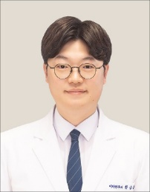 | Family Name (Last Name) | Seung Hoon
 | Given Name (First Name) | Han
 | Country | KOREA
 | Position / Department | Assistant Professor /Department of Otorhinolaryngology-Head and Neck Surgery
 | Institute / Organization | Asan Medical Center, University of Ulsan College of Medicine
Education Background | M.D., Seoul National University, College of Medicine, Seoul, Korea  M.S., Seoul National University, College of Medicine, Seoul, Korea  Ph.D. , Seoul National University, College of Medicine, Seoul, Korea
Professional Career | Internship & Residency, Seoul National University Hospital, Seoul, Korea  Army Surgeon, Ministry of National Defense, Korea  Fellowship, Seoul National University Hospital, Seoul, Korea  Clinical Assistant Professor, Dongtan Sacred Heart Hospital, Korea Assistant Professor, Dongtan Sacred Heart Hospital, Korea  Clinical Assistant Professor, Asan Medical Center, University of Ulsan College of Medicine, Seoul, Korea
Research Field | Head and Neck Oncology
Presentation Topic | Clinical Challenges in Nasopharyngeal Cancer: Insights from a Single-Center Experience
Abstract | The management of nasopharyngeal carcinoma (NPC) has evolved substantially with advances in radiotherapy, systemic therapy, and risk stratification. Nevertheless, several challenges remain in everyday clinical practice, including patient selection for induction chemotherapy (IC), interpretation of Epstein–Barr virus (EBV)-related biomarkers and disease risk, optimization of concurrent chemoradiotherapy (CCRT), and management of persistent or recurrent disease.In this presentation, we review practical clinical issues in NPC management based on our single-center experience, with particular emphasis on risk-adapted treatment selection. Recent data from our institution evaluating patients with stage III–IVA NPC treated between 2020 and 2025 suggest that the benefit of IC before CCRT may not be uniform across all patients. In a propensity score-matched cohort of 43 patients treated with IC followed by CCRT and 86 treated with CCRT alone, 3-year progression-free survival was 88.4% and 81.6%, respectively. Notably, patients with N3 disease demonstrated a greater benefit from IC, whereas the additional benefit was limited in patients with N0–2 disease, supporting a risk-adapted approach to IC.Beyond initial treatment, clinical decision-making becomes increasingly individualized in patients with residual or recurrent disease. The roles of surveillance, salvage neck surgery, re-irradiation, and systemic therapy must be considered according to disease extent, previous treatment, and patient factors. EBV-related biomarkers may provide additional information for risk assessment and surveillance. Overall, integrating baseline risk, treatment response, and patterns of failure may facilitate more individualized management of NPC across the disease course.

Symposium (S10), Reconstruction & Rehabilitation
S10_S1
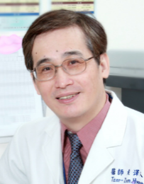 | Family Name (Last Name) | Tzer Zen
 | Given Name (First Name) | Hwang
 | Country | Taiwan
 | Position / Department | Visiting Staff, Department of Otolaryngology - Head and Neck Surgery
 | Institute / Organization | E-Da Hospital/ I-Shou University
Education Background | M.D., China Medical University, Taichung, Taiwan. June 1986.
Professional Career | Second Lieutenant and Surgeon, Marine Corps, ROC (Taiwan). 1986-1988.Residency (1988-1992); Visiting Staff (1992-2002); Chief, Section on Laryngology (1995-2002) - Department of Otolaryngology, National Cheng Kung University Hospital, Tainan, Taiwan.Clinical Researcher, Department of Otolaryngology, Kurume University School of Medicine, Kurume, Japan. 1994. Research Fellow, Laryngeal Physiology Laboratory, Northwestern University Medical School, Chicago, USA. 1999- 2000.Chairman, Department of Otolaryngology - Head & Neck Surgery, Chung Gang Memorial Hospital- Chiayi, Taiwan. 2002- 2007.Chairman, Department of Otolaryngology - Head & Neck Surgery E-Da Hospital, Kaohsiung, Taiwan. 2007- 2026.
Research Field | Head and neck oncology, laryngology
Presentation Topic | Paraglottic approach reconstructive pharyngolayrngectomy for advanced hypopharyngeal cancer
Abstract | Open partial pharyngolaryngectomy can provide oncological outcomes comparable to more extensive treatment modalities in carefully selected patients with advanced hypopharyngeal cancer, while preserving laryngeal function through appropriate reconstruction.This presentation demonstrates a paraglottic approach for tailored resection of advanced hypopharyngeal cancer, incorporating epiglottic flap reconstruction for laryngeal reconstruction and variable regional flaps for pharyngeal reconstruction.The adoption of well-planned reconstructive pharyngolaryngectomy may enhance the feasibility of surgery as a primary treatment option for patients with advanced hypopharyngeal cancer.

Symposium (S10), Reconstruction & Rehabilitation
S10_S2
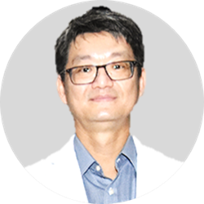 | Family Name (Last Name) | Su
 | Given Name (First Name) | Chin-Chuan
 | Country | Taiwan
 | Position / Department | Attending Physician/ Department of Otolaryngology–Head and Neck Surgery
 | Institute / Organization | Changhua Christian Hospital
Education Background | Ph.D. in Basic Medical Science Graduate Institute of Basic Medical Science, China Medical University, TaiwanM.D. School of Medicine, China Medical University, TaiwanAssistant Professor (MOE-Approved), Taiwan
Professional Career | Board Member, Taiwan Society of Otolaryngology–Head and Neck Surgery (18th Board, Nov 2022 – Nov 2025)Chief, Department of Otolaryngology–Head and Neck SurgeryChanghua Christian Hospital (Jul 2014 – Sep 2024)
Research Field | Head and Neck Cancer SurgeryHead and Neck ReconstructionMicrovascular Free Flap Reconstruction
Presentation Topic | Two Decades of Free-Flap Reconstruction for Head and Neck Ablative Defects: A Single-Service Experience from Taiwan
Abstract | Oral cancer is the most common malignancy of the head and neck and the sixth most common cancer in Taiwan. When feasible, primary tumor ablation remains the treatment of choice for oral cavity cancer. However, ablative surgery can result in substantial functional and aesthetic impairments, making reconstruction an essential component of treatment. Oral cavity reconstruction provides structural support for vital tissues, restores mastication, speech, and swallowing, improves aesthetic outcomes, and ultimately enhances patients’ quality of life.One of the most significant advances in the surgical management of head and neck tumors has been the development of a broad range of reconstructive options. These include healing by primary or secondary intention, allografts, skin grafts, locoregional flaps, and free-tissue transfer. Among these approaches, free-tissue transfer offers exceptional three-dimensional versatility and enables surgeons to customize composite tissues according to the size, thickness, and components of each defect, thereby optimizing functional and aesthetic outcomes.Our head and neck free-flap reconstruction program was established in 2006 at Changhua Christian Hospital, Taiwan. Over the subsequent two decades, a single otolaryngology–head and neck surgery service performed more than 2,300 microvascular free-flap reconstructions for head and neck ablative defects, achieving an overall flap survival rate of 94.3%. This study summarizes our institutional experience, with an emphasis on reconstructive strategies, surgical techniques, and perioperative management. Our findings demonstrate that a single-service model for head and neck free-flap reconstruction is feasible and can achieve favorable outcomes in a high-volume clinical setting.

Symposium (S10), Reconstruction & Rehabilitation
S10_S3
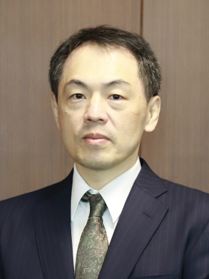 | Family Name (Last Name) | Sugiyama
 | Given Name (First Name) | Yoichiro
 | Country | Japan
 | Position / Department | Professor / Otolaryngology-Head and Neck Surgery
 | Institute / Organization | Saga University / Faculty of Medicine
Education Background | He graduated from Kyoto Prefectural University of Medicine in 2001 and got a Ph.D. at the Graduate School of Medical Science, Kyoto Prefectural University of Medicine 2010. He studied at the University of Pittsburgh as a postdoctoral fellow from 2010 to 2011.
Professional Career | He worked in the Department of Otolaryngology-Head and Neck Surgery, Kyoto Prefectural University of Medicine, from 2012. Assistant professor (2015 – 2017), Lecturer (2017-2024). He worked as a professor in the Department of Otolaryngology-Head and Neck Surgery, Saga University Faculty of Medicine, since 2024. He is a specialist in Laryngology. He majors in clinical and basic Laryngology, particularly voice and swallowing disorders. His research interest is neuronal mechanisms underlying swallowing and vocalization based on electrophysiology.
Research Field | Laryngology, Swallowing, Vocalization, Upper Airway
Presentation Topic | Surgical approach for swallowing disorders
Abstract | Pharyngeal dysphagia is primarily managed through rehabilitation therapy. However, surgical interventions are also recognized as valuable options for patients with severe dysphagia. Surgical procedures can effectively compensate for impaired swallowing function and enhance overall swallowing outcomes. The selection and indication of these surgeries are primarily evaluated by endoscopic and videofluoroscopic assessments. In this presentation, we will provide an overview of current surgical approaches to dysphagia and discuss optimal strategies for selecting and combining procedures tailored to the underlying pathophysiology of swallowing disorders. Swallowing rehabilitation therapy is also critical for improving swallowing outcomes. Electrical stimulation therapy can be beneficial for enhancing the progress of rehabilitation therapy after the surgery. We will also present the treatment approach of swallowing rehabilitation.

Symposium (S10), Reconstruction & Rehabilitation
S10_S4
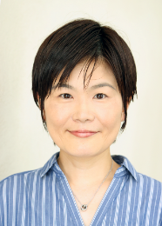 | Family Name (Last Name) | Ueha
 | Given Name (First Name) | Rumi
 | Country | Japan
 | Position / Department | Director / Swallowing Center
 | Institute / Organization | The University of Tokyo Hospital
Education Background | 1997 – 2003 Faculty of Medicine, Nara Medical University (M.D.)2003 Resident, the University of Tokyo hospital2005 Fellow, NTT Medical Center/ Tokyo Metropolitan Neurological Hospital/ Kameda Medical Center2017 The University of Tokyo Graducate School of Medicine (Ph.D.)
Professional Career | 2010 Medical staff, Dept of Otolaryngology, the University of Tokyo hospital2012 Visiting researcher, Dept of Pathology, University of Michigan2012 Assistant Professor, Dept of Otolaryngology, University of Tokyo2018 Visiting researcher, Dept of Otolaryngology, University of California Davis2021 Director, Associate Professor, Swallowing Center, the University of Tokyo
Research Field | Swallowing surgery, Dysphagia, Airway inflammation, Vocal fold regeneration, Olfaction, Olfactory receptor cell regeneration, Swallowing Virtual Reality, Digital Healthcare, Food Physical Properties Research.
Presentation Topic | Tailored Treatment Strategies for Postoperative Dysphagia and Voice Disorders
Abstract | Postoperative dysphagia is a frequent complication following surgeries for brain, head and neck, and esophageal tumors. Although the primary objective of these procedures is complete tumor resection, preservation of postoperative function is of equal clinical importance. Accordingly, treatment planning should include a preemptive assessment of potential functional impairments and incorporate comprehensive strategies to mitigate their impact.Postoperative dysphagia arises from multifactorial etiologies, including structural deficits caused by tumor resection, impairment of swallowing-related muscles or nerves, late-onset cicatricial changes, and secondary factors such as malnutrition and aging. The management of dysphagia remains a major clinical challenge, with significant implications for airway safety and patient quality of life. Proactive management should encompass meticulous oral hygiene, adequate nutritional support, and timely rehabilitation planning. In selected patients, surgical interventions aimed at improving swallowing function—such as laryngeal suspension, cricopharyngeal myotomy, and vocal fold medialization—should also be considered.In addition to dysphagia, hoarseness due to vocal fold paralysis represents another important postoperative functional impairment. Although various treatment options are available, adequate glottal closure may not be achieved with injection therapy or thyroplasty type I alone when a vertical height mismatch exists between the vocal folds. In such cases, arytenoid adduction is indispensable for reconstructing the laryngeal framework and achieving precise approximation of the bilateral vocal processes during phonation.In this lecture, I will present comprehensive treatment strategies for postoperative dysphagia, together with the surgical technique of arytenoid adduction performed under local anesthesia. I will also introduce our current approach to vocal fold regenerative therapy using intracordal injection techniques.

Symposium (S10), Reconstruction & Rehabilitation
S10_S5
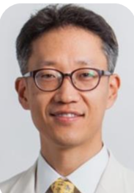 | Family Name (Last Name) | CHUNG
 | Given Name (First Name) | Man Ki
 | Country | South Korea
 | Position / Department | Professor / ENT
 | Institute / Organization | Sungkyunkwan university School of medicine / Samsung medical center
Education Background | MD in Seoul national universityPhD in Sungkyunkwan university
Professional Career | Professor, Otorhinolaryngology-head and neck surgery, Sungkyunkwan university, school of medicineDirector, Head and neck cancer center, Samsung medical center
Research Field | Head and neck surgery
Presentation Topic | Current innovation in head and neck reconstruction
Abstract | Current innovations in HN reconstruction composes of the improvement of surgical techniques & the advancement of technology Through these progress, the trend is changing to prioritize custom, patient-specific reconstructions that consider the unique anatomic, functional, and aesthetic needs of each patient (precision reconstruction) Thoughtful donor site selection with a focus on QoL alongside functional outcomes in the head and neck will ensure a holistic, patient-centered approach to reconstruction In the future, the integration of regenerative medicine, stem cell biology, and tissue engineering, combined with AI and AR technology, will lead to a new era in HN reconstruction.

Symposium (S10), Reconstruction & Rehabilitation
S10_S6
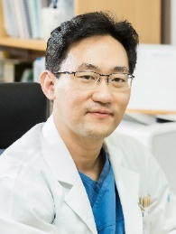 | Family Name (Last Name) | JEONG (鄭)
 | Given Name (First Name) | Woo-Jin (宇軫)
 | Country | Korea
 | Position / Department | Professor, Dept of ORL-HNS
 | Institute / Organization | Seoul National University Bundang Hospital, Seoul National University College of Medicine
Education Background | Dr. Jeong had his education and clinical training as an otolaryngologist at SNU and its affiliated hospitals. He further went on to the NIH and UCSD as a postdoctoral scholar.
Professional Career | Dr. Jeong serves in academic societies including the Korean Society of ORL-HNS (KORL), and Korean Society of H&N Surgery (KSHNS), just to name a few. He is also a member of international societies such as APTS and AACR. He also serves as an Associate Editor of the journals Clinical & Experimental Otorhinolaryngology and Journal of Otolaryngology-Head & Neck Surgery.
Research Field | Dr. Jeong’s clinical expertise encompasses all of head and neck cancers, including thyroid cancers and salivary neoplasms, robotic surgery, and reconstruction. His research topic includes clinical trials for H&N cancers and the application of robotic surgery. His interest extends to laboratory research including carcinogenesis, signaling pathways, and targeted therapy.
Presentation Topic | Midface Defect Reconstruction with Virtual Surgical Planning
Abstract | Midface defect reconstruction is challenging because both function and facial contour must be restored. Complex Brown class III and IV defects are particularly difficult, requiring oral-nasal separation, orbital support, midface projection, and sometimes future dental rehabilitation.Virtual surgical planning (VSP) has improved reconstruction by allowing more accurate assessment, flap selection, osteotomy design, and plate preparation. Fibula and scapular flaps are useful when bony reconstruction is needed.This presentation reviews the current role of VSP in midface reconstruction with representative cases. However, bony reconstruction is not necessary in all patients. In selected cases, soft tissue reconstruction or an obturator may provide better function with less morbidity. Reconstruction should be individualized according to the defect and patient condition.

