Keynote Lecture (KS01), Keynote Lecture
KS01_S1
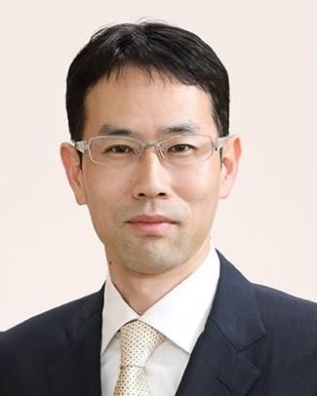 | Family Name (Last Name) | SANUKI
 | Given Name (First Name) | TETSUJI
 | Country | JAPAN
 | Position / Department | Professor/ Department of Otolaryngology
 | Institute / Organization | Nagoya City University East Medical Center
Education Background | 1995: MD, Ehime University, Ehime, Japan1997–2001: PhD in Medicine, Ehime University Graduate School of Medicine, Ehime, Japan2001–2003: Postdoctoral Fellow, Department of Otolaryngology, Washington University School of Medicine, St. Louis, Missouri, USA2003–2006: Fellowship in Laryngology and Plastic Surgery, Kyoto Voice Surgery Center, Kyoto, Japan
Professional Career | 2001–2002: Assistant Professor, Ehime University2006–2010: Assistant Professor, Kumamoto University2010–2017: Associate Professor, Kumamoto University2017–2024: Associate Professor, Nagoya City UniversityMarch 2024–present: Professor, Nagoya City UniversityMarch 2024–present: Director, Nagoya City University East Medical CenterApril 2024–present: Director, Nagoya Voice & Sinus Center
Research Field | Voice disorders, including spasmodic dysphoniaPhonosurgery and laryngeal framework surgeryClinical and translational research in laryngology
Presentation Topic | Redefining Clinical Guidelines for Spasmodic Dysphonia: Integrating Pathophysiology and Surgical Innovation
Abstract | Background:Spasmodic dysphonia (SD) is a rare focal laryngeal dystonia characterized by involuntary spasms of the intrinsic laryngeal muscles during speech, resulting in substantial communication impairment and reduced quality of life. Despite advances in diagnosis and treatment, considerable variability remains in clinical practice, and current severity classifications do not always reflect real-world treatment selection or patient outcomes.Objectives:This keynote lecture aims to present recent developments that have led to the revision of clinical guidelines for SD, highlighting how emerging evidence regarding pathophysiology, nationwide registry data, and surgical innovations are reshaping contemporary management strategies.Methods and Recent Advances:A nationwide multicenter SD registry involving nearly 50 institutions has provided real-world data on patient demographics, disease severity, treatment selection, and long-term outcomes. These findings have revealed discrepancies between conventional severity grading systems and actual clinical decision-making. Concurrently, advances in neurobiological research have strengthened the concept of SD as a network disorder involving abnormal sensorimotor integration and basal ganglia–cortical dysfunction.On the therapeutic front, botulinum toxin injection remains the standard first-line treatment; however, surgical interventions have evolved considerably. Type II thyroplasty using titanium bridges has demonstrated durable voice improvement and has recently achieved broader clinical acceptance. Long-term outcome studies and post-market data have clarified its safety profile and role within treatment algorithms. In addition, refinements in laryngeal framework surgery, endoscopic techniques, and perioperative visualization systems have contributed to improved surgical precision and educational dissemination.Conclusions:The integration of pathophysiological insights, real-world evidence, and surgical innovation necessitates a redefinition of contemporary SD guidelines. Future clinical frameworks should move beyond symptom-based classifications toward precision medicine approaches that incorporate disease mechanisms, objective outcome measures, and individualized treatment selection. These developments are expected to improve diagnostic accuracy, optimize therapeutic strategies, and ultimately enhance patient-centered care for individuals with SD.

Keynote Lecture (KS02), Keynote Lecture
KS02_S1
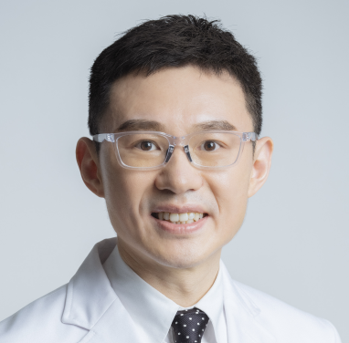 | Family Name (Last Name) | Lai
 | Given Name (First Name) | Ying-Ta
 | Country | Taiwan
 | Position / Department | Attending Physician
 | Institute / Organization | Taipei Medical University—Shuang Ho Hospital, Ministry of Health and Welfare
Education Background | Medical Degree, Taipei Medical University (September, 1998-June, 2005)Honorary laryngology research fellow and visiting scholar, Division of Otolaryngology/Department of Surgery, University of Wisconsin, Madison, Wisconsin (July, 2012-April, 2013)Laryngology research fellow, Otolaryngology Head and Neck Surgery Department, Kyoto University, Kyoto, Japan (October, 2013-November, 2013)
Professional Career | Attending Physician, Department of Otolaryngology–Head and Neck Surgery, Taipei Medical University—Shuang Ho Hospital, Ministry of Health and Welfare (2014-now)Chair, International Relations Committee, ABEA (American Broncho-Esophagological Association) (2023-now)
Research Field | Laryngology
Presentation Topic | Voice Odyssey: Exploring the Elite Art and Craft in Phonosurgery with the Novel 445-nm Blue Laser
Abstract | Since the renowned opera maestro Manuel Garcia presented “Observations on the Human Voice” using mirror laryngoscopy in 1855, there has been an inextricable link between performing vocalists and laryngologists. Today, specialized laryngeal surgeons continue the tradition of integrating medical and surgical management of performing vocalists with those skilled in vocal arts as well as voice science and therapy. Photoangiolytic lasers in laryngology have been widely developed and used in the past 25 years. Recently, a new 445-nm laser has been developed for clinical use and it shows effective in treating vocal fold vascular and nonvascular lesions. Moreover, blue laser reveals less tissue damage than the KTP laser which indicates the benefits in treating elite performers. In this speech, the speaker will focus on the delicate phonosurgery and the cutting edge photoangiolytic blue laser by reviewing the past history, introducing the current treatment, and revealing the trends in the future.

Keynote Lecture (KS03), Keynote Lecture
KS03_S1
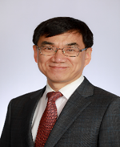 | Family Name (Last Name) | Lee
 | Given Name (First Name) | ByungJoo
 | Country | Korea
 | Position / Department | 1. Professor Emeritus/ENT department2. Director/ENT department
 | Institute / Organization | 1. Pusan National University2. Good Gang-An Hospital
Education Background | 2000, 3 – 2003, 2 Graduate School of Medicine (Ph.D.), Pusan National University, Busan, Korea2010, 3 - 2011, 2 Visiting Physician, Department of Surgery, Division of Otolaryngology-Head and Neck Surgery, Madison, Wisconsin, USA
Professional Career | Professor, Department of ORL-Head and Neck Surgery, Pusan National University School of Medicine.2019-2021: President, Korean Society of Laryngology, Phoniatrics and Logopedics
Research Field | Thyroid surgery, Intraoperative neuromonitoring, Aging, tonsil stem cells
Presentation Topic | Can we prevent vocal fold fibrosis caused by aging and radiation?
Abstract | Vocal fold fibrosis can occur due to aging, radiation exposure, or post-surgical scarring. Vocal fold fibrosis is primarily attributed to changes in the extracorporeal membrane (ECM) of the vocal fold lamina propria. Changes in the ECM caused by aging and radiation exposure generally involve an increase in collagen and a decrease in HA. However, the molecular biological mechanisms behind these ECM changes and effective drugs remain uncertain. The presenter intends to discuss the following three aspects:1. Verification of the effects of antioxidants on changes in the ECM of the vocal fold lamina propria due to changes in sex hormones. 2. Discovery of new substances associated with vocal fold fibrosis and elucidation of regulatory mechanisms through NGS studies on the aging vocal cord lamina propria. 3. Verification of the mechanisms of vocal fold fibrosis following radiation exposure and the effects of antioxidants. Through these studies, the presenter intends to discuss the mechanisms of vocal fold fibrosis and new substances capable of preventing it.

Meet the professor (MP01), Meet the professor
MP01_S1
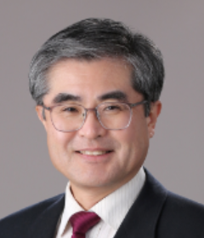 | Family Name (Last Name) | Sung
 | Given Name (First Name) | Myung Whun
 | Country | Korea (South)
 | Position / Department | Department of Otolaryngology
 | Institute / Organization | Seoul National University
Education Background | Seoul National University, College of Medicine
Professional Career | Seoul National University Hospital
Research Field | Otolaryngology
Presentation Topic | The Evolution of the Human Vocal System
Abstract | During evolution, humanity underwent three major changes in the head and neck region. The brain and head enlarged, the lower face retracted backward, and the larynx descended.The descent of the larynx was a fundamental structural change that enabled humans to control speech. However, voice production relies on a complex system shaped over millions of years rather than a single organ.Humans are the only animals that use language through their voice. While other animals produce vocal sounds, the human voice possesses unique characteristics required for language that the voices of other animals do not have.Anatomy and physiology are like the relationship between geography and history. They serve as the background against which biological events take place. Examining how the organs responsible for the human voice have evolved over millions of years will help us understand the core functions of these organs, better grasp clinical challenges, and find effective directions for treatment

Meet the professor (MP02), Spasmodic dysphonia ABC approach
MP02_S1
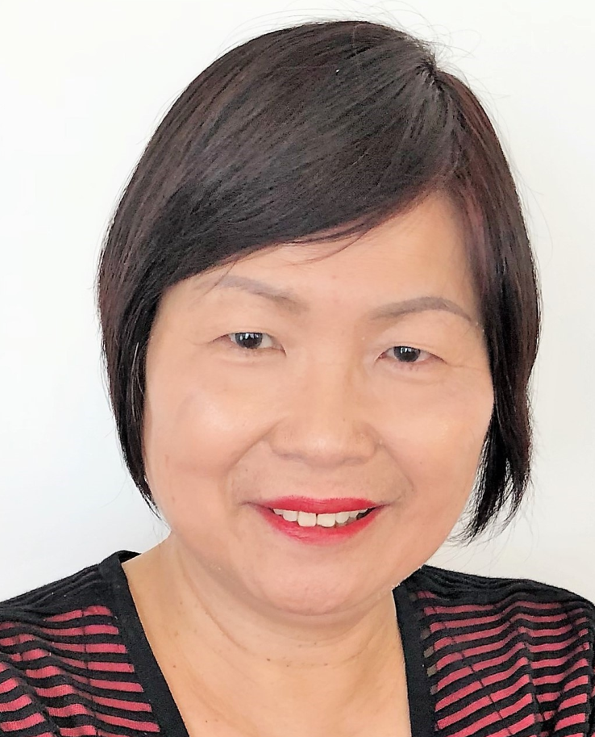 | Family Name (Last Name) | Ouyoung
 | Given Name (First Name) | Laishyang(Melody)
 | Country | USA
 | Position / Department | Speech Manager at Speech Pathology Department
 | Institute / Organization | Keck Medical Center of USC
Education Background | Doctor of Education at USC, Master of Science in Speech Pathology
Professional Career | Speech Manager of the Speech Pathology Department at Keck Medical Center of USC
Research Field | Head and Neck Cancer, dysphagia, and dysphonia
Presentation Topic | Spasmodic Dysphonia: ABCLOVE Approach
Abstract | This study describes the effects of ABCLOVE Voice Training-an eclectic and multi-faceted rehabilitation approach to treat the challenging dysphonia-Spasmodic Dysphonia. Current treatment standard is Botox injection every 3 months by an ENT doctor. Very few patients received both voice treatment and Botox injection as a combined treatment. This presenter has pioneered to use ABCLOVE Voice training to treat dysphonia caused by head and neck cancer treatment with positive results (Ouyoung et al, 2015). Can ABCLOVE Voice training treat spasmodic dysphonia with positive outcome? This study reported the early success of utilizing ABCLOVE voice training to manage spasmodic dysphonia. MethodA total of 14 patients were included in this study. Three males and eleven females with average of 52 years received voice therapy at an outpatient clinic. 2/14(14%) were diagnosed with abductor spasmodic dysphonia while 12/14(64%) were diagnosed with adductor spasmodic dysphonia. 3/12(25%) were diagnosed with both tremors and adductor spasmodic dysphonia. All subjects received pre-and post-treatment objective data measurements included stroboscopic findings. The Kay-Pentax Viso-Pitch IV model 3950 machine was used to measure Maximum Phonation Time (MPT), hoarseness measured by Relative Average Perturbation (RAP) and Pitch Range (PR). The Voice Handicap index (VHI), and Consensus Auditory Perceptual Evaluation -Voice (CAPE) were used to measure patients’ perceptual impairment. All these parameters were determined at the initial evaluation and at the completion of the voice program. Specific voice training (ABCLOVE voice training) was applied to all patients.  ResultsAll subjects demonstrated progress in their voice as measured by RAP (hoarseness), MPT (maximum Phonation Time), and PR (Pitch Range). Early referrals to receive voice treatment after diagnosis of spasmodic dysphonia within six months tends to make considerable progress, and no further Botox injection is needed. In summary, spasmodic dysphonia can benefit from voice treatment with the injection of Botox. Early referrals to have voice treatment tend to make considerable progress without further Botox injections. ABCLOVE Voice training can be the treatment choice to address this challenge of dysphonia.

Meet the professor(MP03), Meet the professor
MP03_S
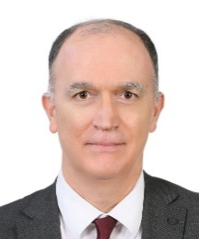 | Family Name (Last Name) | YILMAZ
 | Given Name (First Name) | TANER
 | Country | TURKEY
 | Position / Department | Professor/Dept. of Otolaryngology & HNS
 | Institute / Organization | Hacettepe University Faculty of Medicine
Education Background | Hacettepe University Faculty of Medicine 1991
Professional Career | Professor, Hacettepe University Faculty of Medicine 2006
Research Field | Laryngology & Phonosurgery
Presentation Topic | Voice Feminisation & Voice Masculinisation
Abstract | Introduction：  In order to feminize voice of a transgender female, voice therapy may be chosen as a non-surgical option. Among surgical procedures, cricothyroid approximation (Thyroplasty type IV), anterior glottic web formation (Wendler glottoplasty), laser reduction glottoplasty and their various combinations will be demonstrated on surgical videos. Other surgical procedures described in the literature, such as feminization laryngoplasty, LAVA (Laser Assisted Voice Adjustment) and vocal fold shortening & retrodisplacment of anterior commissure type 1 and 2 will also be mentioned and demonstrated on pictures. The advantages and disadvantages of each surgical procedure will be discussed.  In order to masculinize voice of a transgender male parenteral testosterone treatment for one year is compulsory. Voice therapy is also a non-surgical option. Thyroplasty type III, its modification (Relaxation thyroplasty), window anterior commissure relaxation laryngoplasty (Diamond anterior commissure relaxation laryngoplasty or Baklava thyroplasty) and coronal & sagital release glottoplasty (unpublished technique) will be demonstrated on pictures and videos. The advantages and disadvantages of each surgical procedure will be discussed.  Surgical Technique / Procedural Steps：  For voice feminization, cricothyroid approximation (Thyroplasty type IV), anterior glottic web formation (Wendler glottoplasty), laser reduction glottoplasty and their various combinations will be demonstrated on surgical videos.  For voice masculinization, thyroplasty type III, its modification (Relaxation thyroplasty), window anterior commissure relaxation laryngoplasty (Diamond anterior commissure relaxation laryngoplasty or Baklava thyroplasty) and coronal & sagital release glottoplasty (unpublished technique) will be discussed in detail.Technical Pearls and Pitfalls：  Technical pearls and pitfalls of each surgical procedure will be demonstrated and discussed.Outcome and Clinical Implications ：  Several surgical options are available for modifying transgender voice. Voice therapy is usually the first step in treatment. Phonosurgery for transgender person is a very gratifying modification in voice. Patient satisfaction is generally very high.

Symposium (S01), Office Procedure
S01_S1
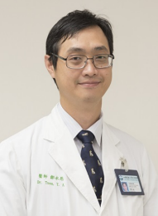 | Family Name (Last Name) | Tsou
 | Given Name (First Name) | Yung-An
 | Country | Taiwan
 | Position / Department | Direct of Laryngology/Department of OHNS
 | Institute / Organization | China Medical University Hospital
Education Background | Graduate School of Medicine, China Medical University
Professional Career | President, Taiwan Voice Society Director of Laryngolgy, China Medical University Hospital, Taichung, Taiwan.Professor of Department of Audiology and Speech-Language Pathology, Asia University, Taichung, Taiwan.Professor of School of Medicine, China Medical University, Taichung, Taiwan.
Research Field | Laryngology, phonosurgery, pharyngeal cancer & dysphagia
Presentation Topic | Office-Based Injection Laryngoplasty for Dysphonia: Modulating Vocal Tension in Glottal Insufficiency and Spasmodic Dysphonia
Abstract | Office-based laryngeal procedures have revolutionized the management of voice disorders by providing immediate, minimally invasive alternatives to traditional surgery. This abstract evaluates the application of percutaneous and transoral injections to treat dysphonia caused by abnormal vocal fold position or tension. 1. Glottal Insufficiency & Vocal Fold Paralysis. 2. Hyperfunctional Disorders (Spasmodic Dysphonia AD and AB): A unique advantage of this setting is the ability to perform real-time voice monitoring, allowing the physician to adjust the injection based on the patient's immediate vocal output. It is safe, cost-effective, and highly efficacious. it reduced systemic risk and personalized functional outcomes. This approach remains the gold standard for managing a spectrum of dysphonias ranging from glottal gaps to laryngeal dystonia.

Symposium (S01), Office Procedure
S01_S2
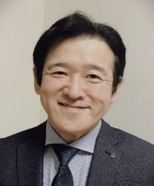 | Family Name (Last Name) | Tokashiki
 | Given Name (First Name) | Ryoji
 | Country | Japan
 | Position / Department | Professor
 | Institute / Organization | Shinjyuku Voice Clinic
Education Background | MD, Tokyo Medical University, Japan, 1990
Professional Career | Professor of Otolaryngology, Tokyo Medical University (since 2009)  Director, Shinjuku Voice Clinic (since 2010)
Research Field | Voice disorders, phonosurgery, and neurological and psychological aspects
Presentation Topic | Simple Office-Based Voice Procedures Under Topical Anesthesia
Abstract | Recent advances in endoscopic imaging and surgical instruments have enabled a wide range of office-based laryngeal procedures to be performed safely and effectively under topical anesthesia. This presentation describes the anesthetic techniques, surgical procedures, indications, and clinical benefits of office-based laryngeal surgery in awake patients.Successful completion of these procedures requires patients to tolerate transnasal flexible endoscopy without a significant gag reflex. Topical anesthesia is achieved by inhalation of 4% lidocaine for 3–5 minutes, followed by additional spraying of lidocaine through the working channel of the endoscope under direct visualization. Patients with severe bronchial asthma are generally excluded because airway exposure to lidocaine may provoke bronchospasm.Two basic techniques are employed. The first is vocal fold injection through the thyrohyoid approach using a curved needle. The second is transnasal endoscopic excision of lesions using biopsy forceps.Injection procedures are indicated for unilateral vocal fold paralysis, vocal fold atrophy, vocal fold scar, and Reinke's edema. Injectable materials include hyaluronic acid, basic fibroblast growth factor (bFGF), and triamcinolone, depending on the pathology. The same approach is also routinely used for botulinum toxin injection in patients with spasmodic dysphonia, accounting for several hundred procedures annually at our institution.Forceps-based procedures are indicated for vocal fold polyps, nodules, and cysts. Broad-based polyps are removed using forceps after incision of their base, whereas cysts are treated by endoscopic incision.Real-time observation of vocal fold vibration using stroboscopy during phonation allows intraoperative assessment of voice outcomes while helping preserve vocal fold function. These minimally invasive procedures reduce patient burden, avoid general anesthesia, and enable rapid recovery and return to daily activities.

Symposium (S01), Office-based procedure
S01_S3
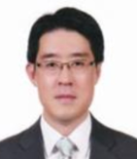 | Family Name (Last Name) | Lee
 | Given Name (First Name) | Sang-Hyuk
 | Country | Republic of Korea
 | Position / Department | Professor / Otolaryngology
 | Institute / Organization | Kangbuk Samsung Hospital / Sungkyunkwan University, School of Medicine
Education Background | Chungnam National University Medical School, BachelorAjou University Medical School Otorhinolaryngology, MasterHallym University Medical School Otorhinolaryngology, Doctor
Professional Career | Korean Society of Laryngology, Phoniatrics and Logopedics, Vice presidentKorean Society of Head and Neck Surgery, Director of insurance committeeKorean Society of Pediatric Otorhinolaryngology, General secretaryKorean Society of Head and Neck Oncology, Director of training committeeKorean Society of Otorhinolaryngology, Director of insurance committee
Research Field | Cancer stem cell biology, vocal fold wound healing and laryngeal reflux disease.
Presentation Topic | Office-Based Vocal Fold Steroid Injection: A Minimally Invasive Paradigm Shift for Benign Vocal Fold Disorders
Abstract | The management of benign vocal fold disorders, including vocal nodules, polyps, and Reinke’s edema, has traditionally centered on voice therapy as the primary line of treatment, followed by microlaryngeal surgery (MLS) under general anesthesia for refractory cases. However, the advent of office-based procedures has revolutionized this paradigm. Office-based vocal fold steroid injection (VFSI) offers a potent anti-inflammatory effect directly to the lamina propria. It serves as a bridge between conservative therapy and invasive surgery, providing an alternative option that avoids the risks of general anesthesia, reduces healthcare costs, and minimizes the duration of mandatory post-operative voice rest. Office-based VFSI is a safe, effective, and cost-efficient alternative to MLS for benign vocal fold disorders. It significantly improves both objective voice parameters and patient-reported quality of life. We propose that VFSI should be considered early in the treatment algorithm for patients who are recalcitrant to voice therapy, potentially sparing many from the necessity of surgical intervention. This presentation evaluates the clinical efficacy, technical considerations, and case-dependent outcomes of VFSI.

Symposium (S01), Office Procedure
S02_S1
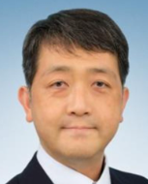 | Family Name (Last Name) | Araki
 | Given Name (First Name) | Koji
 | Country | Japan
 | Position / Department | Professor & Chairman, Department of Otorhinolaryngology - Head & Neck Surgery
 | Institute / Organization | National Defense Medical College
Education Background | 1997 M.D. Keio University School of Medicine, Tokyo, Japan2006 Ph.D. Keio University School of Medicine, Tokyo, Japan
Professional Career | 1997 Resident in ORL-HNS, Keio University, Tokyo, Japan2001 Fellow in ORL-HNS, Keio University, Tokyo, Japan2004 Director in ORL, Ohtawara Red Cross Hospital, Tochigi, Japan2006 Research Fellow, The University of Pennsylvania School of Medicine, Philadelphia, Pennsylvania, USA 2009 Assistant Professor, ORL-HNS, National Defense Medical College (NDMC), Saitama, Japan2016 Associate Professor, ORL-HNS, NDMC2022 Professor & Chairman, ORL-HNS, NDMC
Research Field | Laryngology, Head & Neck Surgery
Presentation Topic | Research on a novel therapeutic approach to promote recovery of vocal fold movement
Abstract

Symposium (S02), Basic Research
S02_S2
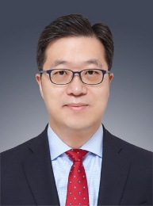 | Family Name (Last Name) | Kwon
 | Given Name (First Name) | Seong Keun
 | Country | Korea
 | Position / Department | Vice President & CSO of SNUHDirector of Biomedical Research InstituteProfessor / Otorhinolaryngology-Head & Neck Surgery
 | Institute / Organization | Seoul National University Hospital (SNUH)
Education Background | MD, MS, & PhD degrees from SNU College of MedicineInternship, Residency, Fellowship from SNUH
Professional Career | President-Elect of Korean Tissue Engineering & Regenerative Medicine Society
Research Field | Tissue engineering, Biomaterials, Airway stenosis, Laryngeal cancer
Presentation Topic | An Integrative Tissue Engineering Platform for Long-Segment Tracheal Regeneration: Biomimetic Scaffold, Bioinks and Stem Cell Spheroids
Abstract | Long-segment tracheal stenosis remains a major clinical challenge, as conventional surgical approaches are often inadequate for defects exceeding 5 cm. Recent advances in tissue engineering have focused on developing biomimetic scaffolds that combine mechanical resilience with high biological functionality. To optimize stem cell engraftment and tissue integration, we designed a highly sophisticated, flexible 3D-printed polycaprolactone (PCL) scaffold incorporating a wet-spinned nanotrap and a leaf-stacked structure. This unique architecture significantly enhances mesenchymal stem cell (MSC) adhesion and maintains luminal patency under bending stress.Notably, the introduction of MSC spheroids into the scaffold further promoted accelerated mucosal regeneration through improved epithelialization. In parallel, a novel detergent-free decellularization approach was established to generate extracellular matrix (dECM)–derived bioinks with superior preservation of native ECM components, enabling cartilage-derived DFdECM to promote robust chondrogenesis both in vitro and in vivo. Additionally, preliminary investigation into the early host response underscored the role of targeted immunomodulation in preventing early graft failure and supporting stable long-term integration.This integrative approach moves the field closer to addressing the clinical unmet need of reconstructing tracheal defects larger than 5 cm, and future studies employing large-animal models will be critical for bridging translation toward human application.

Symposium (S02), Basic Research
S02_S3
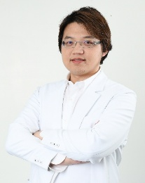 | Family Name (Last Name) | Chen
 | Given Name (First Name) | Andy Wei-Ge
 | Country | Taiwan
 | Position / Department | Attending physician
 | Institute / Organization | Voice center, Far Eastern Memorial Hospital
Education Background | Ph.D. Candidate, Program in Translational Medicine, National Chung Hsing University, TaiwanM.D., School of Medicine, Kaohsiung Medical University, Taiwan
Professional Career | Secretary General, Taiwan Voice SocietyFormer Director, Division of Laryngology, Changhua Christian HospitalVisiting Scholar, Voice Center, University of Pittsburgh Medical Center (UPMC), USA
Research Field | Laryngology & Phonosurgery, Office-based Laryngeal Surgery, Translational Vocal Fold Biology
Presentation Topic | Before the Mature Scar: Early Proliferative Drivers in Vocal Fold Fibrosis from In Silico Discovery to In Vivo Validation
Abstract | Background/Objective: Vocal fold scarring results refractory dysphonia, leading to significant clinical challenge due to irreversible extracellular matrix (ECM) alteration. While current regenerative therapies and biomaterials are introduced to treat mature scars, targeting the early proliferative phase offers a critical window to halt fibrogenesis before permanent scarring occurs. This study aims to identify and validate early molecular drivers of vocal fold fibrosis to enable possible therapeutic strategies. Methods: A cross-species, translational approach was employed. In silico analysis of a rat vocal fold injury database was utilized to identify differentially expressed genes at Day 14 (the proliferative phase). For in vitro mechanistic validation, primary human vocal fold fibroblasts (hVFFs) were stimulated with TGF-β (5-10 ng/mL) for 24 and 48 hours. Findings were corroborated in vivo using a standardized rat vocal fold mucosal stripping model. Results: In silico screening identified 301 significant differentially expressed genes at Day 14, prominently featuring ECM organizers such as Periostin (Postn) and Lysyl oxidase (Lox). In vitro HVFF models confirmed robust, dose-dependent Collagen Type I production under TGF-β stimulation. Concurrently, high baseline α-SMA expression remained stable without further TGF-β induction, likely influenced by the rigidity of standard culture substrates, hinting a predominantly synthetic phenotype. In vivo rat models successfully demonstrated mature scar formation at 8 weeks, marked by structural changes and altered fundamental frequency, setting the stage for targeted validation at the 2-week window. Conclusion: Intervening before the mature scar by targeting early fibrotic triggers provides a promising therapeutic frontier. This translational framework paves the way for novel prophylactic treatments in vocal fold surgery.

Symposium (S02), Basic research
S03_S1
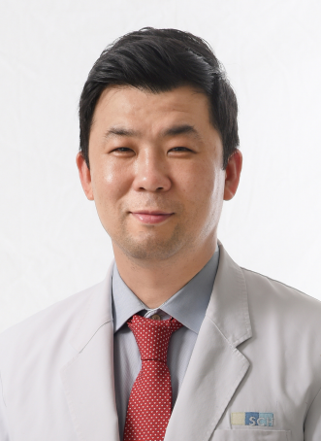 | Family Name (Last Name) | Lee
 | Given Name (First Name) | Seung-Won (SW Lee / Steve Lee)
 | Country | Korea
 | Position / Department | Department of Otolaryngology - Head and Neck Surgery
 | Institute / Organization | Soonchunhyang University College of Medicine
Education Background | Doctorate (Ph.D.), Department of Otolaryngology Head Neck Surgery, Yonsei University School of Medicine (2011)Medical Doctor’s License, Korea (1996)
Professional Career | Professor, Division of Head Neck Surgery, Soonchunhyang University Bucheon Hospital (2005 – Present)President, Korean Society of Laryngology (2025.3 – Present)Board Member (Director of Editorial Board), Korean Thyroid Association (2017.9 – Present)Corresponding Member, American Laryngological Association (ALA) & American Broncho-Esophagological Association (ABEA)
Research Field | Laryngology & PhoniatricsRegenerative Medicine.Head and Neck Surgery
Presentation Topic | Development of a Novel Treatment Strategy for Vocal Fold Scarring
Abstract | The vocal fold has a delicate multilayered structure, and once this structure is disrupted, complete restoration is difficult. Vocal fold scarring reduces mucosal pliability through abnormal collagen accumulation, decreased elastin and hyaluronan, and disruption of the lamina propria. These changes alter the layered microstructure of the vocal fold, reduce tissue elasticity, and ultimately result in dysphonia, including a breathy voice that can significantly impair communication. Moreover, because vocal fold scarring remains refractory to many current interventions, its clinical and societal burden continues to increase, underscoring the need for more effective treatment strategies.The management of vocal fold scarring depends on its etiology and severity. Current treatment options range from conservative management to operative procedures, including scar lysis and suture techniques. However, these surgical approaches are technically demanding and often provide limited and unpredictable functional improvement.Vocal fold scarring is one of the most challenging disorders in laryngology. To overcome the limitations of conventional scar-lysis techniques, we have developed and investigated novel therapeutic approaches, including basic fibroblast growth factor (bFGF), stromal vascular fraction, and 532nm laser treatment, using a rabbit vocal fold scar model. These experimental studies have subsequently been translated into clinical practice through long-term translational research.In this symposium, I will present our preclinical findings, clinical experience, and treatment outcomes with these emerging therapeutic strategies for vocal fold scarring. In particular, I will focus on a combined treatment strategy consisting of 532nm laser therapy followed by intralesional bFGF injection, and discuss its potential role as a novel therapeutic option for patients with vocal fold scarring.

Symposium (S03), Phonomicrosurgery
S03_S2
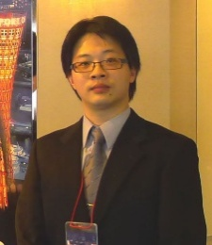 | Family Name (Last Name) | Ting-Shou
 | Given Name (First Name) | Chang
 | Country | Taiwan
 | Position / Department | Chief, Division of Laryngology, Department of Otolaryngology–Head and Neck Surgery
 | Institute / Organization | Kaohsiung Veterans General Hospital
Education Background | School of Medicine, National Defense Medical University
Professional Career | Attending Physician, Kaohsiung Veterans General HospitalVisiting Scholar, Voice Center, Vanderbilt University Medical Center, Tennessee, USA (Oct 2016 – Apr 2017)Board Member, Taiwan Voice SocietyBoard Member, Taiwan Society of Pediatric OtolaryngologyBoard Member, Taiwan Laryngectomee Association
Research Field | Laryngology and Tracheal Disorders
Presentation Topic | Clinical Applications of Nonintubated Videolaryngoscopic Surgery Combined with THRIVE (Transnasal Humidified Rapid-Insufflation Ventilatory Exchange)
Abstract | Nonintubated videolaryngoscopic surgery (NIVS) combined with THRIVE (transnasal humidified rapid-insufflation ventilatory exchange) has emerged as a promising alternative to conventional intubated general anesthesia in laryngeal microsurgery. Building on our prior prospective cohort at Kaohsiung Veterans General Hospital, we evaluated the safety, feasibility, and physiologic profiles of NIVS using high-flow nasal oxygenation, with particular emphasis on the role of superior laryngeal nerve block (SLNB) in maintaining spontaneous ventilation. This technique represents a meaningful advancement in the collaboration between laryngology and anesthesiology, with potential to improve surgical efficiency, patient outcomes, and airway management paradigms.

Symposium (S03), Phonomicrosurgery
S03_S3
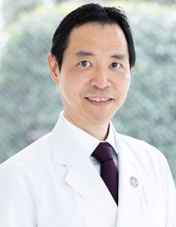 | Family Name (Last Name) | Saito
 | Given Name (First Name) | Koichiro
 | Country | JAPAN
 | Position / Department | Otolaryngology-HNS
 | Institute / Organization | Kyorin University School of Medicine
Education Background | 1995 MD Keio University School of Medicine, Tokyo, Japan2003 PhD Keio University School of Medicine, Tokyo, Japan
Professional Career | 1995- Resident in Otolaryngology-HNS, Keio University School of Medicine, Tokyo, Japan2003-2004 Visiting Scientist, Johns Hopkins University, USA2005-2006 Postdoctoral fellow, University of Pennsylvania, USA2006- Director, Div. of Laryngology, Keio University2015-present Professor and Chairman, Dept. of Otolaryngology-HNS, Kyorin University School of Medicine, Tokyo, Japan2020-present Visiting professor, Keio University
Research Field | Laryngology, Phonosurgery
Presentation Topic | Office-based surgery, surgical management of RRP, green laser
Abstract | Introduceion Although multiple promising medicatons have been reported, surgical management is still a standard tool to manage RRP. Microlaryngeal surgery has advantages to enable precise 3D mapping of the disease, and to ensure pathological diagnosis. However, less-invasive office-based surgical options are needed to treat this disease with relapsing nature to require multiple surgeries.Surgical Technique / Procedural StepsOur basic protocol for adult onset RRP is to perform microlaryngeal surgery (MLS) in the OR using CO2 laser as first surgery. Flexible endoscopy with narrow band imaging (NBI) is utilized together with microscopy for precise mapping of the disease. For residual/recurrent tumors, office-based green laser surgeries (GLSs) are performed. Green laser has a wavelength of 532 nm, to enable the management of RRP with photoangiocoagulation. For the patients who already had MLS in other institutions, or who are clinically/socially in need of procedures without general anesthesia/hospitalization, GLS is considered as a primary procedure after thorough discussionTechnical Pearls and PitfallsAs for MLS using CO2 laser, handpiece delivered surgery is performed for supraglottic lesions under endoscopic NBI view, followed by manipulator delivered surgery for glottic/subglottic lesions under microscopy. Office-based GLS is performed using flexible channel scope. Topical anesthesia using endoscopic spray catheter is followed by green laser application. Fraenkel Laryngeal Forceps is also utilized against bulky lesions in the office.Outcome and Clinical ImplicationsOver 90 RRP patients were treated during the last 10 years in our institution. Successful management of RRP to achieve significant tumor suppression together with satisfactory voice was observed after either MLS or GLS. We recently experienced multiple patients with relatively severe (Derkay Score>10) tumors who got remission after office-based surgeries without visiting OR. Although more studies are required, to follow the worldwide trend, less-invasive office-based management could be the mainstay to manage RRP in the future.

Symposium (S04), Artificial Intelligence
S04_S1
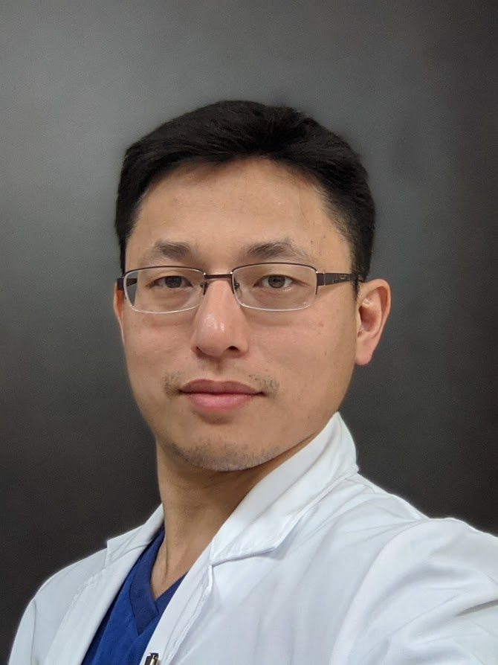 | Family Name (Last Name) | TSAI
 | Given Name (First Name) | SHUWEI
 | Country | TAIWAN
 | Position / Department | NCKUH ENT
 | Institute / Organization | NCKUH ENT
Education Background | National Cheng Kung University medicine
Professional Career | National Cheng Kung University.Otolaryngology
Research Field | ENT oncology surgical management, medical device developmentMedical device development Voice synthesis prosthesis
Presentation Topic | The Usage and improvement of the transnasal Communication System
Abstract | Tracheostomy severely diminishes a patient’s ability to vocalize, leading to profound physiological and psychological isolation. Traditional vocal rehabilitation devices, such as the mechanical electrolarynx, often suffer from low acoustic naturalness, high muscular fatigue, and poor user adherence. To address these limitations, this study presents TSVoice, an innovative non-invasive transnasal communication system designed to restore functional speech through peripheral intent decoding. TSVoice leverages high-frequency aoustic sensors placed at the nasal vestibule to capture minute pressure dynamics generated during attempted articulation. Although the vocal folds are bypassed or removed, the central language network and respiratory motor cortex remain intact, leaving residual motor signals encoded in nasal airflow patterns.  By framing TSVoice as an external peripheral Brain-Computer Interface (BCI), this research highlights the technological framework and clinical enhancement strategies of the system. We developed a lightweight Deep Neural Network (DNN) architecture that maps non-linear transnasal aerodynamic features directly into personalized acoustic parameters. Furthermore, the system relies on bi-directional neuroplasticity; through real-time auditory biofeedback, users undergo closed-loop learning to optimize and fostering neuroprosthetic integration over time.  Recent clinical iterations demonstrate significant improvements over conventional devices. TSVoice achieves a 70% reduction in intent-decoding latency while preserving individual voice characteristics via personalized acoustic synthesis. Ergonomic hardware refinements and a "fabless" software-first approach further lower user friction, addressing failure modes observed in prior silent-speech interfaces. By bridging the gap between non-invasive usability and high-bandwidth neural decoding, TSVoice transforms traditional assistive communication into a neuroplasticity-driven speech neuroprosthetic, offering a scalable, dignity-preserving alternative for tracheostomy care and clinical speech rehabilitation.

Symposium (S04), Artificial intelligence
S04_S2
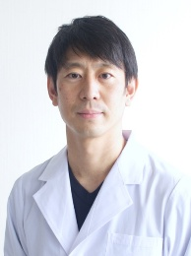 | Family Name (Last Name) | Kojima
 | Given Name (First Name) | Tsuyoshi
 | Country | JAPAN
 | Position / Department | Senior Lecturer / Otolaryngology, Head and Neck Surgery
 | Institute / Organization | Kyoto University
Education Background | 1996-2002 Shiga University of Medical Science, JAPAN2008-2012 Graduate school of Medicine, Kyoto University, JAPAN
Professional Career | Senior Resident 2003-2004Department of Otolaryngology, Tenri Hospital, Nara, Japan Clinical Staff 2004-2008Department of Otolaryngology, Tenri Hospital, Nara, Japan Research Fellow 2011-2014Department of Otolaryngology, Vanderbilt University Clinical Staff 2014-2018Department of Otolaryngology, Tenri Hospital, Nara, Japan Deputy Director 2018-2021Department of Otolaryngology, Tenri Hospital, Nara, Japan Director 2021-2023Department of Otolaryngology, Tenri Hospital, Nara, Japan Senior Lecturer 2023-Department of Otolaryngology, Kyoto University, Kyoto, Japan
Research Field | Laryngology, Voice Disorders, Head and Neck Oncology, and Dysphagia
Presentation Topic | Artificial Intelligence in Voice Assessment
Abstract | Voice assessment is fundamental to the diagnosis and treatment of voice disorders, yet conventional approaches remain imperfect for routine clinical use. Auditory-perceptual scales such as GRBAS are practical but inherently subjective, with limited intra- and inter-rater reliability. Acoustic analysis offers greater objectivity, but specialized equipment and complex workflows have restricted its adoption outside dedicated voice clinics. Artificial intelligence (AI) provides a means to combine perceptual relevance with objective, reproducible measurement on everyday devices.  We have developed deep learning models based on one-dimensional convolutional neural networks to classify the severity of pathological voice according to the GRBAS scale using sustained vowel samples. Building on this work, we implemented a clinically usable iPhone application, GRBASZero, with Apple Create ML and Core ML. The app enables rapid, noninvasive, real-time GRBAS estimation without specialized hardware and is publicly available. Because clinical recordings are rarely noise-free, we systematically evaluated the effect of ambient noise on model performance and showed that noise-augmented training improves robustness under realistic outpatient and perioperative conditions.  Complementary efforts include machine-learning discrimination of “hot potato voice,” disease-oriented classification of voice disorders, smartphone-based real-time acoustic analysis, and novel acoustic indices such as the harmonics-to-fundamental ratio. Together, these approaches aim to transform voice assessment from an experience-dependent judgment into an objective, portable decision-support tool. AI-assisted voice assessment may facilitate consistent pre- and postoperative evaluation in phonosurgery, support screening and remote monitoring, and ultimately improve patient feedback and adherence in voice rehabilitation.

Symposium (S04), Artificial Intelligence
S04_S3
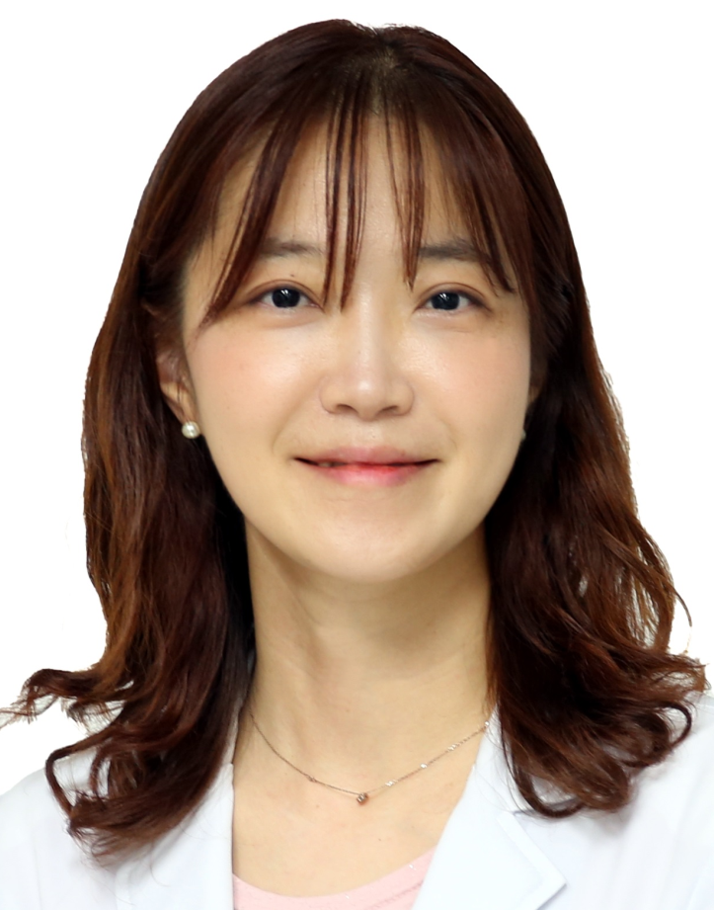 | Family Name (Last Name) | Eui-Suk
 | Given Name (First Name) | Sung
 | Country | Korea
 | Position / Department | Associate Professor/ Otolaryngology-Head and Neck Surgery
 | Institute / Organization | Pusan National University Yangsan Hospital
Education Background | Professor Sung received residency training in Otolaryngology-Head and Neck Surgery at Hanyang University Hospital. She subsequently completed fellowships training in laryngololgy and thyroid surgery at Hanyang University Hospital. She also obtained a Ph.D degree from Pusan National University, focusing on Head and Neck Oncology.
Professional Career | Professor Sung is currently an Associate Professor in the Department of Otolaryngology–Head and Neck Surgery at Pusan National University Yangsan Hospital. She has extensive clinical experience in the management of laryngology and thyroid surgery, e.g., voice disorders, thyroid cancer, and airway diseases. She serves as leadership roles, e.g., Chairman of the International Committee of the Korean Society of Laryngology, Phoniatrics and Logopedics, and actively participates in multiple national and international academic societies. She has also contributed to multidisciplinary collaborations in both clinical practice and research.
Research Field | Professor Sung’s research focuses on the application of artificial intelligence in the early detection and diagnosis of laryngeal and pharyngeal cancers. Her work also includes the development and clinical validation of AI-based surgical assistance system
Presentation Topic | Convolutional Neural Network-Based Vocal Cord Tumor Classification Technique for Home-Based Self-Prescreening Purposes.
Abstract | Background: In this study, we proposed a deep learning technique that can simul taneously detect suspicious positions of benign vocal cord tumors in laparoscopic images and classify the types of tumors into cysts, granulomas, leukoplakia, nodules and polyps. This technique is useful for simplifed home-based self-prescreening purposes to detect the generation of tumors around the vocal cord early in the benign stage. Results: We implemented four convolutional neural network (CNN) models (two Mask R-CNNs, Yolo V4, and a single-shot detector) that were trained, validated and tested using 2183 laryngoscopic images. The experimental results demonstrated that among the four applied models, Yolo V4 showed the highest F1-score for all tumor types (0.7664, cyst; 0.9875, granuloma; 0.8214, leukoplakia; 0.8119, nodule; and 0.8271, polyp). The model with the lowest false-negative rate was diferent for each tumor type (Yolo V4 for cysts/granulomas and Mask R-CNN for leukoplakia/nodules/polyps). In addition, the embedded-operated Yolo V4 model showed an approximately equivalent F1-score (0.8529) to that of the computer-operated Yolo-4 model (0.8683).Conclusions: Based on these results, we conclude that the proposed deep-learning based home screening techniques have the potential to aid in the early detection of tumors around the vocal cord and can improve the long-term survival of patients with vocal cord tumors.

Symposium (S05), Thyroplasty
S05_S1
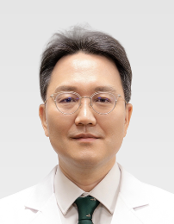 | Family Name (Last Name) | Kim
 | Given Name (First Name) | Han Su
 | Country | Republic of Korea
 | Position / Department | Professor / Otorhinolaryngology Head & Neck Surgery
 | Institute / Organization | Ewha Womans University College of Medicine
Education Background | 1991.03. – 1997.02: College of Medicine, Yonsei University, Seoul, Korea (M.D.)2001.09. – 2003.08: Graduate School, Yonsei University, Seoul, Korea (M.S.)2004.09. – 2007.02.: Graduate School, Yonsei University, Seoul, Korea (Ph.D.)
Professional Career | <Postdoctoral Trainings & Experiences> Mar. 1997 - Feb.1998: Internship in Severance Hospital, College of Medicine, Yonsei University, Seoul, KoreaMar. 1998 - Feb. 2002: Residency in the Dept. of Otolaryngology-HNS, Severance Hospital, College of Medicine, Yonsei University, Seoul, KoreaMar. 2002 - Feb. 2004: Fellowship in the Subdivision of Head & Neck Surgery, Laryngology, Yongdong Severance Hospital, Seoul, KoreaMar. 2004 - Present: Assistant, Associated & Full Professor in the Dept. of Otolaryngology-HNS, School of Medicine, Ewha Womans University, Seoul, Korea Jan. 2019 – Present: Chairperson in the Dept. of Otolaryngology-HNS, School of Medicine, Ewha Womans University, Seoul, Korea <Professional Experiences>Jan. 2003: Visiting Fellowship in the Dept. of Otolaryngology-HNS, College of Medicine, Kumamoto University, Kumamoto, JapanFeb. 2003: Visiting Fellowship in Noguchi thyroid clinic, Beppu, JapanFeb. 2004: Visiting Fellowship in Dept. of Otolaryngology-HNS, College of Medicine, Goettingen University: Laser surgery courseAug. 2013- Aug 2014: Visiting Fellowship in WFIRM (Wake Forest University Institute for Regenerative Medicine), Winston-Salem, NC, USA
Research Field | tissue engineering and regenerative medicine: tracheal regeneration and tonsil-derived mesenchymal stem cells / Laryngology
Presentation Topic | Laryngeal Framework Surgery in the Era of Injection and Office-Based Phonosurgery: When, Why, and How
Abstract | The management of glottic insufficiency has undergone a profound transformation with the widespread adoption of injection laryngoplasty and the rapid evolution of office-based phonosurgical procedures. These developments have reshaped clinical practice by enabling earlier intervention with reduced invasiveness and greater flexibility in patient care. In this changing landscape, the role of laryngeal framework surgery is often reconsidered. Nevertheless, it continues to represent a fundamental and irreplaceable modality for achieving stable, precise, and durable structural correction in selected patients.This invited lecture provides a comprehensive overview of the contemporary role of laryngeal framework surgery within the modern phonosurgical paradigm. Rather than focusing on a single technique, the presentation will revisit the conceptual foundations of framework surgery and examine how its indications, timing, and technical execution have evolved in relation to injectable and office-based approaches. Emphasis will be placed on indication-driven decision making and on the integration of framework procedures into a stepwise treatment algorithm for various types of glottic insufficiency, including unilateral vocal fold paralysis, vocal fold atrophy, sulcus vocalis, and complex or revision cases.Current perspectives on medialization thyroplasty and arytenoid adduction will be discussed in terms of patient selection, functional goals, and the achievement of optimal vocal outcomes. Practical considerations for enhancing surgical precision—such as intraoperative voice monitoring, control of the medialization vector, implant selection, and anesthesia strategies—will be addressed based on accumulated clinical experience. In addition, the analysis of unsatisfactory results and the principles of revision framework surgery will be presented as an essential component of contemporary voice surgery.Finally, future directions will be explored in the context of precision phonosurgery, including individualized surgical planning, advanced imaging, and the potential application of patient-specific implants.By re-examining its role from a modern, integrative perspective, this lecture will demonstrate that laryngeal framework surgery is not a competing alternative to injection techniques, but a complementary and indispensable pillar in the comprehensive management of voice disorders.

Symposium (S05), Thyroplasty
S05_S2
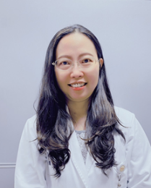 | Family Name (Last Name) | Hsieh
 | Given Name (First Name) | Li-Chun
 | Country | Taiwan
 | Position / Department | 1. Director, Division of Laryngology and Pediatric Otolaryngology, Department of Otolaryngology – Head and Neck Surgery 2. Professor, Department of Audiology and Speech Language pathology
 | Institute / Organization | 1. MacKay memorial hospital 2. MacKay medical university
Education Background | 2004 M.D. National Yang Ming University, Taipei, Taiwan 2015 Ph.D. Institute of Brain Science, School of Medicine, National Yang-Ming University, Taipei, Taiwan
Professional Career | 2009.07~ Attending physician, Mackay Memorial hospital2016.05 Assistant professor, Mackay Medical College2019.08~ 5th ,6th ,7th Director of Taiwan voice society 2020.02 Associate Professor, Mackay Medical College2021.07~ 1st & 2nd Director of Taiwan Society of Pediatric Otorhinolaryngology2023.08~ Professor, Mackay Medical College
Research Field | Voice and swallowing disorders and rehabilitation, phono-surgery, thyroplasty
Presentation Topic | Our experiences of Type I thyroplasty with adjustable implant
Abstract | Unilateral vocal fold paralysis (UVFP) may result in incomplete glottal closure, leading to varying degrees of voice, swallowing, and breathing impairment. While voice therapy and injection laryngoplasty with resorbable materials are commonly used during the acute and intermediate phases, type I thyroplasty remains a well-established surgical option for patients with permanent UVFP.Although type I thyroplasty provides durable vocal improvement, revision surgery may occasionally be required because of suboptimal window position, inappropriate implant size or position, persistent posterior glottal gap, implant migration, or progressive laryngeal muscle atrophy. An ideal laryngeal implant should therefore offer three key characteristics: biocompatibility, adjustability, and reversibility.The VOIS implant provides the unique advantage of both intraoperative and postoperative adjustability. Intraoperative adjustment allows the degree of medialization to be tailored to individual laryngeal anatomy and voice outcomes. More importantly, postoperative adjustment enables further optimization of medialization in response to progressive anatomical or functional changes after surgery.In this presentation, I will share our clinical experience with type I thyroplasty using the VOIS implant, with particular emphasis on practical surgical techniques, implant adjustment, and long-term voice outcomes. Important surgical considerations include creating the thyroplasty window parallel to the inferior border of the thyroid lamina and positioning it as low as possible. Based on our experience, the adjustability of the VOIS implant facilitates individualized vocal fold medialization and provides additional flexibility for postoperative optimization. Favorable long-term voice outcomes have been observed, supporting the VOIS implant as a versatile option for the surgical management of UVFP.

Symposium (S05), Thyroplasty
S05_S3
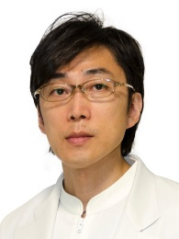 | Family Name (Last Name) | Matsushima
 | Given Name (First Name) | Koji
 | Country | Japan
 | Position / Department | Associate professor
 | Institute / Organization | Toho University
Education Background | Graduated from Toho University in 2000.
Professional Career | Isshiki Clinic 2009-2010
Research Field | Laryngology
Presentation Topic | The Evolving Laryngeal Framework Surgery of Dr. Isshiki
Abstract | Laryngeal framework surgery involves surgically manipulating the laryngeal framework cartilage according to the underlying pathology, thereby altering the position and tension of the vocal folds within it and improving symptoms. There are three main causes of voice deterioration due to recurrent laryngeal nerve paralysis: lateral deviation and bowing of the vocal fold, and insufficient fixation of the arytenoid cartilage. For this condition, arytenoid adduction is performed to move and fix the vocal fold in the midline, and type I thyroplasty is used to increase the vibrating portion of the vocal fold. By combining these two laryngeal framework surgeries, the paralyzed vocal fold can be brought closer to its physiological state during phonation. At the time when Dr. Isshiki first devised the technique, identification of the arytenoid cartilage and determination of the fenestration position in the thyroid cartilage were performed based on anatomical landmarks. Subsequently, advancements in diagnostic imaging technology, particularly in CT scans, have made it possible to accurately assess individual differences in the positional relationship between the framework cartilage and the vocal folds. I have devised a modified laryngeal framework surgery technique using imaging diagnostic technology, enabling minimally invasive and effective procedures.There is still no implant approved for use in type I thyroplasty under Japan’s national health insurance system. To solve this problem, we have been developing and conducting clinical research on implants using titanium, a material with high biocompatibility. Currently, investigator-initiated clinical trial is being conducted with support from the Japan Agency for Medical Research and Development (AMED) to obtain approval for use under Japan’s national health insurance system.In this symposium, we will report the outcomes of the laryngeal framework surgeries we are currently performing and introduce the newly developed 『Type I Thyroplasty Implant System』.

Symposium (S06), Laryngopharyngeal reflux (LPR)
S06_S1
 | Family Name (Last Name) | Tseng
 | Given Name (First Name) | Wen-Hsuan
 | Country | Taiwan
 | Position / Department | Assistant professorOtolaryngology- Head & Neck Surgery
 | Institute / Organization | National Taiwan University Hospital
Education Background | MD, National Taiwan University College of MedicinePhD, Graduate Institute of Clinical Medicine, National Taiwan University
Professional Career | Attending physician, Department of Otolaryngology, National Taiwan University HospitalVisiting scholar, Division of Otolaryngology-Head & Neck Surgery, Department of Surgery, University of Wisconsin- Madison, Madison, WisconsinDirector, Taiwan Association of DysphagiaSupervisor, Taiwan Voice SocietyMember, American Broncho-esophageal Association
Research Field | Laryngology, Voice science, Dysphagia
Presentation Topic | Taiwan Consensus of Laryngopharyngeal Reflux Disease- An Update on Definition, Diagnosis, and Management
Abstract | Laryngopharyngeal reflux disease (LPRD) is a heterogeneous condition characterized by chronic upper aerodigestive tract symptoms. Its diagnosis and management remain challenging because symptoms are nonspecific and often overlap with other otolaryngologic or functional disorders, causing substantial medical burden. To establish regionally relevant and interdisciplinary guidance, Taiwanese consensus was developed to standardize the definition, diagnostic evaluation, and management of LPRD. Using a modified Delphi process, 52 experts from otolaryngology, gastroenterology, and pediatrics participated in three rounds of anonymous voting supported by structured evidence reviews. Thirty-nine consensus statements addressing definition, epidemiology, pathophysiology, diagnostic criteria, treatment strategies, and special considerations were validated with ≥85% agreement. The consensus emphasizes that laryngopharyngeal symptoms alone are insufficient for diagnosis and highlights the importance of validated patient-reported outcome measures, laryngoscopy to exclude alternative diagnoses, and objective reflux testing when appropriate. Empiric proton pump inhibitor therapy is recommended primarily for patients with concomitant gastroesophageal reflux symptoms or high reflux probability, while objective reflux monitoring is advised for isolated or refractory laryngopharyngeal symptoms. The framework also recognizes the role of laryngeal hypersensitivity, hypervigilance, and multidisciplinary care. This Taiwanese consensus provides an evidence-informed framework intended to reduce diagnostic uncertainty, minimize unnecessary empiric therapy, and promote mechanism-directed, transdisciplinary management of LPRD.

Symposium (S06), Laryngopharyngeal reflux (LPR)
S06_S2
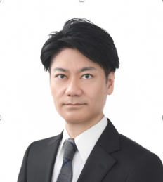 | Family Name (Last Name) | SUZUKI
 | Given Name (First Name) | TAKESHI
 | Country | Japan
 | Position / Department | Lecture / Otolaryngology, Head and Neck Surgery
 | Institute / Organization | Graduate School of Medicine, Chiba University
Education Background | MD, PhD, Chiba University, Japan
Professional Career | 2022-Present Lecture, 2012-2022 Assistant Professor, Chiba University, Japan2010-2012 Postdoc, University of Pittsburgh, USA2003-2010 Resident/Staff, Chiba University Hospital, Japan
Research Field | Laryngology, Head and Neck Surgery
Presentation Topic | Chronic Cough Associated with Laryngopharyngeal Reflux Disease: From Diagnosis with HMII to Optimal Treatment Strategies
Abstract | Laryngopharyngeal reflux disease (LPRD) is increasingly recognized as an important cause of chronic cough (CC), yet it remains underdiagnosed in routine clinical practice. Many patients are classified as having unexplained CC because conventional diagnostic approaches, including upper gastrointestinal endoscopy and standard esophageal pH monitoring, primarily assess distal esophageal reflux and often fail to detect reflux reaching the hypopharynx. Hypopharyngeal multichannel intraluminal impedance (HMII) is currently the most reliable tool for the direct detection of laryngopharyngeal reflux (LPR). In studies of Japanese patients with unexplained CC, HMII identified abnormal proximal exposure (APE) in 73% of cases. Importantly, approximately 65% of patients with APE had normal esophageal acid exposure times, and 41% of proximal reflux episodes were non-acidic in the distal esophagus. These findings explain why conventional pH-based testing frequently fails to diagnose CC associated with LPRD. The efficacy and limitations of optimal medical therapy were evaluated in patients with CC associated with LPRD. A three-month course of the potassium-competitive acid blocker (P-CAB) vonoprazan, a more potent acid suppressant than proton pump inhibitors (PPIs), achieved symptomatic improvement in 58% of patients, including many who had previously failed PPI therapy. However, symptom recurrence was common after treatment discontinuation, suggesting that, although P-CAB therapy represents the best available conservative treatment, durable symptom control may ultimately require elimination of reflux itself. For patients with persistent or recurrent symptoms, laparoscopic antireflux surgery (LARS) demonstrated excellent efficacy, with 93% of patients achieving significant symptomatic improvement. This symposium will review the pathophysiology of CC associated with LPRD, discuss the diagnostic advantages of HMII over conventional reflux testing, and present current evidence regarding medical and surgical treatment strategies. While P-CAB therapy is an appropriate first-line treatment, LARS offers excellent outcomes for patients with persistent or recurrent symptoms.

Symposium (S06), Laryngopharyngeal reflux (LPR)
S06_S3
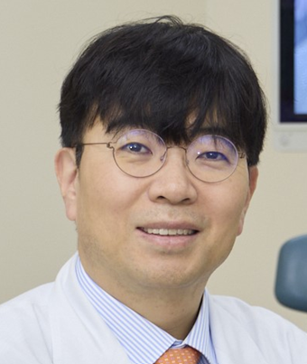 | Family Name (Last Name) | Yoon Se
 | Given Name (First Name) | Lee
 | Country | Republic of Korea
 | Position / Department | Professor / Otolaryngology-Head and Neck Surgery
 | Institute / Organization | Asan Medical Center / University of Ulsan College of Medicine
Education Background | Mar. 1994 to Feb. 2000 B.A. Medicine, University of Ulan, Seoul KoreaMar. 2004 to Feb. 2006 M.S. Otolaryngology, University of Ulsan, Seoul KoreaMar. 2006 to Aug. 2011 Ph.D. Otolaryngology, University of Ulsan, Seoul Korea
Professional Career | Apr. 2008 to Feb. 2009 Clinical fellow, Asan Medical Center, University of Ulsan, College of MedicineMar. 2009 to Feb. 2013 Clinical assistant professor, Pusan National University Yangsan HospitalMar. 2013 to Associate professor, professor, Asan Medical Center, University of Ulsan, College of Medicine
Research Field | Immunotherapy, robotic surgery, phonosurgery
Presentation Topic | Clinical Application of Potassium-Competitive Acid Blocker (P-CAB) in the Treatment of Laryngopharyngeal Reflux
Abstract | Laryngopharyngeal reflux disease (LPRD) is a common disorder encountered in otolaryngology practice, presenting with a wide spectrum of symptoms including chronic cough, globus sensation, throat clearing, dysphonia, and excessive throat mucus. Although proton pump inhibitors (PPIs) have long been considered the cornerstone of medical treatment, their therapeutic efficacy remains inconsistent, with many patients experiencing persistent symptoms despite adequate treatment. This limited response reflects the multifactorial nature of LPRD, including weakly acidic or non-acid reflux, pepsin-mediated mucosal injury, and functional laryngeal disorders, highlighting the need for more effective therapeutic strategies.Potassium-competitive acid blockers (P-CABs) represent a novel class of acid-suppressive agents that provide rapid, potent, and sustained inhibition of gastric acid secretion by reversibly blocking the H+,K+-ATPase. Compared with PPIs, P-CABs achieve a faster onset of action, more consistent intragastric pH control, superior nocturnal acid suppression, and minimal influence from CYP2C19 genetic polymorphisms. These pharmacologic advantages have translated into improved clinical outcomes in gastroesophageal reflux disease and raise the possibility of enhanced efficacy in selected patients with LPRD.This presentation reviews the evolving role of P-CABs in the management of LPRD by discussing their pharmacologic mechanisms, clinical rationale, and currently available evidence. Comparative data between PPIs and P-CABs, including recent studies of vonoprazan, tegoprazan, and fexuprazan, will be critically evaluated, with particular attention to symptom improvement, laryngoscopic findings, and safety profiles. In addition, the presentation will discuss practical indications for P-CAB therapy, current limitations of the evidence, and future perspectives for phenotype-directed management of LPRD. Integrating P-CABs into a comprehensive treatment strategy may offer new opportunities to optimize outcomes in patients with refractory or selected forms of laryngopharyngeal reflux.

Symposium (S07), Laryngeal electromyography (LEMG)
S07_S1
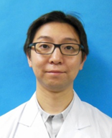 | Family Name (Last Name) | Konomi
 | Given Name (First Name) | Ujimoto
 | Country | JAPAN
 | Position / Department | Director/(Otolaryngology)
 | Institute / Organization | Voice and Dizziness Clinic Futakotamagawa Otolaryngology
Education Background | 2003 graduated from Tokyo Medical University (TMU), M.D. (No.437453)
Professional Career | 2011 Clinical assistant at the Dept. of Otolaryngology, TMU2011-2012 Research fellow at the Dept. of Otolaryngology, and Auditory laboratory, University of Toronto. (Prof. Robert V. Harrison)2014 Dispatch lecturer from the Dept. of Otolaryngology, TMU2016 Associate professor at the Tokyo Voice Center, International University of Health and Welfare (IUHW) Sanno Hospital2018-present Director of Voice and Dizziness Clinic Futakotamagawa Otolaryngology, Adjunct lecturer of the Dept. of Otolaryngology, TMU(Qualifications)2008 Board-certified Otorhinolaryngologist2011 Ph.D. (TMU) Thesis: Morphological change of the cupula due to an ototoxic agent: a comparison with semicircular canal pathology.2018 Councilor of The Japan society of Logopedics and Phoniatrics.2018 Delegate of Japan society of Equilibrium Research.2022 Board certificated fellow of the Japanese society of Sleep Research(Awards and disciplinary action)2017 Best paper award of Japan society of Equilibrium Research.
Research Field | Laryngology, phonosurgery, Equilibrium science, Sleep medicine, Otology
Presentation Topic | The potentiality of LEMG for dysphonia and Botulinum toxin injection treatment for Posterior cricoarytenoid muscle.
Abstract | Laryngeal electromyography (LEMG) was performed on patients with voice disorders had asymmetrical glottal disclosure. Botulinum toxin (BT) was injected to PCA on affected side in patients had abnormal contractions of posterior cricoarytenoid muscle (PCA) during phonation. This presentation will provide the features of BT injection effects for PCA.The first case was a 48-year-old woman. She developed oropharyngeal herpes 1.5 years ago and had repeated relapses every 2-3 months thereafter. She had an acute onset of hoarseness when herpes relapsed, and the patient finally visited our clinic with no improvement in her voice.Since, LEMG revealed that she was suspected of having left vocal fold (VF) paresis and being synkinesis in the PCA, BT injection into left PCA was performed. After injection, the movement of abduction was restricted and glottic disclosure was improved. Since, her compliance of voice therapy improved after BT injection, her improvement voice was maintained. The second case was 26-year-old female. 22 years prior (at age 4), she was diagnosed with VF paralysis after surgery for mitral valve regurgitation. The chief complaints were difficulty of producing loud voice and high note. Nevertheless, laryngeal endoscopy revealed poor mobility of left VF, LEMG showed contractions of adductor muscles on the affected side at the same level as the healthy side. Therefore, LEMG also showed abnormal PCA contraction during phonation, BT injection for the PCA was performed. Voice evaluations before and 4 months after injection showed obvious improvements in VHI-10, MPT, PQ, and vocal range, respectively. These improvements persisted even after 6 months.Possible effectiveness of BT injection into PCA was suggested in suspected patients with hypofunctional dysphonia, vocal fold palsy such as breathiness voice with endoscopic muscle tension dysphonia.

Symposium (S07), Laryngeal electromyography (LEMG)
S07_S2
 | Family Name (Last Name) | Jung
 | Given Name (First Name) | Soo Yeon
 | Country | Korea
 | Position / Department | Associate professor/ Otorhinolaryngology and Head & neck Surgery
 | Institute / Organization | Ewha Womans University
Education Background | B.A, College of Medicine, Ewha Womans University  M.D. Graduate school of Medicine, Ewha Womans University  Ph.D. Graduate school of Medicine, Ewha Womans University
Professional Career | Residency, Ewha Womans University Mok-dong hospital  Fellow, Ewha Womans University Mok-dong hospital  2024. 09 ~ 2025. 08 Visiting Professor, Stanford University  Associate professor, Ewha Womans University, College of Medicine
Research Field | Voice  Head and neck Oncology  Tissue engineering and regenerative medicine
Presentation Topic | The Role of Laryngeal EMG in Clinical Practice
Abstract | Laryngeal electromyography (LEMG) is a valuable but still underused tool in phonosurgery. It provides objective electrophysiological data that adds to what laryngostroboscopic and acoustic assessment alone can show about vocal fold pathology.  When managing vocal fold immobility, LEMG provides critical differentiation between neurogenic paralysis and mechanical fixation—such as cricoarytenoid joint ankylosis or arytenoid dislocation—directly informing whether medialization, reinnervation, or joint mobilization is the appropriate surgical path. This distinction is often difficult to establish by endoscopic examination alone, particularly in early postoperative or post-traumatic settings.  Its prognostic value, while widely cited, remains an area of active debate: patterns of fibrillation potentials, polyphasic reinnervation waveforms, and motor unit recruitment are used to predict recovery likelihood and timing, but reported predictive accuracy varies considerably across studies, depending on the timing of testing, technique standardization, and the confounding effect of synkinesis during reinnervation. Serial LEMG evaluation and comparison with stroboscopic findings over time are therefore recommended to improve reliability, rather than relying on a single measurement or subjective voice outcomes alone.  Recent advances include quantitative LEMG using turns-per-second analysis to objectify motor unit recruitment, electrical synkinesis testing to refine prognostic accuracy, and normative quantitative values derived from the contralateral mobile vocal fold in unilateral paralysis. Emerging modalities such as laryngeal magnetic stimulation, functional electrostimulation, and laryngeal pacing are extending LEMG's role from diagnosis toward individualized neuromodulation-based treatment.

Symposium (S07), Laryngeal electromyography (LEMG)
S07_S3
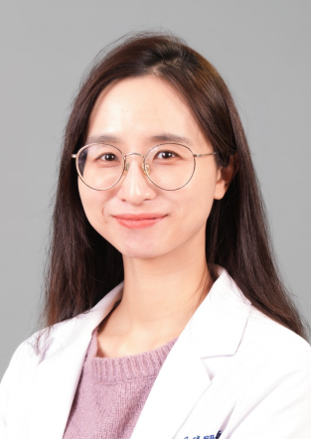 | Family Name (Last Name) | Hua
 | Given Name (First Name) | Man wei
 | Country | Taiwan
 | Position / Department | Otolaryngology-head and neck surgery
 | Institute / Organization | Taichung veterans general hospital
Education Background | School of Medicine, National Defense Medical Center
Professional Career | Attending Physician, Department of Otolaryngology-Head and Neck Surgery, Taichung Veterans General Hospital (2024/01–Present)
Research Field | Otolaryngology, Laryngology/ Rhinology
Presentation Topic | Longitudinal Laryngeal Electromyography for Unilateral Vocal Fold Paralysis
Abstract | Objective: To investigate the longitudinal electrophysiologic changes in patients with unilateral vocal fold paralysis (UVFP) using serial laryngeal electromyography (LEMG) and to elucidate their relationship with clinical functional recovery.Methods: A retrospective longitudinal study was conducted on 60 patients with UVFP who underwent at least two consecutive LEMG examinations. The primary outcomes measured were the longitudinal changes in the presence of fibrillation potentials (Fibs) and the motor unit recruitment reduction percentage (RR%) of the thyroarytenoid-lateral cricoarytenoid muscle complex between the first and second evaluations.Results: The median [IQR] duration from the onset of symptoms to the first LEMG was 81.5 [IQR: 50.5-141] days, while the interval to the second LEMG was 164.5 [IQR: 113.8-362.3] days. Between the two LEMG assessments, the presence of fibrillation potentials decreased significantly from 58.3% to 36.7% (p = 0.011). The median RR% remained stable and unchanged at 70% across both evaluations (p = 0.217). Three patients (5%) in the cohort achieved macroscopic recovery of vocal fold motion. Conclusion: While spontaneous denervation activity may diminish as a natural part of the degenerative process, the stability of recruitment deficits suggests that an initial, appropriately timed LEMG can reliably predict the prognosis of unilateral vocal fold paralysis for the subsequent half year. These findings support the practical value of early electrophysiologic assessment in guiding timely clinical interventions.

Symposium (S08), Voice Therapy
S08_S1
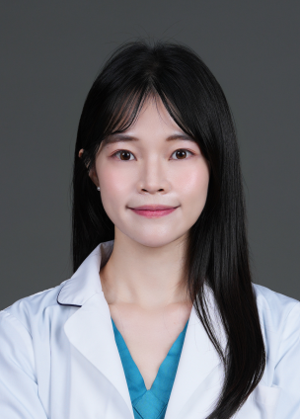 | Family Name (Last Name) | Qiu
 | Given Name (First Name) | Wei-Qian
 | Country | Taiwan
 | Position / Department | Speech-Language Pathologist/ Department of Otolaryngology Head & Neck
 | Institute / Organization | Taichung Veterans General Hospital
Education Background | Master’s Program in Speech-Language Pathology and Audiology, National Taipei University of Nursing and Health Sciences
Professional Career | Speech-Language Pathologist at Taichung Veterans General Hospital (2020-Present)
Research Field | Clinical Voice Assessment, Voice Disorders, Voice Therapy, Dysphagia in Head and Neck Cancer
Presentation Topic | From Voice Assessment to Clinical Decision-Making: Bridging Diagnostic Findings and Therapeutic Planning
Abstract | (Could be provided before June 15)

Symposium (S08), Voice therapy
S08_S2
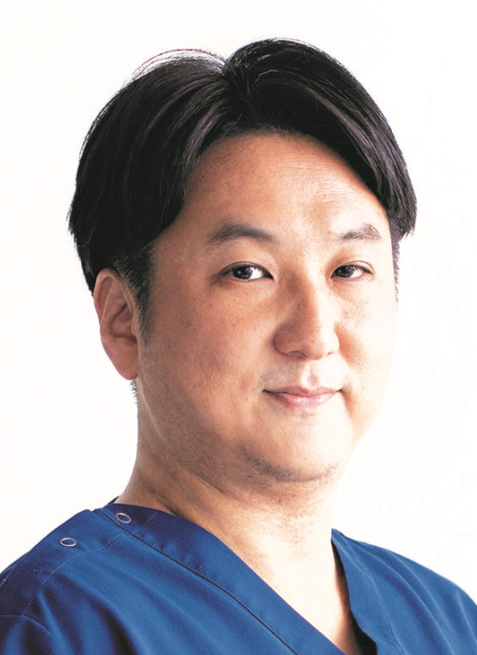 | Family Name (Last Name) | Suehiro
 | Given Name (First Name) | Atsushi
 | Country | Japan
 | Position / Department | Institute / Organization
 | Institute / Organization | Kyoto University
Education Background | 1999 M.D., Faculty of Medicine, Kyoto University, Japan 2010 Ph.D., Graduate School of Medicine, Kyoto University, Japan
Professional Career | Mar 2024–Present Associate Professor, Department of Otolaryngology–Head and Neck Surgery, Graduate School of Medicine, Kyoto University, Japan Dec 2020–Feb 2024 Lecturer, Department of Otolaryngology–Head and Neck Surgery, Graduate School of Medicine, Kyoto University, Japan April 2016–Nov 2020 Assistant Professor, Department of Otolaryngology–Head and Neck Surgery, Graduate School of Medicine, Kyoto University, Japan Apr 2014–Mar 2016 Senior Staff Physician (Chief), Department of Otolaryngology–Head and Neck Surgery, Kobe City Medical Center General Hospital, Japan Jun 2011–Mar 2014 Chief, Department of Otolaryngology–Head and Neck Surgery, Kusatsu General Hospital, Japan Jan 2009–Jun 2011 Research Fellow, Department of Otolaryngology, Vanderbilt University, USA Apr 2004–Mar 2006 Chief, Department of Otolaryngology, Ako City Hospital, Japan Jun 2000–Mar 2004 Staff Physician, Department of Otolaryngology–Head and Neck Surgery, Kurashiki Central Hospital, Japan May 1999–May 2000 Resident, Department of Otolaryngology, Kyoto University Hospital, Japan
Research Field | Laryngology
Presentation Topic | Integration of Voice Therapy and Phonosurgery
Abstract | Voice therapy is a behavioral intervention designed to improve voice quality by modifying inappropriate vocal habits and phonatory behaviors. It is particularly indicated for voice disorders caused by functional factors, such as maladaptive vocal techniques, regardless of the presence of organic vocal fold lesions. Voice therapy may be applied as a standalone treatment or in combination with pharmacological and surgical interventions.Voice therapy is broadly classified into indirect and direct approaches. Indirect therapy, or vocal hygiene education, aims to prevent vocal misuse and maintain optimal vocal fold mucosal health. Direct therapy involves active voice training that targets the physiological processes of voice production, including respiration, phonation, and resonance, to correct functional abnormalities and optimize vocal dynamics.Among various techniques, semi-occluded vocal tract exercises (SOVTE) have gained increasing evidence for their efficacy. These exercises involve phonation through a partially constricted and extended vocal tract, promoting efficient expiratory airflow. During SOVTE, the pharyngeal cavity expands, the larynx descends, and the glottis remains slightly open. Clinical studies have demonstrated improvements in vocal function in patients with voice disorders, as well as in healthy individuals and professional voice users.The primary goal of voice training is to achieve adequate vocal output while minimizing the risk of vocal fold injury. Experimental studies using excised canine larynges suggest that an optimal glottal configuration corresponds to a slightly abducted position with an interarytenoid distance of approximately 0.6 mm, which is approximated by SOVTE. When abnormalities in vocal fold viscoelastic properties are present, additional adjustments in pitch, airflow, and resonance are required. These factors can be evaluated using laryngeal endoscopy, videostroboscopy, and aerodynamic assessment.(Could be provided before June 15)

Symposium (S08), Voice therapy
S08_S3
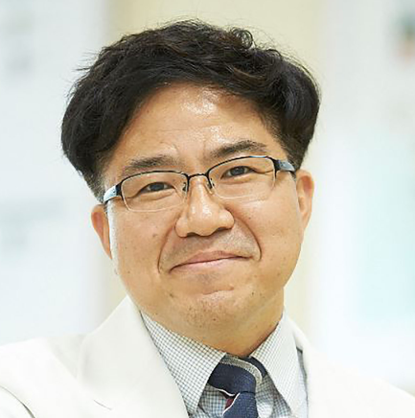 | Family Name (Last Name) | Choi
 | Given Name (First Name) | Jeong-Seok
 | Country | Korea
 | Position / Department | Professor/Department of Otorhinolaryngology
 | Institute / Organization | Inha University College of Medicine
Education Background | March 1996 – February 2002: College of Medicine, Inha University, Incheon, KoreaMarch 2005 – August 2006: Master’s degree course in the department of Otorhinolaryngology, The Graduate School, Inha University, Incheon, KoreaSeptember 2006– August 2011: Ph.D in the department of Otorhinolaryngology, The Graduate School, Inha University, Incheon, Korea
Professional Career | 2010 ~ 2011: Clinical Fellow in Department of Otorhinolaryngology, Inha University College of Medicine, Incheon, Korea 2012 ~ 2013: Clinical Lecturer in Department of Otorhinolaryngology, Inha University College of Medicine, Incheon, Korea2014: Clinical Assistant Professor in Department of Otorhinolaryngology, Inha University College of Medicine, Incheon, Korea2015 ~ 2017: Assistant Professor in Department of Otorhinolaryngology, Inha University School of Medicine, Incheon, Korea 2018 ~ 2022: Associate Professor in Department of Otorhinolaryngology, Inha University School of Medicine, Incheon, Korea2023 ~ : Professor in Department of Otorhinolaryngology, Inha University School of Medicine, Incheon, KoreaSeptember 2018– August 2019: Visiting scholar in Department of Biostatistics and Bioinformatics, Department of Otorhinolaryngology, Duke University, NC, USA
Research Field | Aerospace Medicine, Medical Informatics, Translational Medicine
Presentation Topic | Contemporary Approaches to Voice Therapy in Clinical Settings
Abstract | The landscape of voice therapy has evolved significantly, moving beyond traditional vocal exercises toward an integrated, multidimensional approach. As our understanding of laryngeal physiology and neuroplasticity deepens, clinical interventions must adapt to encompass both the physiological and psychological aspects of vocal disorders. This presentation explores the current paradigms in vocal rehabilitation, emphasizing evidence-based practices that bridge the gap between clinical research and bedside application. Key contemporary methodologies discussed include physiological voice therapy programs such as Resonant Voice Therapy (RVT) and Vocal Function Exercises (VFE) alongside the integration of digital health technologies. The role of biofeedback, including real-time acoustic and aerodynamic monitoring, is examined as a tool to enhance patient self-awareness and treatment efficacy. Furthermore, the shift toward patient-centered care is highlighted, focusing on the importance of tailoring therapy to the individual's vocal demands and lifestyle. The discussion will also address the challenges of maintaining treatment compliance in a clinical setting and the emerging role of tele-practice in expanding access to specialized care.Contemporary voice therapy is no longer a one-size-fits-all model but a precision-based discipline. By synthesizing traditional techniques with modern technological advancements and personalized strategies, clinicians can significantly improve functional outcomes and the overall quality of life for patients with voice disorders.

Symposium (S09), Voice and Gender
S09_S1
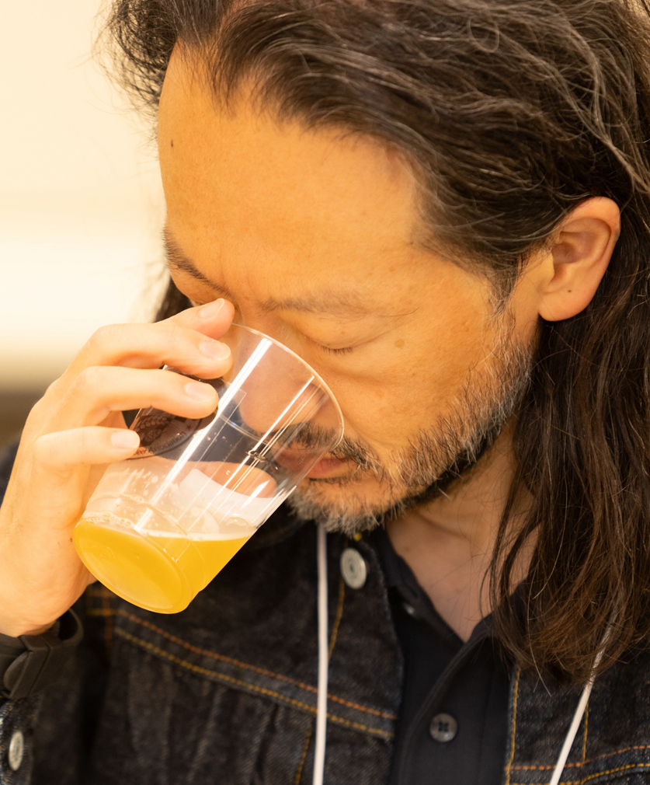 | Family Name (Last Name) | Nakamura
 | Given Name (First Name) | Kazuhiro
 | Country | JAPAN
 | Position / Department | Associate professor
 | Institute / Organization | Nihon university school of medicine
Education Background | Tokyo Medical University
Professional Career | Research Field
Research Field | Laryngology & Phonosu rgery
Presentation Topic | Phonosurgery can change the voice of transgender to experienced gender
Abstract | Among the patients with gender incongruence（GI）, female to male(FTM) can get low-pitched voice by male hormone treatment, but male to female(MTF) cannot get high-pitched voice by female hormone treatment.Therefore, MTF feel difficulties in passing as female due to their low-pitched voice.Our phono-surgery can raise the voice of MTF.There are three methods of surgery to raise the voice.The first is surgery to increase the tension of the vocal cords.The second is surgery to narrow the vocal cords.The third is surgery to shorten the vocal cords.Surgery to increase vocal cord tension is called thyroplasty type 4 (TP4).The TP4 is performed as the first choice treatment.TP4 was devised by Dr. Nobuhiko Isshiki, and it was published in 1974 in the textbook titled Laryngeal Framework Surgery.In TP4, traction sutures are placed on the cricoid cartilage to approximate to the thyroid cartilage.To increase the tension in the anterior-posterior diameter of the vocal cords and raising the voice.This mechanism is the most physiologically effective way of raising the voice among the three methods mentioned above.TP4 is performed under local anesthesia.The strap muscles are divided in the midline and accessed to the thyroid cartilage and cricoid cartilage.Four 2-0 nylon sutures are used for traction.The sutures are passed from the lower edge of the cricoid cartilage to the cricothyroid membrane, and then to the thyroid cartilage.The traction sutures are tied while monitoring the voice to raise high-pitched level.The postoperative pitch decrease in general, it need to slightly high-pitched level. This presentation will describe the pre- and postoperative vocal findings and details of the surgical procedure for TP4.

Symposium (S09), Voice and Gender
S09_S2
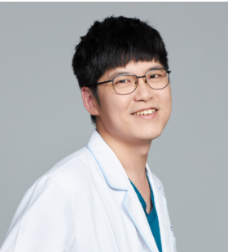 | Family Name (Last Name) | Lin
 | Given Name (First Name) | Feng-Chuan
 | Country | Taiwan
 | Position / Department | Department of Otolaryngology
 | Institute / Organization | Far Eastern Memorial Hospital
Education Background | M.A., Communication Disorders, Taipei Municipal University of Education (now University of Taipei)
Professional Career | ● Senior Speech-Language Pathologist, Department of Otolaryngology, Far Eastern Memorial Hospital   Adjunct Assistant Professor-level Professional Technical Personnel, Department of Audiology and Speech-Language Pathology, Asia University   President, New Taipei City Speech-Language Pathologists Association   Standing Director, Taiwan Speech Language Pathologist Union   Supervisor, Taiwan Voice Society   Director, The Speech-Language-Hearing Association of Taiwan   Editor-in-Chief, TSLHA Newsletter   Founding President, New Taipei City Speech-Language Pathologists Association   Speech-Language Pathologist, Department of Rehabilitation, Far Eastern Memorial Hospital
Research Field | ● Voice Disorders and Voice Rehabilitation   Phonation Training and Vocal Health Promotion   Speech and Communication Rehabilitation
Presentation Topic | The Role of Perioperative Voice Therapy for Patients Undergoing Gender-Affirming Phonosurgery
Abstract | Gender-affirming phonosurgery is an effective intervention for modifying vocal pitch and improving voice-related outcomes in transgender and gender-diverse individuals. However, successful surgical outcomes do not always translate into satisfactory functional voice outcomes. Some patients continue to use preexisting speaking patterns despite anatomical changes achieved through surgery, resulting in a mismatch between vocal capability and everyday voice use. This highlights the importance of perioperative voice therapy as an integral component of comprehensive gender-affirming voice care.  This presentation explores the role of voice therapy across the perioperative continuum, including preoperative assessment, early postoperative management, voice reactivation, functional voice training, and generalization to daily communication. Before surgery, voice therapy focuses on establishing baseline voice measures, identifying patient-centered goals, and setting realistic expectations. Following surgery, therapy supports healing, monitors vocal readiness, and facilitates a gradual return to phonation. As patients begin using their modified vocal mechanism, therapy targets efficient voice production, reduction of excessive vocal effort, and development of new speaking patterns that align with individual communication goals.  Beyond pitch modification, intervention may address resonance, voice quality, loudness, intonation, speech patterns, and communication behaviors that contribute to overall gender perception. A clinical decision-making framework is proposed, emphasizing collaboration between surgeons and speech-language pathologists to guide individualized treatment planning. The framework includes five key stages: Assess, Protect, Reactivate, Retrain, and Generalize.  The central premise of this presentation is that surgery changes vocal anatomy, whereas voice therapy helps patients effectively use that new anatomy in real-world communication. Ultimately, the goal of perioperative voice therapy is not merely to increase fundamental frequency, but to help individuals develop a voice that is functional, comfortable, natural, and personally meaningful.

Symposium (S09), Voice and Gender
S09_S3
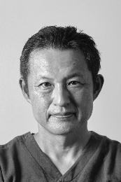 | Family Name (Last Name) | Hiroshiba
 | Given Name (First Name) | Shinya
 | Country | Japan
 | Position / Department | President
 | Institute / Organization | Kyoto ENT Voice Surgicenter
Education Background | Graduated from Kyoto Univ. Facluty of Medicine on 1994
Professional Career | Kyoto Univ. Hospital, Osaka Red-cross Hospital
Research Field | Laryngology
Presentation Topic | Comparison of Cricothyroid Approximation and Wendler Glottoplasty in Voice Feminization Surgery
Abstract | Introduction：  Cricothyroid approximation (CTA) and Wendler glottoplasty are widely used procedures for voice feminization surgery. However, direct comparisons of their clinical outcomes remain limited. This study compared postoperative pitch elevation, voice-related quality of life, and patient satisfaction between the two procedures.  Materials & Methods：  A retrospective review was conducted of transgender women who underwent voice feminization surgery at our institution. The study included 140 patients treated with CTA and 86 patients treated with Wendler glottoplasty. Fundamental frequency (F0), Voice Handicap Index-10 (VHI-10), and patient satisfaction scores were evaluated. The primary outcome was the change in fundamental frequency (ΔF0) between preoperative and postoperative assessments. Patient satisfaction was graded on a four-point scale (1 = very satisfied, 4 = dissatisfied).  Results：  The mean preoperative F0 was 143.7 Hz in the CTA group and 153.3 Hz in the Wendler group. Postoperative F0 was significantly higher in the CTA group (238.9 Hz) than in the Wendler group (206.4 Hz). Mean ΔF0 was 91.6 Hz for CTA and 53.1 Hz for Wendler (p < 0.001). Despite the greater pitch elevation achieved with CTA, overall patient satisfaction did not differ significantly between groups. The proportion of highly satisfied patients (score 1) was higher in the CTA group (34.9%) than in the Wendler group (20.0%). Regression analysis suggested that patient satisfaction was more strongly associated with ΔF0 and VHI-10 scores than with the surgical procedure itself.  Conclusion(OA)：  CTA produced significantly greater pitch elevation than Wendler glottoplasty. However, patient satisfaction was not determined solely by postoperative pitch elevation. These findings suggest that factors beyond F0, including perceived voice quality, may contribute to successful voice feminization.

Symposium (S10), Unilateral vocal fold paralysis
S10_S1
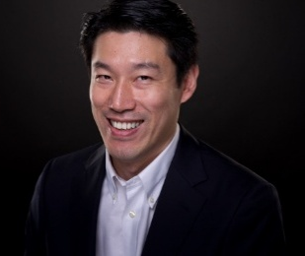 | Family Name (Last Name) | Ho
 | Given Name (First Name) | Guan-Min
 | Country | Taiwan
 | Position / Department | Attending Physician/Otorhinolaryngology
 | Institute / Organization | Yomin Otorhinolaryngolgoy Clinic / Mackay Memorial Hospital
Education Background | Medical University of Vienna, MD, PhD
Professional Career | Attending physician at Yomin Otorhinolaryngolgy Clinic, New Taipei CityAttending physician at Mackay Memorial Hospital, Taipei CityAssistant Prof. at National University of Taipei Nursing and Health SciencesResearch Fellow and Tutor at Institute for General and Experimental Pathology, General Hospital Vienna, Medical University of Vienna
Research Field | Laryngology, hearing, murine bone marrow cell culture, osteoporosis, design of medical devices
Presentation Topic | Medialization Thyroplasty With The Innovative VOIS-Implant – From Concep to Realization
Abstract | Unilateral vocal fold paralysis (UVFP) occurs after damage to the vagal- or recurrent laryngeal nerve and may result in decreased laryngeal function with incomplete glottal closure. Consequently, dysphonia or dysphagia may occur, severely impairing quality of life of those affected. Medialization thyroplasty is a surgical technique with a history of more than 100 years. In 1974 Prof. Isshiki modified and popularized this phonosurgical procedure by shaping silastic blocks intraoperatively and named it the “type I thyroplasty”. However, it is associated with steep learning-curve. Since then alternative implants such as hydroxyapatite implants, polytetrafluoroethylene (Gore-Tex) stripes, or preformed implants like titanium vocal fold medialization implant (TVFMI) and Montgomery silicone blocks were introduced. Crucial to the surgical outcomes with these implants are proper positioning, selection of the best-fit size and fixation. Incorrect positioning, an improperly sized or inadequately fixated implant can lead to insufficient medialization, granuloma formation due to erosion of the overlying mucosa, implant extrusion and thus impair the improvement of voice quality, requiring revision .surgeries. To address these issues, high-precision VOIS-Implant was developed to preserve long-term vocal functionality.

Symposium (S10), Unilateral vocal fold paralysis
S10_S2
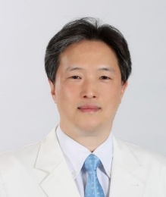 | Family Name (Last Name) | KWON
 | Given Name (First Name) | TACK-KYUN
 | Country | REPUBLIC OF KOREA
 | Position / Department | PROFESSOR IN DEPARTMENT OF ORL-HNS
 | Institute / Organization | SEOUL NATIONAL UNIVERSITY
Education Background | Feb. 1994 : M.D., SNU College of Medicine, Seoul, KoreaFeb. 2003 : M.S, SNU Postgraduate School, Seoul, KoreaMar. 2006 : PhD, SNU Postgraduate School, Seoul, Korea Dec. 2013: MAS. on ”Clinical Research” at UCSD, Postgraduate School, CA, USA
Professional Career | May. 2002 - June. 2003 : Clinical & Research Fellow,SNU Hospital, Seoul, KoreaJuly 2003 – June 2004: Instructor and Fellow of Voice, UPMC, Pittsburgh, USAMarch 2005 - : Professor in Department of Otolaryngology SNU, Seoul, Korea
Research Field | Laryngology, Professional Voice
Presentation Topic | Arytenoid Surgery for Unilateral Vocal Fold Paralysis
Abstract | Unilateral vocal fold paralysis (UVFP) often causes glottic insufficiency, resulting in dysphonia, vocal fatigue, and aspiration. Although medialization thyroplasty effectively improves glottic closure, it may be insufficient in patients with a significant posterior glottic gap, vertical level difference, or unfavorable arytenoid position. In such cases, arytenoid surgery plays an important role in restoring more physiologic vocal fold position and glottic competence.Arytenoid adduction repositions the arytenoid cartilage by reproducing the action of the lateral cricoarytenoid muscle. Rotation and medialization of the vocal process can reduce the posterior glottic gap and correct vertical mismatch. The procedure may be performed alone but is often combined with medialization thyroplasty to address both posterior and membranous glottic insufficiency.Successful arytenoid surgery requires careful patient selection, precise understanding of laryngeal framework anatomy, and appropriate control of the direction and degree of arytenoid rotation. Intraoperative assessment of voice and glottic configuration is essential to avoid overcorrection and optimize phonatory outcomes.This presentation will review the rationale, indications, surgical techniques, technical modifications, and pitfalls of arytenoid surgery, with particular emphasis on arytenoid adduction and its integration with medialization thyroplasty.

Symposium (S10), Unilateral vocal fold paralysis
S10_S3
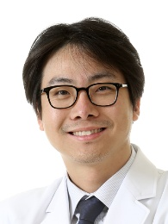 | Family Name (Last Name) | Cha
 | Given Name (First Name) | Wonjae
 | Country | Republic of Korea
 | Position / Department | Professor/Department of Otorhinolaryngology-Head and Neck Surgery
 | Institute / Organization | Seoul National University Bundang Hospital
Education Background | 1997-2003 M.D. degree from Seoul Nat’l Univ. College of Medicine, Korea2006-2012 Master’s degree from Seoul Nat’l Univ. College of Medicine, Korea2013-2015 PhD from Seoul Nat’l Univ. College of Medicine, Korea
Professional Career | 2003.3-2004.2 Internship at Seoul Nat’l University Hospital (SNUH)2004.3-2008.2 Residency of Department of Otorhinolaryngology-Head and Neck Surgery (ORL-HNS) at SNUH2011.5-2012.12 Fellowship of Department of ORL-HNS at SNUH 2012.12~2013.9 Assistant Professor, Department of ORL-HNS, SNUH2013.9~2020.2 Assistant Professor, Department of ORL-HNS, PNUH2020.3~ 2020.8 Associate Professor, Department of ORL-HNS, Seoul Nat’l Univ. Bundang Hospital (SNUBH)2024.9~ Clinical Professor, Seoul Nat’l Univ. College of Medicine2025.9~ Professor, Department of ORL-HNS, SNUBH
Research Field | Head and Neck Cancer, Thyroid Cancer, Laryngology
Presentation Topic | Real-time light-guided vocal fold injection (RL-VFI)
Abstract | Abstract (up to 300 words)

Workshop (WS01), Transgender (SLP)
WS01_LP1
 | Family Name (Last Name) | Fu
 | Given Name (First Name) | Sherry
 | Country | Taiwan
 | Position / Department | Speech-Language Pathologist
 | Institute / Organization | Taipei American School
Education Background | University of Queensland – PhD in Speech-Language PathologyUniversity of Queensland – Master of Speech Pathology Studies
Professional Career | Associate Professor – Macky Medical University (Part-time)Speech-Language Pathologist – Taipei Veterans General Hospital, Department of OtorhinolaryngologyPresident/Board of Directors – Taiwan Association of Resource Integration in Medical Care Board of Directors – Taiwan Voice Society; Speech-Language-Hearing Association of TaiwanManaging Supervisor – Taipei Speech-Language Pathology Union
Research Field | Voice disorders, Dysphagia
Presentation Topic | Overview of the Current Clinical Landscape of Transgender Voice Services in Taiwan
Abstract | In recent years, the number of transgender and gender-diverse individuals seeking voice-related services in Taiwan has gradually increased. These services are currently provided primarily by hospital-based otolaryngology departments, speech-language pathology units, and professionals with experience in gender-affirming care. Intervention typically addresses multiple aspects of voice and communication, including pitch, resonance, intonation, vocal quality, and communication style, with each individual’s gender identity and real-life communication needs serving as the central focus.At present, several challenges remain, including the concentration of professional resources in limited areas, restricted access to services, and the absence of locally developed standards for assessment and intervention. Although Taiwan has introduced reimbursement for certain forms of telemedicine, telepractice for transgender voice therapy has not yet been widely covered by the National Health Insurance system.In response to advances in digital technology and changes in lifestyle, further consideration should be given to the development of telepractice service models, quality standards, and reimbursement mechanisms for transgender voice therapy. Such efforts may improve the accessibility, continuity, and overall quality of care.

Workshop (WS01), Transgender (SLP)
WS01_LP2
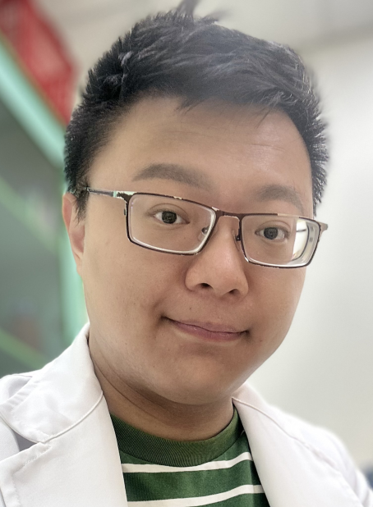 | Family Name (Last Name) | Chou
 | Given Name (First Name) | Jasan
 | Country | Taiwan
 | Position / Department | SLP
 | Institute / Organization | Gongguan Clinic
Education Background | Chung Shan Medical University Bachelor of Science
Professional Career | Speech Language Pathology
Research Field | Acoustic Phonetic
Presentation Topic | Feasibility and Acoustic Analysis of Transgender Voice Training Interventions: Outcomes From a 10-Session VCMtF Program
Abstract | This study evaluates the clinical efficacy of a systematized transgender voice affirmation program, integrating Vocal Function Exercises (VFE) and Resonant Voice Therapy (RVT), in optimizing social communication characteristics. Eight transgender women completed a 10-session intervention. Utilizing the Computerized Speech Lab (CSL), the research team recorded sustained vowels, running speech, and glide tasks to precisely extract and quantify the fundamental frequency (F0) the first two formants (F1, F2), and Cepstral Peak Prominence-Smoothed (CPPS).Acoustic analysis revealed a significant post-intervention increase in F0, confirming the feminized adaptation of cricothyroid modulation and vocal fold vibratory patterns. Concurrently, F1 and F2 exhibited anticipated upward shifts, physically demonstrating the forward resonance shaped by shortening the apparent vocal tract length. Regarding voice quality stability, CPPS extracted from running speech showed statistically significant post-intervention growth. This global filtering metric, grounded in the cepstral domain, demonstrates high objective predictive power in evaluating voice quality integrity, noise tolerance, and aerodynamic coordination during natural dialogue. Furthermore, CPPS provides a highly stable and clinically robust basis for voice quality affirmation in dynamic contexts, successfully overcoming the fundamental frequency tracking limitations commonly associated with time-domain perturbation metrics such as Jitter and Shimmer. These findings contribute quantitative evidence, distinguished by scientific precision and biofeedback utility, to advance speech science and prospective speech-language pathology practices.Keywords: Transgender women, fundamental frequency (F0), formants (F1, F2), Cepstral Peak Prominence-Smoothed (CPPS), speech-language pathology

Workshop (WS02), Laryngeal massage (SLP)
WS02_S1
 | Family Name (Last Name) | Ouyoung
 | Given Name (First Name) | Laishyang(Melody)
 | Country | USA
 | Position / Department | Speech Manager at Speech Pathology Department
 | Institute / Organization | Keck Medical Center of USC
Education Background | Doctor of Education at USC, Master of Science in Speech Pathology
Professional Career | Speech Manager of the Speech Pathology Department at Keck Medical Center of USC
Research Field | Head and Neck Cancer, dysphagia, and dysphonia
Presentation Topic | Laryngeal Manipulation in the management of Dysphonia
Abstract | Voice treatment outcomes are shown to be positive for vocal disorders of various etiologies. Many of the same techniques for voice therapy can be applied across diverse patients resulting in improved vocal quality as measured by hoarseness, breath control, and pitch range. Creating an effective voice treatment program to treat a variety of dysphonia is a big challenge for speech-language pathologists. Laryngeal Manipulation (LM) (Madill, 2022, Mathieson et al, 2009, Roy et al, 1997) was widely used to treat Muscle Tension Dysphonia (MTD). The purpose of this workshop is to review the literature of laryngeal manipulation and the effect of using LM on vibration, laryngeal muscles, and pitch. The specific population can benefit from using this technique and will be reviewed. The speech pathologist will explain which population can benefit from this technique and demonstrate this unique approach. A variety of dysphonia cases such as Muscle Tension Dysphonia (MTD), Spastic dysphonia (SD), Vocal Cord Dysphonia (VCD), and Unilateral Vocal Ford Paralysis Dysphonia will be presented and discussed. The speech pathologist will demonstrate laryngeal manipulation on one of the volunteers. The audience will have the chance to practice this unique technique with each other. Three learner OutcomesUnderstanding about laryngeal manipulation, the rationality of this technique and targeted population Learning the impact of laryngeal manipulation on voice-vibration, laryngeal muscles and pitchApplying LM in a variety of dysphonia patients-hands on practice-step by stepEducational/Gap/NeedsVery few speech pathologists are familiar with this unique approach and will welcome this learning opportunity to apply to a variety of dysphonia clients with improved clinical outcomes. Format & structureCase-based discussion and hands on-simulationTarget Audience-Resident/junior/specialist/multidisciplinary team members Speaker: Dr. Laishyang (Melody) OuyoungTimeline: 0-10 minutes: Introduction10-40 minutes: case presentation40-60 minutes: hands-on and Q&A

Workshop (WS03), The YUBA Method
WS03_S1
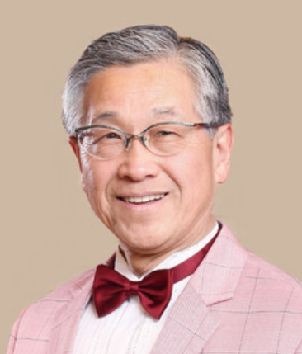 | Family Name (Last Name) | Yuba
 | Given Name (First Name) | Toru
 | Country | Japan
 | Position / Department | Professor Emeritus
 | Institute / Organization | Mie University
Education Background | Tokyo University of the Arts (as a scholarship student)
Professional Career | Toru Yuba, PhD (Kaoru Iwanaga) Operatic Tenor & Voice Researcher Founder and Director, The YUBA Method™ Institute Professor Emeritus, Mie UniversityFormer Appointments:・Visiting Professor | Teachers College, Columbia University (2001)・Visiting Researcher | Faculty of Medicine, The University of Tokyo (2002–2008)・Visiting Researcher | National Hospital Organization, Tokyo Medical Center (2013–2016)・Visiting Researcher | RIKEN (The Institute of Physical and Chemical Research), Wako Campus (2015–2020)Memberships:・The Japan Society of Otorhinolaryngology-Head and Neck Surgery・The Japan Society of Logopedics and Phoniatrics・The Japan Laryngological AssociationBiography:Born in Oketo, Hokkaido, Japan. He has performed in concerts and delivered academic lectures in the United States, Canada, Italy, Brazil, and China. In New York, he passed an opera company audition and was praised by The Westsider magazine for his "first-class singing." Professor Yuba is the world's first developer of a scientifically grounded method for correcting off-key singing (so-called tone-deafness) known as The YUBA Method™, with over 1,500 documented successful cases. The YUBA Method™ has been featured in over 100 television and radio programs—including NHK News, national science programs, and major news features—as well as in numerous newspapers and magazines. He has also trained many professional singers across various musical genres both in Japan and abroad. His research results at The University of Tokyo Faculty of Medicine were selected for presentation at the International Congress of Otorhinolaryngology hosted by Seoul National University in 2007. He has been listed in Who's Who in the World since the 2005 edition. Professor Yuba has delivered special lectures at The Japan Society of Otorhinolaryngology-Head and Neck Surgery, the Japan Society of Logopedics and Phoniatrics, the Japan Bronchoesophagological Society (JBES), and The Japan Society for Dysphagia Medicine (JSDM), as well as guest lectures at the Science Council of Japan and The University of Tokyo. Internationally, he has lectured and conducted workshops at Columbia University, the University of Hawaiʻi, the University of São Paulo, and the China University of Political Science and Law, among others. He was also invited to present his research by the National Association for Music Education (NAfME, formerly MENC) in the United States. Researchers of the YUBA Method™ have now emerged overseas as well. The Ministry of Foreign Affairs of Japan introduced the Method to over 110 countries as one of Japan's representative scientific topics, and it has been featured in international television news programs. The method was introduced by the ABC affiliate KITV News (USA) and broadcast throughout the Pacific region on the public educational program Music Factory. Both "The YUBA Theory" (Theoretical Framework of Phonation) and "The YUBA Method™" (Practical Vocal Approach) are included in medical textbooks.Major Publications and WorksBooks・Vocal Training for Aspiration Prevention: Fundamentals and Practice of The YUBA Method ™ (with DVD & CD) — Hajime Hirose & Toru Yuba, Interna Publishing・JOHNS (Japanese Journal of Otolaryngology, Head and Neck Surgery): "Disorders of Language, Cognition, Articulation, and Voice" — Co-author, Tokyo Igakusha・JOHNS (Japanese Journal of Otolaryngology, Head and Neck Surgery): "Music, Voice, and Environmental Sound — The World of Sound and Otorhinolaryngology" — Co-author, Tokyo Igakusha・ENT and Head & Neck Surgery Clinical Trend Part 3 — Co-author, Nakayama Shoten and Other Works
Research Field | Vocal Performance, Laryngology, Vocal Control System, and The YUBA Vocal Exercise Therapy for Healthy Aging
Presentation Topic | The Art and Science of The Operatic Voice: A Singer’s Perspective on Vocal Longevity through The YUBA Method
Abstract | Why do some voices remain strong throughout life while others decline with age? This question has guided both my career as an operatic tenor and my research into vocal function. Having continued to sing into my seventies, I have become increasingly interested in the relationship between vocal longevity and healthy longevity.The vocal techniques of the Bel Canto tradition in 18th-century Italy emphasized efficient voice production through the separation and coordination of vocal registers, particularly falsetto and natural voice. Skilled singers learned to integrate these registers into a flexible and efficient vocal system. This principle became one of the foundations of the YUBA Method. Building upon both traditional vocal pedagogy and contemporary voice science, The Yuba–Hirano Redefinition of Vocal Registers and Their Clinical Significance proposes a physiological perspective on vocal register function and highlights its relevance not only to vocal performance but also to voice therapy, rehabilitation, and healthy vocal aging.From a physiological perspective, vocal aging is associated with atrophy and structural changes of the vocal folds, weakening of the respiratory and intrinsic laryngeal muscles, and reduced neuromuscular coordination. These changes contribute to declines in vocal power, pitch range, and phonatory efficiency. However, vocal and singing training function as forms of sensorimotor exercise involving the coordinated activity of the respiratory system, larynx, articulatory organs, auditory feedback mechanisms, and the brain. Such training may help preserve both vocal and physiological function.The YUBA Method was developed through the integration of artistic experience and scientific investigation. Research has demonstrated potential applications in pitch-matching improvement, singing rehabilitation for cochlear implant users, non-pharmacological intervention for Alzheimer’s disease, and aspiration prevention in older adults. These findings suggest that singing is not only an art form but also a potential tool for voice therapy, rehabilitation, and healthy aging.This presentation reviews the physiological basis of vocal longevity and introduces the YUBA Vocal Exercise Therapy together with related research findings. It also discusses how principles derived from the development of the YUBA Method, including the Yuba–Hirano Redefinition of Vocal Registers, may provide a bridge between vocal longevity and healthy longevity. Vocal longevity may represent an important link connecting voice science, voice therapy, and healthy aging.

